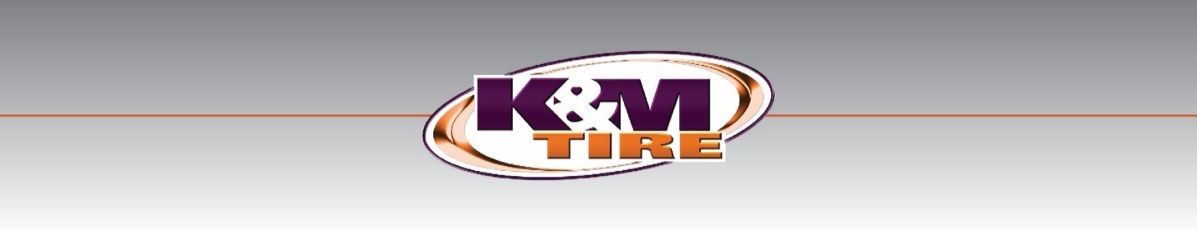
K&M Tire

Call Center SOP
4/21/2025

Table of Contents
Call Center SOP i
Table of Contents ii
1. K&M Tire Introduction 6
1.1 K&M Timeline 8
1.2 Important Company Information 9
2. Welcome to the Call Center 11
3. Policies 12
3.1 Phone 12
3.2 Special Order Non – Stock Policy 12
3.3 Non stock unlisted item procedure. 13
3.4 Transferring non-stock unlisted items 14
3.5 Receiving non-stock unlisted items 14
3.6 K&M Policy on Tire Rack 15
3.7 Changing Prices 16
3.8 Processing Returns on the Sales Dashboard 16
3.9 K&M Tire Return Policy 17
3.10 Purchase/Resale (PR) Guidelines for Returns 18
3.11 Employee Purchase 19
4. Tire Knowledge Training 21
4.1 Tire Basics 21
4.2 Tire Brand Abbreviations 23
4.3 Training/Testing 23
5. MaddenCo Basics 24
5.1 MaddenCo How-To Video 24
5.2 How to Place a Tire Order 24
5.3 Transfers 26
5.4 Picking up New Returns 27
5.5 Picking up Adjustments 28
5.6 Looking up Customer by Name & City 29
5.7 Looking up Tires, Tubes, Wheels & Equipment 29
5.8 Looking up Product History 30
By customer 30
By product number 30
5.9 Looking up Returns & Credits 31
5.10 NET State Orders 32
5.11 Credit Authorization 35
5.12 Credit Card Authorization 36
5.13 Invoicing 38
5.14 Will-Call Printing (WISE) 40
5.15 Will-Call Printing (non-WISE) 41
6. Dashboard 42
6.1 Dashboard Best Practices Video 42
6.2 Dashboard Outline Sheet 42
6.3 Looking up Customer 43
6.4 Placing Orders 44
6.5 Looking up Product History 45
Basic Product History 45
Looking up Returns & Credits 47
6.6 Notes 47
6.7 Delivery Issue Log 48
6.8 Purchasing Log 49
6.9 Weblink Usage 54
6.10 Reset Weblink 54
6.11 Looking up Routes 55
6.12 Will-Call Order 55
6.13 Open Orders 57
6.14 Printed Orders 57
7. Intranet 58
7.1 Credit Card Orders Report 58
Merchant Partners 59
7.2 Back Order Report 62
7.3 Closed Order Search 66
7.4 Customer Caller ID Maintenance 68
7.5 Customer Information 70
7.6 Customer Ranking Report 71
7.7 Delivery Issue Log 74
7.8 Display Invoice 77
7.9 Display Signed Invoice 78
7.10 Inside Sales Commission 79
7.11 Inventory Control Tool 80
7.12 Invoicing Sequences 81
7.13 Open Order Report 83
7.14 Pre-Closing Tasks 85
7.15 Process Load Sheet 86
7.16 Product History Inquiry 87
7.17 Sales Analysis/Product History Report 89
7.18 Sales Summary (3 Period Comparison) 92
7.19 Sales Transfer Audit 94
7.20 Weblink Login Report 96
7. Weblink 98
8.1 Set-up 98
8.2 Basics 98
9. Programs 99
9.1 Dealer Programs 99
Goodyear G3X 99
Goodyear Tire & Service Network 100
Bridgestone BARNN 101
Bridgestone Associate 102
Continental Gold 103
Yokohama Advantage 104
Cooper Medallion 105
Mastercraft Century 106
Kumho Premium Fuel 107
Hankook ONE 108
Falken Fanatic 109
Pirelli FasTrack 110
Mickey Thompson MTMA 111
Nexen Next Level 112
Trelleborg Associate 113
BKT Growing Together 114
Firestone Certified AG 115
Goodyear G3X Commercial 116
Yokohama Commercial Advantage 117
9.2 K&M’s Special Program Requests 118
Mr. Tire/Big 3 Tire 118
10. End of the Day 119
10.1 Invoicing Procedure 119
11. Forms 122
11.1 Price Level Change Request Form 122
11.2 Order Point Request Form 123
11.3 Product Set-Up Form 123
11.4 Limited Warranty Claims & “How To” 124
11.5 Release of Liability 126
11.6 Credit Application 127
11.7 Common Ownership Form 129
11.8 Dealer Request Form 130
11.9 Training Plan 131
12. Customer Service – Additional Procedures 132
12.1 Telenotes 132
12.2 New Customer Call-Outs 133
12.3 OE Connections 135
13. Video Library 136
13.1 How To’s 136
MaddenCo 136
https://kmtire.vids.io/videos/d49fd5bb1f16efc25c/sop-maddenco 136
Dashboard 136
https://kmtire.vids.io/videos/d49fd5bb1f17eac65c/sop-intranet-dashboard 136
Price Level Request 136
https://kmtire.vids.io/videos/a49fd5bb1f1de0c22c/sop-plr 136
Program Request 136
https://kmtire.vids.io/videos/1c9fd5bb1f1de6ca94/sop-program-requests 136
Spot Opportunities 136
Credit Application 136
https://kmtire.vids.io/videos/189fd5bb1f1be3c490/sop-credit-app 136
Dealer Request Form 136
https://kmtire.vids.io/videos/489fd5bb1f1be0c3c0/sop-dealer-request-form 136
Common Ownership Form 136
https://kmtire.vids.io/videos/a09fd5bb1f18e4c628/sop-common-ownership-form 136
Release of Liability 136
13.2 Intranet 136
Customer Information 137
https://kmtire.vids.io/videos/a49fd5bb1f18e7c02c/sop-intranet-customer-information 137
Sales Analysis 137
Ranking Report 137
https://kmtire.vids.io/videos/e89fd5bb1f19e7ce60/sop-intranet-ranking-report 137
Inventory Control 137
https://kmtire.vids.io/videos/a09fd5bb1f19e2c128/sop-intranet-inventory-control-report 137
Open Closed Order 137
13.3 Weblink 137
Weblink Login 137
14. Conclusion 138
15. Shipping & Receiving Clerk 139
15.1 How to Release Backorders from Order Entry 139
15.2 How to release Backorders from Inventory Receivers menu 143
15.3 How to do a credit /Rebill 146
15.4 How to Release Transfer Invoices 152
15.5 Fillable Order Report 154
16. Key Account 160
16.1 Sun Auto 160
Appendix A: Reference Documents 162
Appendix B: Revisions 164

K&M Tire Introduction

Video about K&M Tire
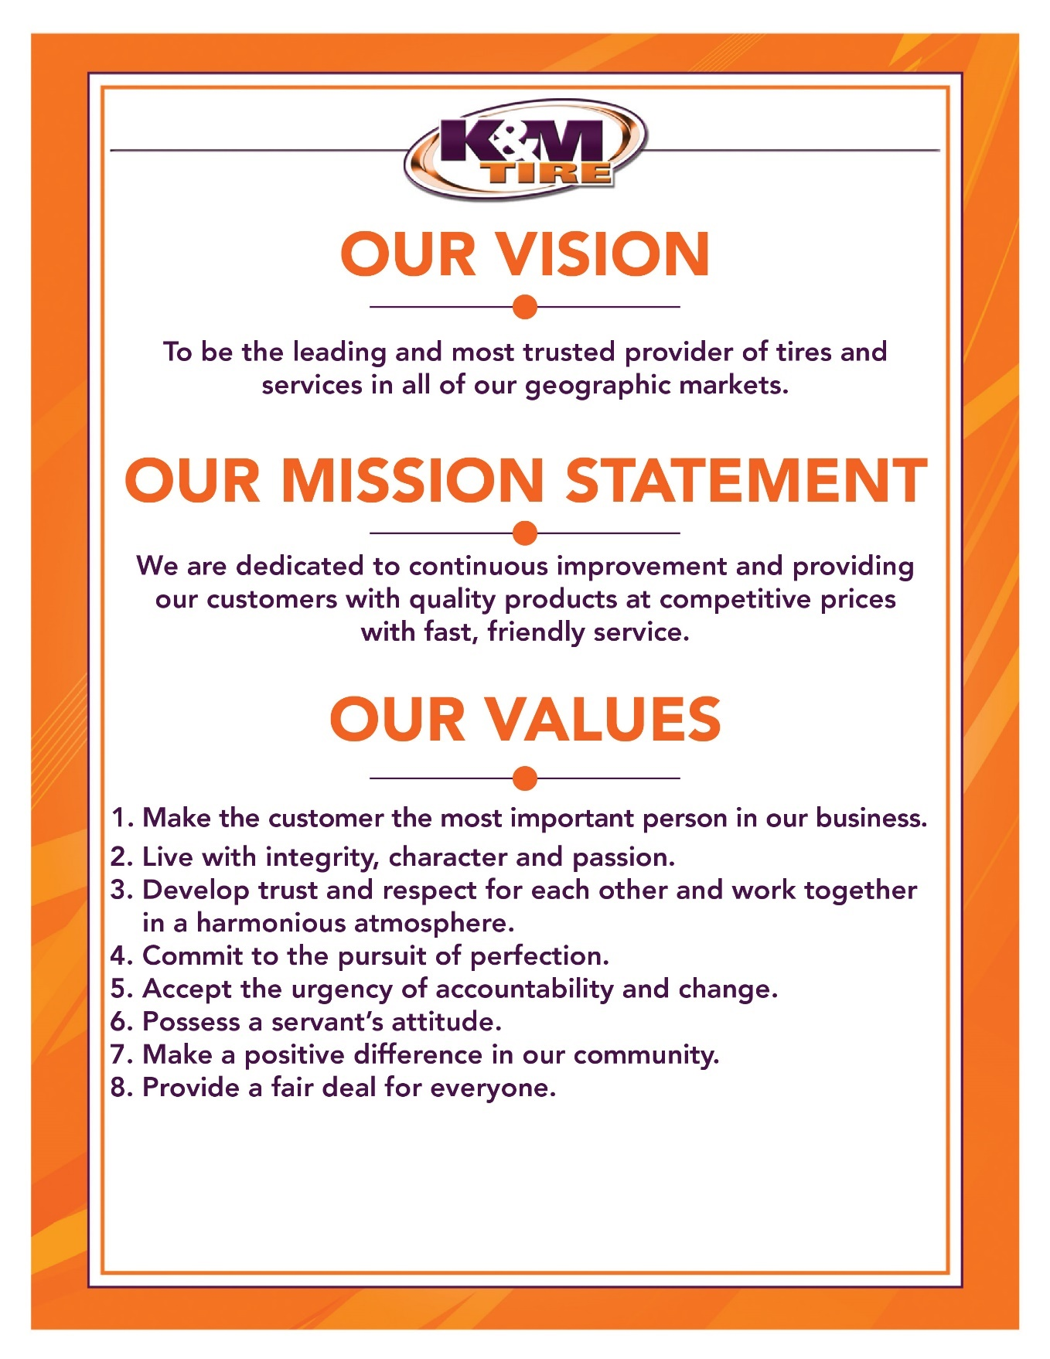

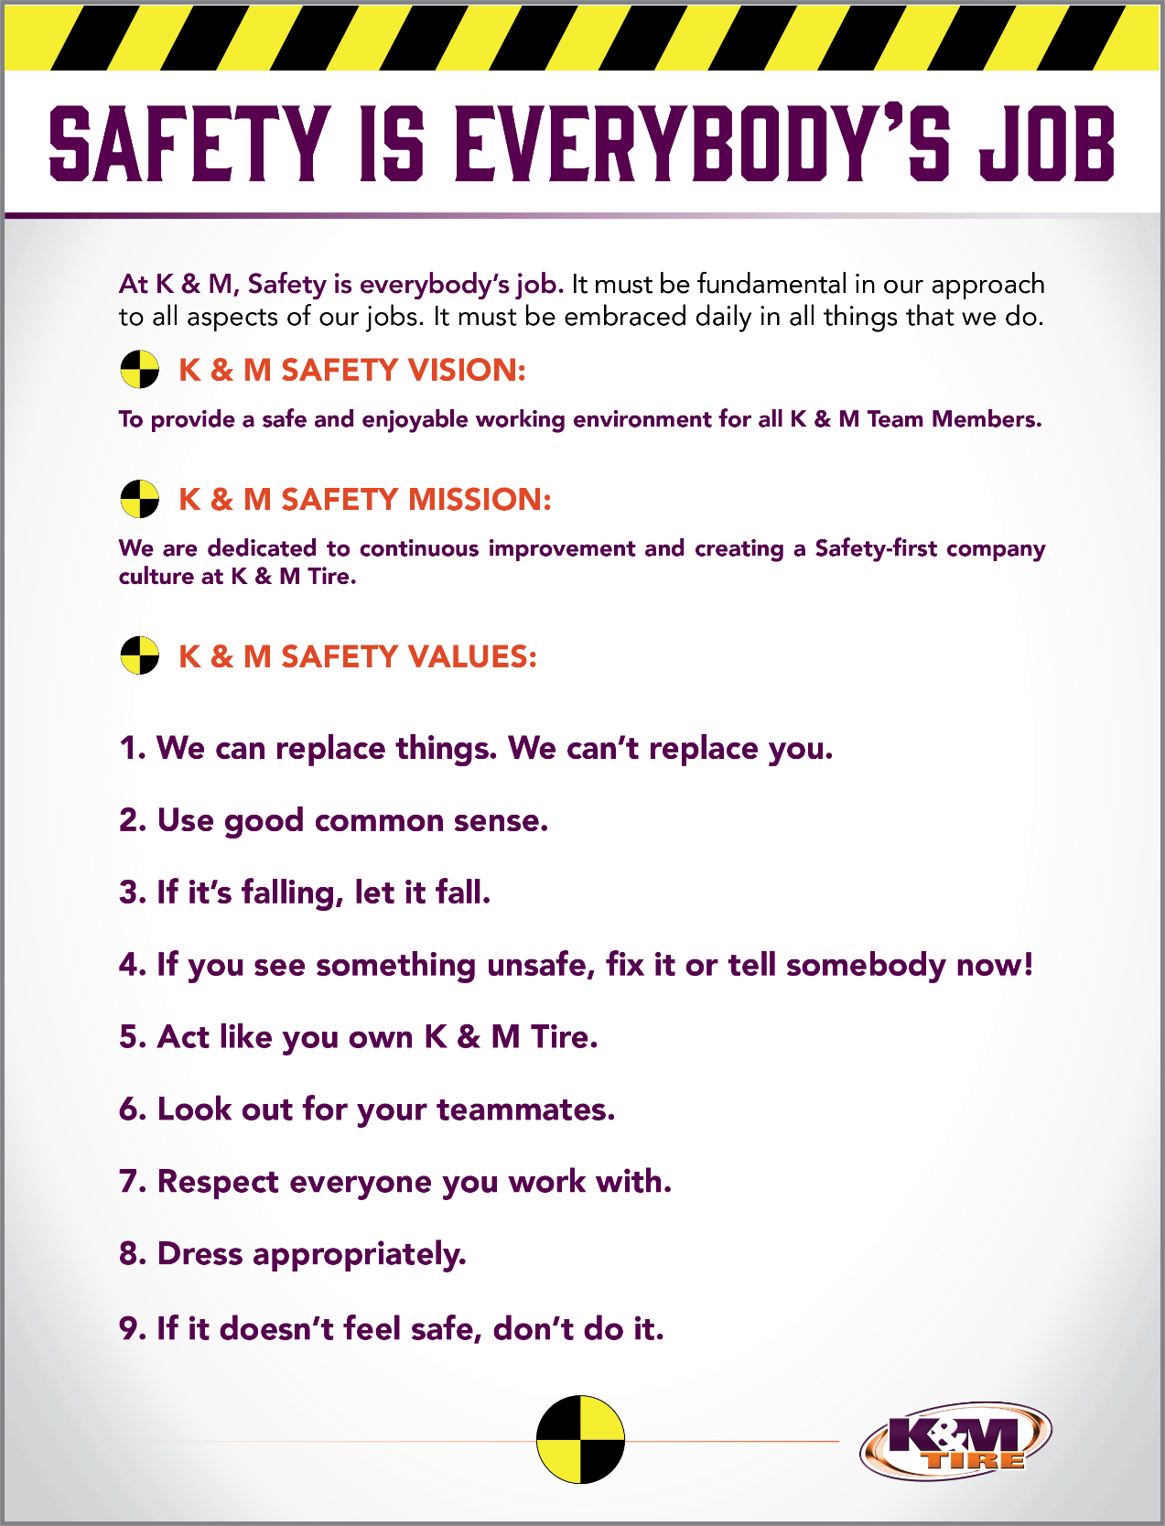

K&M Timeline
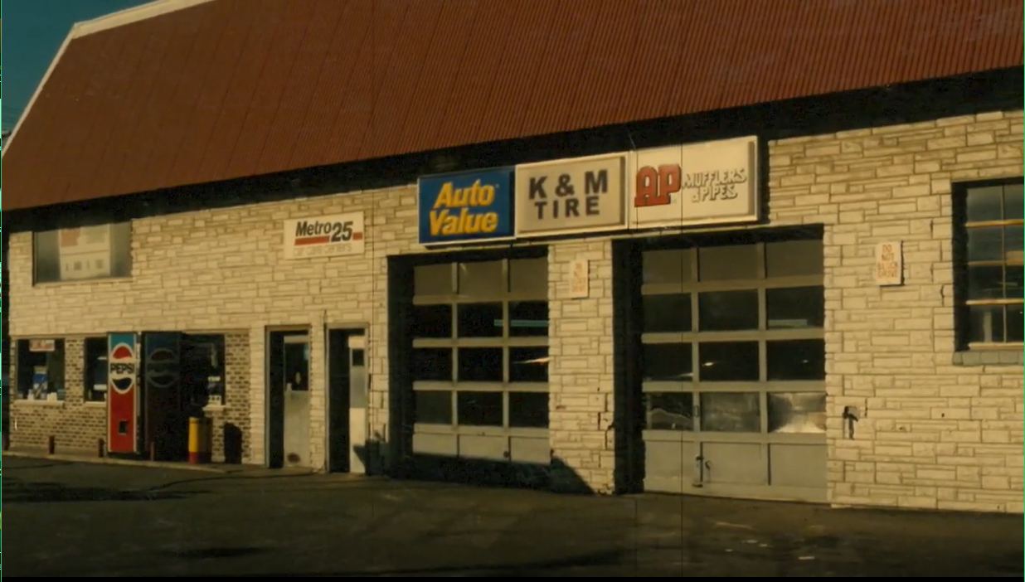

Important Company Information
This information is updated frequently. To ensure you are viewing the most current and accurate information, please use the links to access each document.

Employee Handbook
Employee Handbook can be found in Paylocity under Self – Service Portal then unemployment and is accessible HERE.

Organizational Chart
The organizational chart is a breakdown showing who is on each team and the chain of command throughout the entire company starting with the CEO and President. It is maintained on Paylocity and is accessible HERE.
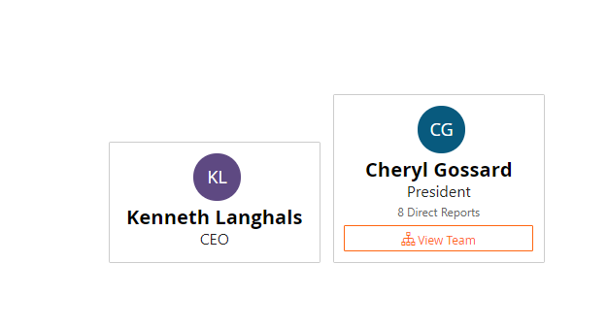
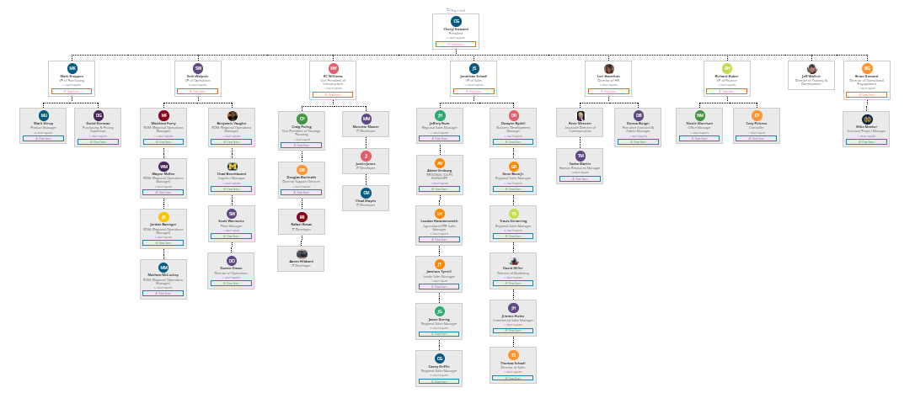

Our Locations:
http://kmtire.com/km-cgi/distmap

Warehouse Locations - Contact Information
The Warehouse Locations – Contact Information is a Word document listing each of our warehouse locations’ addresses, a phone number to reach the warehouse/manager, the manager’s name and an email address for to reach the warehouse manager directly as well as a “location” email. When sending an email to the location email address, it will be sent to anyone associated with that warehouse who has an active email address. This list is maintained by our Human Resources department and can be found on the F: Drive. You can also view the list by clicking HERE.

Welcome to the Call Center
Welcome to the K&M Tire Call Center, and congratulations on being selected for this position! This important area of K&M consists of two distinct branches: Inside Sales and Customer Service. The staff in both departments communicate with each other regularly to ensure that our company’s #1 Core Value, “Make the customer the most important person in our business”, is upheld to the highest degree. You are joining a dedicated team of individuals that, collectively, aims to keep the operations of our corporation running smoothly!
Inside Sales, as the name implies, handles the placing of call-in orders for customers, puts in returns for our drivers to pick up, and to a degree, provides customer service regarding minor issues, including but not limited to: whereabouts of delivery trucks, assistance with Weblink, and calling customers to confirm special orders of non-stock items. They also are knowledgeable about the products K&M sells and make recommendations and suggestions to our customers. Although the primary goal of an Inside Sales representative is to sell product to customers that call, a degree of problem solving is recommended as minor issues arise in order to keep the Customer Service representatives free to address more major problems.
The Customer Service team serves as a more direct link between the customer and our warehouses. It is in that department where escalated issues such as tire shortages, tire adjustment questions, and concerns about pricing, just to name a few, are addressed. Customer Service representatives each oversee a region of locations for which they can be called in the event a customer cannot easily contact his or her Outside Sales Representative. The Customer Service team strongly holds the standard of Core Value #6, “Possess a servant’s attitude” as they attempt to find quick but effective solutions to the problems that may arise at any given time.
It is worth mentioning that one crucial aspect of both departments is the timely and detailed printing of invoices at the end of each business day. The processes involved with this are among the most sensitive, as an oversight here can delay a customer receiving their orders, resulting in lost sales for our customers, and possibly lost business for K&M from said customers!
The above descriptions of both teams barely scratch the surface of the specific duties and responsibilities of each. That is where this Standard Operations Procedure manual comes into play; its purpose is to serve as a walkthrough of the policies and procedures put forth by K&M. Many of the procedures you will see in this manual will become second nature as they are done countless times during the week, sometimes even several times a day. Others, however, will serve as reminders on how to address the actions one must take in regards to special ordering products, handling government pricing, and returns for certain accounts. Several team members dedicated hours of their time to ensure this SOP is up to the high standards to which we hold each other as employees of K&M; however, please remember that there is never any harm or shame in reaching out to another team member or even your department’s supervisor for clarity and/or advice. Good luck and welcome aboard!

Policies

Phone
We are never allowed to call a driver. If a driver needs to be contacted their manager will place the call.
We also should never transfer a customer to a warehouse manager or the adjustment department.
- If you have a question, see your manager or assistant manager

ACCEPTING PERSONAL CHECKS
K&M will not accept personal checks unless it is from the owner of the company.

SELLING TO OUR CUSTOMERS EMPLOYEES
K&M does not sell to individuals and therefore will not sell to our customers employees directly. If a customer’s employee wants to purchase tires from K&M, it must be ran thru our customers account and our customer is ultimately responsible for payment. We will accept cash, credit card or we can bill our customer’s account.

Special Order Non – Stock Policy
Occasions arise when customers order product from us that we do not stock and will need to special order either by will-call or regular order. To help reduce the amount of non-stock inventory we end up with we have an automatic 10% restocking fee on all special order non-stock tires.
At time of order via phone the salesman is to check if the product requested are products that are not stocked in any warehouse. To check this you use an “M” on the OPT line of the product you are looking at and look for any order points(Min/Max). If we do not stock anywhere you must inform the customer that it is a special order non-stock item and subject to a 10% restocking fee. On weblink orders you must call the customer to inform them.
On the invoice under the special ordered product use this part number to confirm customer is aware of the policy:
Part# SPECIALORDER Description: 99 TIRE SUBJECT TO RESTOCKG FEE

Non stock unlisted item procedure.
- Billing Non Stock (unlisted items)
  - Non-stock items should be items you will not inventory. Non-stock items should not be received in on a receiver in Maddenco.
- Non-stock mark ups if not already given by our purchasing department.
- All Tires – 15%
- All Unverferth – 20%
- Parts & Equipment – Managers approved increase
  - All prices plus freight if applicable
- All non-stock orders are considered special order (follow special order procedure) and subjected to a restocking fee and possible additional freight cost to return the tires to the manufacture

- All non-stock orders must include the name of the person that is agreeing to our return policy (we must also memo the invoice with the person’s name under the special order line)

- When billing an unlisted item in maddenco follow our how to Place a Tire Order procedure at step 3 product inquiry screen, type NS (for non-stock) on the size line and press enter.

- A list of several non-stock options will be displayed. Select the item that describes what you are billing out. Enter the quantity and sale price to the customer. Enter our cost that we will be billed for the item in Act Cost and Repl Cost. Type over the description to explain what the item is (tire size and tread design, etc.).

Part # Description use when selling
NS 99 NON STOCK tires, tubes
NSAP XX NON-STOCK AUTO PARTS auto parts
NSBATT 99 NON STOCK BATTERY batteries
NSEQ 99 NON STOCK EQUIPMENT equipment
NSUM MV NON-STOCK U/M Unverferth

****DO NOT ADD TO THIS ORDER****
Must add part # DONOT To all non-stock unlisted orders.

*** MUST BACK-ORDER NS IF NOT ON HAND ITEM WILL NOT BACK ORDER AUTOMATICALLY ***

Transferring non-stock unlisted items
If transferring non-stock (unlisted items) the transfer invoice must include our cost that we will be billed for the item in all 3 areas. Selling, Act Cost and Repl Cost. Type over the description to explain what the item is (tire size and tread design, etc.)

Example of transfer
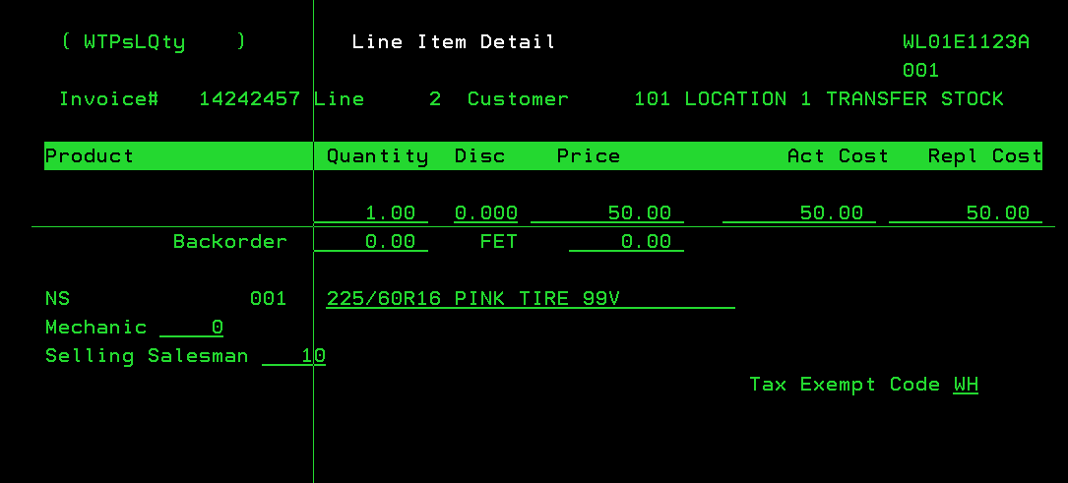

As always transfer should have account number invoice number and route code of the account we are selling the item to.

404338 41256781562 4G

Please also add part # DONOT ****DO NOT ADD TO THIS ORDER****

Receiving non-stock unlisted items
- Warehouse sends receiving invoice for unlisted items received
- Shipping and receiving clerk releases back order from invoice and or transfer
- Shipping and receiving clerk also sends email to shipping warehouse, sales person and A/P

Example below
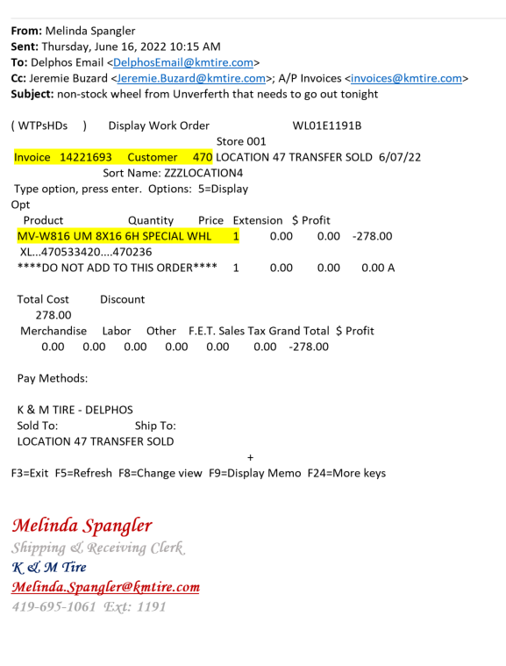

K&M Policy on Tire Rack
- K&M will match Tire Rack price on all passenger and light truck tires plus $20.00.
- The Tire Rack warehouse must have enough inventory on product in question to fill an order for us to match the price.
- Every request must be individually verified on Tire Rack website to check accuracy of price and availability.
- This is to be used only as needed and Dealer must let salesperson know at the time of order that they would like us to match the Tire Rack price.
- Salesperson will add a message line to the invoice that indicates reason for price change was to match the Tire Rack.
Tires acquired from the Tire Rack cannot be sold on PR, SSP, National or Government Accounts

Changing Prices
You had the option of changing the selling price on items in Maddenco, so you can match competition.

However, you have the opportunity to make more money by sticking to the customers programmed price levels.

Some customers know if they just ask for a better price that a majority of the time we will lower the price to them. This only encourages our customers to continue to call in so they can receive a better price instead of placing their orders on-line on weblink.

We would like to correct this mind set some of our customers might have. All sales people should stick to the customers programmed price unless you are meeting competition. If you feel a customer is not assigned the correct price level, please send an email to the Sales manager and they will review the request and discuss it with you to decide if a change should be made.

The call center manager receives a report daily of all sales prices that were changed from the previous day. This report gives the manager a chance to talk to each sales person on the prices they changed so we can stay on top of what the competition is doing.

Processing Returns on the Sales Dashboard
- Navigate to Product History/Customer Return:
  - Go to the Product History section, then select Customer Return.
- Viewing Product History:
  - The system will automatically display 730 days of history for the selected item.
- Search Criteria: You can search for the product using the following options:
  - Tire Size
  - Part Number
  - Invoice Number
  - PO Number
  - Date
  - Class
  - Brand

- Search for the Item:
  - After entering the return information, click Search Tire.
  - The system will display the product’s history along with month-to-date, year-to-date, and last year’s sales data.
- Enter Return Information:
  - Add the return amount in the box next to the Return Amount field and click Continue.
- Handling Multiple Purchase Dates:
  - If the dealer purchased the product on different dates, the system will prompt the user to confirm the restocking fee for each return based on the individual purchase dates.
  - The system will then categorize and place each return according to its purchase history date.
- Return Processing Confirmation:
  - Once the return is processed, a pop-up will appear, confirming the success of the return.
  - The system will also display the Estimate Number for the return(sample shown below).

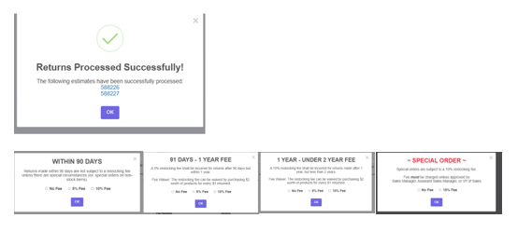

K&M Tire Return Policy

- Return Authorization:
  - Customers must contact a K&M salesperson to authorize a return. The salesperson will review the sales history for the items being returned to verify the purchase details.
  - If the return does not meet K&M’s return criteria, the salesperson will inform the customer. Any exceptions to this policy must be pre-approved by Mark Knippen
  - Important: Do not print a return ticket for any exceptions that have not been approved.

- Return Pickup:
  - The K&M delivery driver must have a return ticket to pick up any returns.
  - K&M drivers are not authorized to pick up returns without prior approval from a K&M salesperson.
  - If a customer is upset and insists on returning the tires, an exception can be made, wherein the driver may contact the sales department to request return authorization.
- Condition of New Returns:
  - All items must be clean and in like-new condition. Tires without their original stickers are still eligible for new return. Take-offs or previously mounted items will not be accepted.
- Discounted Items:
  - Discounted items will not be accepted for return without Mark Knippen’s approval, unless the dealer purchased the tires from K&M within the past 90 days.
- Non-K&M Tires:
  - Tires not purchased from K&M will not be accepted for return, except with Mark Knippen’s approval.
- Age of Tires:
  - Tires with a purchase date older than two years will not be accepted for return, except with Mark Knippen’s approval.
- Restocking Charges:
  - A 5% restocking fee will apply to items returned more than 90 days after the invoice date.
  - A 10% restocking fee will apply to items returned more than 1 year after the invoice date.
  - PR/SSP accounts are exempt from restocking fee.
- Special Order Restocking Fee:
  - A 10% restocking fee will apply to special order items.
  - PR/SSP accounts are also exempt from this restocking fee.
- Fee Waiver Option:
  - The restocking fee may be waived if the customer purchases $2 worth of products for every $1 returned.

Purchase/Resale (PR) Guidelines for Returns
- Car Dealer Program (Ford, GM, and FCA):
  - All vendors: 1 year from the date of purchase
- All Other Programs:
  - Goodyear: 1year
  - BS/FS: 1 year (Returns processed after a year are accepted because we don’t need to provide an original, and Bridgestone doesn’t require it in their system.)
  - General: 6 months online but can process up to 11 months if sent to Continental. Continental will process returns over a year old for us.
  - Pirelli: Returns only allowed for car dealers and Discount Tire, up to 1 year old. No returns for Simple Tire or Belle.
  - Hankook: 1 year for car dealers and secondary supply customers.
  - Falken: 1 year
  - Kumho: 1 year
  - Nexon: 1 year
  - Yokohama: 1 year
- Additional Guidelines:
  - All vendors must be billed on a separate invoice.
    - If the items were not purchased on the same invoice, they cannot be returned on the same invoice.
  - Tires must be returned, the credit must be issued, and our NAB department must have the credit processed within the year from original purchase date. This is not a pickup-for-credit deadline.

Employee Purchase
- Employee notifies manager to purchase tires. If an employee contacts the call center manager / assistant call center manager directly, they will be referred to the employee’s manager. An employee must go through their manager to purchase tires.
- Manager contacts (VIA Email) call center manager / assistant call center manager to process order along with form of payment using. If employee is using payroll deduction a completed form is included in the email. If paying with credit card the call center manager will call at time of creating invoice for card information.
  - K&M employees are not charged a 2% credit card fee
  - For Cash / Check purchases, the employee must submit payment to the AR department prior to receiving the tires. Employees working at a warehouse can make payment to the warehouse manager.
- Call center manager/ Assistant call center manager determine eligibility (according to handbook policy) and verifies form of payment before placing order.
  - At this time if an account is needed to be set up call center will contact our credit department to get the account set up.
- Call center manager/ Assistant call center manager creates invoice
  - At this time if the employee is using payroll deduct form a copy is emailed to HR & Credit
  - if employee is paying with credit card call center to handle and note invoice
- Credit / AR manager approves every order and releases from hold.
- Employee receives tire

Tire Knowledge Training

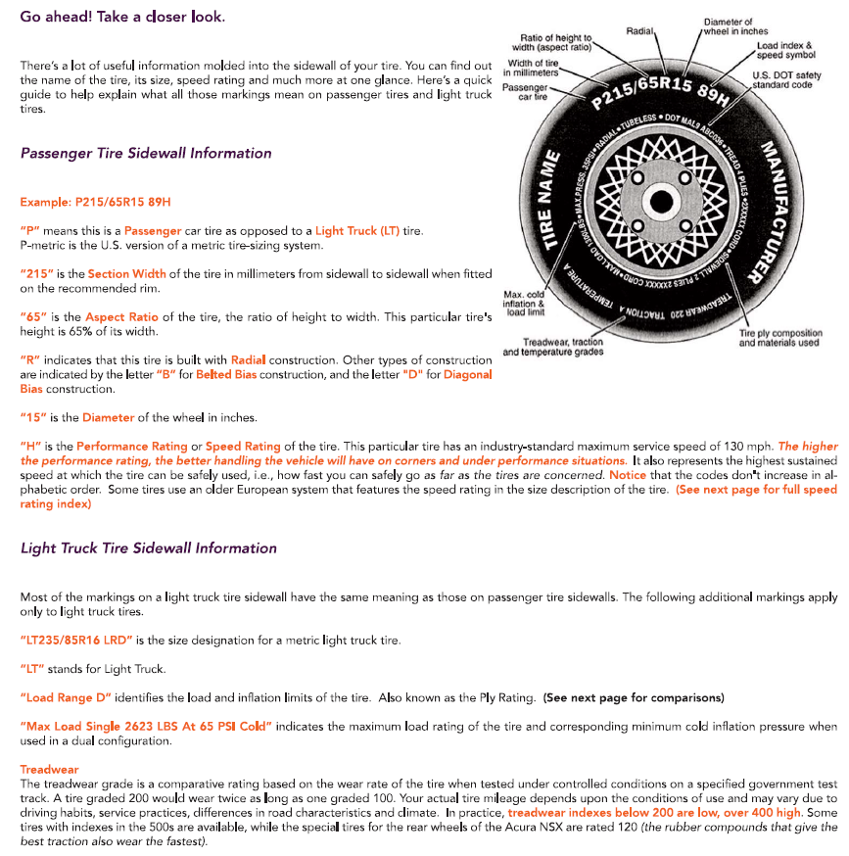
Tire Basics

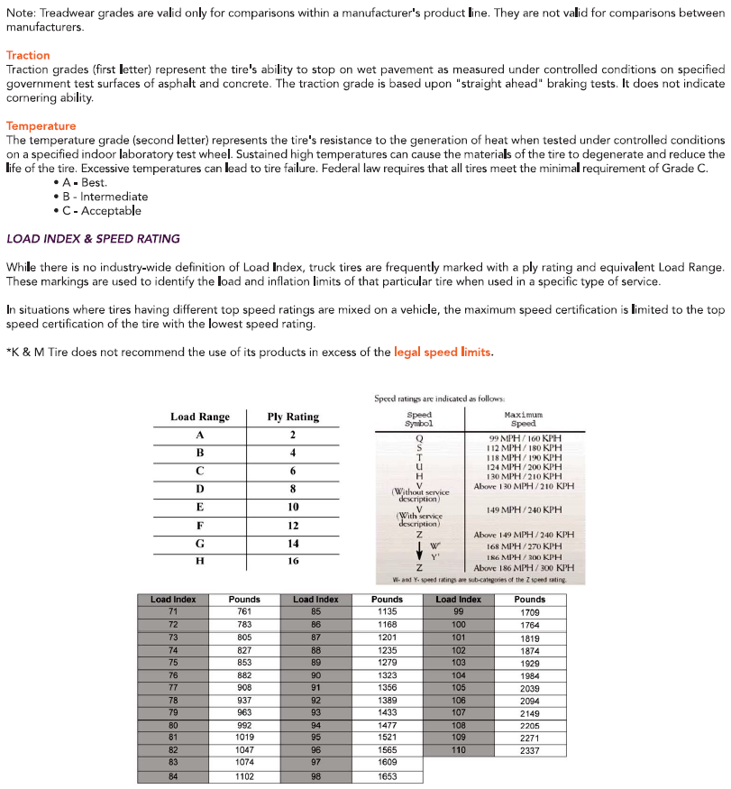

Tire Brand Abbreviations

Tire Brand | Abbreviation
Firestone | FS
Bridgestone | BS
Dayton | DA
Goodyear | GY
Kelly | KE
Dunlop | DU
Continental | CO
General | GE
Hankook | HK
Cooper | CP
Roadmaster | RM
Mastercraft | MA
Yokohama | YO
Pirelli | PI
Falken | FA
Nexen | NX
Kumho | KU
Michelin | MI
BF Goodrich | BF
Uniroyal | UN

Training/Testing

MaddenCo Basics

MaddenCo How-To Video
The below link will provide you with some basics on navigation throughout MaddenCo. There are many different functions within this system, and this video will provide you an introduction to the most used avenues within our MaddenCo system for sales purposes.
https://www.youtube.com/watch?v=ZahZmcrH3Gs

How to Place a Tire Order
- To get to order entry:
  - 1 – Tire Dealer System on line, enter
  - 7 – Warehouse Order Entry Menu, enter
  - 1 – Order Entry, enter
  - You are now in order entry to select which warehouse you wish to search product in – select home store of customer as store number to be used shown below.

  - Press enter
- Place the customer you wish o place an order for on the line that shows “Customer” as shown below.

  - Press enter
- Once you have the customer number placed in the allotted location you can press “F2” to search for a tire size.
  - Place the tire size provided on the “tire size” line as shown below, next press enter.
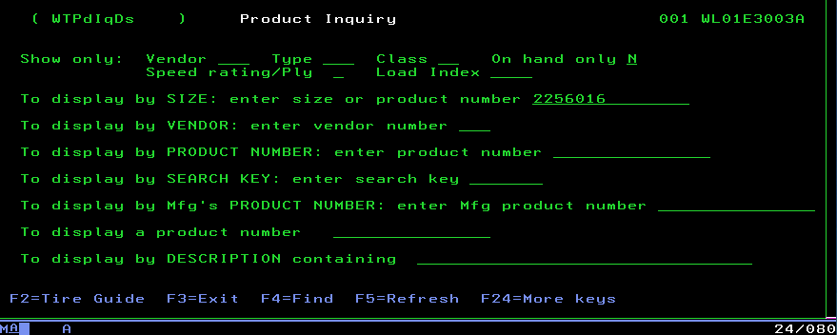

- This will show all the tires we list within the company for this specific size. It also shows the quantity “available here” for the selected warehouse.
  - Select the tire you wish to place on order and put the quantity desired on the line to the left as shown below, next press enter.
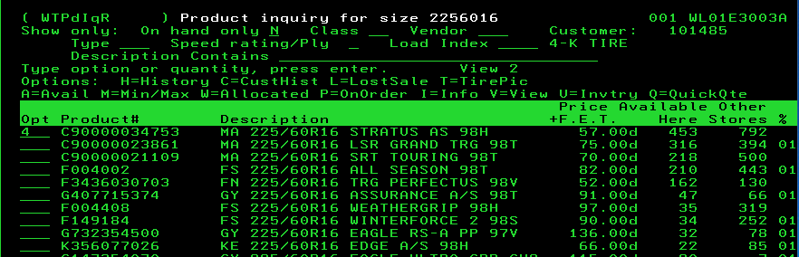
- Next it will ask you if you want to enter “E” for estimate or “I” for invoice.
  - When placing an order, we want to select “I”
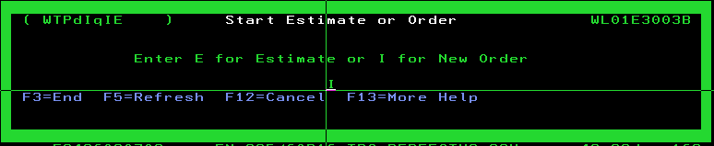
- After step 5 you will see the following screen.
  - Place your selling number on the “sell salesman” line.
  - Place the PO# on the line as well if the customer provides one.
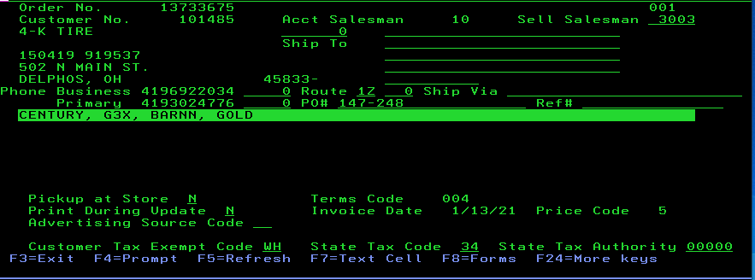
- Press “enter” and the order will be created.
  - Hit “F3” to back out of the invoice and you will see the invoice listed.

Transfers
Transfers are put into place when we have to move product from one warehouse to another.

● For Example: The below invoice is not in stock in the local warehouse.
- These tires show to be in loc 45 (Des Moines warehouse) this is designated by the
“on order from 45” message line.

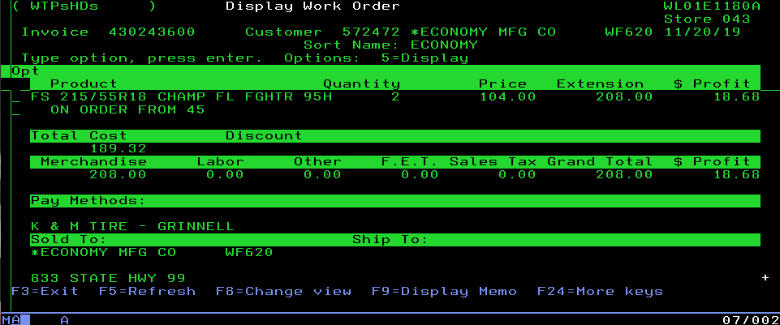

● The next step is to create a transfer to fill this invoice
- Enter the store number the tires are to be transferred from; in this scenario it is loc 45

●Under customer number, place the store we would like to transfer the tires to. While doing this always place a zero on the end of the warehouse number “press enter”
-Example: location 43 would be customer number 430
-Example: location 1 would be customer number 100
Doing so will bring you to the following screen. You will see the location we want to transfer from (45) in the top right corner and the location we are transferring to under customer number (430)
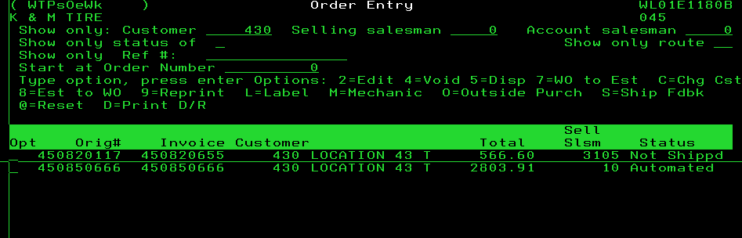

Next, we search the tire to transfer
-Press F2 to search for tire
-select quantity that needs transferred: select invoice and use salesmen 10

The final step is to reference the transfer to the original invoice with a message line
- The format to do so is route code, customer number, invoice number and your sales number
When done correctly it should look like below: Transfer completed
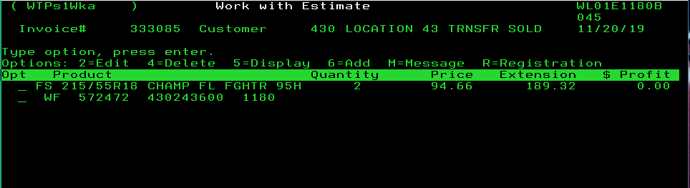

Picking up New Returns
- Make sure you are in the customer’s home location. The return must be placed in the same location that the customer’s route truck leaves from.
- Always return most recent tires purchased, unless asked to do differently by the customer.
- “Shift F2” to see inventory history.
- Use vendor # option in invoice history to narrow down search.
- Always copy invoice number of items being returned.
- Select quantity to be returned on “opt” line.
- Use an “E” for estimate.
- IMPORTANT: For PR/SSP returns, you can ONLY add tires that were purchased together on one pick up estimate. If tires are of different brands or were purchased separately, they MUST be on separate return tickets.
- Put an “M” to add a message line on the product, and paste the referenced invoice number that was copied, where tires were purchased.
- Change quantity to a negative by putting a 2 on the option line, and hitting enter twice to get you to the quantity page.
- After all tires have been entered, look up product number “PICK UP” and add quantity 1 to the pick-up slip.
- Count your total tires being picked up.
- Put a “2” on the option line to edit the pick-up line, hit enter twice to get to the quantity page. Change the quantity to a negative amount to tell the driver how many tires are on that pick up slip.
- Clear price on the “price” line.
- DO NOT zero out the F.E.T. line.
- DO NOT zero out state tire tax if the customer is charged these taxes.
*********Restocking Fees*********
● All restocking fees must be notated on invoice
● If tires returned are over 90 days old restocking fee of 5% will be charged.
● If tires returned are over 1-year old restocking fee of 10% will be charged.
● Fee can be waived if dealer purchases $2.00 for every $1.00 returned.
● Special order/Non stock tire returns require 10% restocking fee.
●Discontinued tires over 90 days old cannot be returned.

****Restocking fee may be waived pending Manager or Purchasing approval***
- state tire tax if the customer is charged these taxes.

Picking up Adjustments
To place an adjustment pickup, we use the same process as a normal new tire return. Instead of selecting “pick up for credit” select “pick up adjustment+ claim form”
Adjustment returns require the following:
- Proof of purchase (unless purchasing replacement tire with us)
- K&M Tire adjustment claim form number
Below is an example of how an adjustment pickup should be formatted.
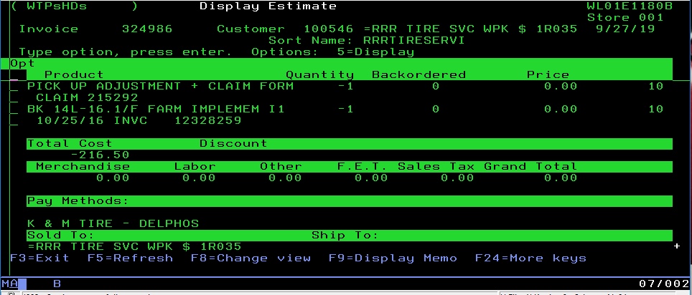

Looking up Customer by Name & City
- From order entry screen:
  - Press F4 and type in customer name. The more letters you type the narrower your search will be.
  - Select customer by putting a “1” on the line and press enter.
  - If you have trouble understanding the customer, ask what city he is in and search that way.
  - To search by city, from order entry screen: F4, then SHIFT F4, and type the name of the city.
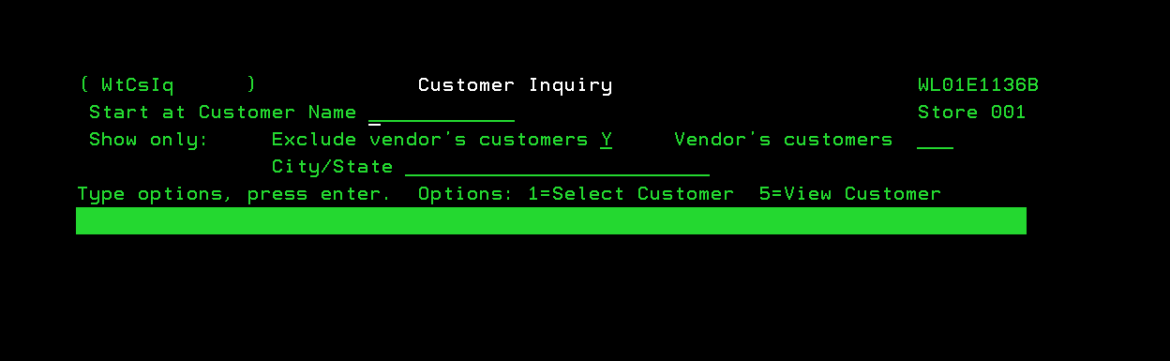

Looking up Tires, Tubes, Wheels & Equipment
- From order entry screen, press F2. On the “Display by size line” type in the tire size. No dots, dashes, or slashes, and then press enter.
- To narrow your search, press F6 to place to jump your cursor to the “vendor” line at the top of your screen. Press F4 to see vendor list. To narrow your search even more, place cursor on “on hand only” and place an “A” to show all inventory, or a “Y” to show only that location’s inventory.
- To Find wheels, do as above, except type “W” and the diameter of the wheel (ex. W42 for a 16x42 wheel).
- To find tubes, do as above except type “T” and the diameter of the wheel (ex. T42 for a 42-inch tube).
  - If you cannot find the diameter that you are looking for, type in a diameter smaller. Many tubes that are in a combination size. It will benefit you to have a tube book, and a copy of the various valves used.
- ***Whenever you are looking at inventory, place an “M” on the inventory line. Backordered inventory, when greater than on hand inventory, will hide any on hand inventory which you will not see unless you are viewing inventory in this way.

Looking up Product History

By customer
- From the order entry menu, select customer either by searching for the customer or typing in the customer number.
- Once the customer number is selected, press SHIFT + F2 to pull up history. You can narrow results by placing a vendor number on the “vendor” line, or pressing F4 to select from vendor number list. You can also narrow by using a product class, 01-Winter Tires, 02-Passenger, 03-Light Truck, 04-Commercial, 15-Trailer Tires.
- Another way to check history:
  - Do step 1, then search for a tire by pressing F2. Once you find your product, put a “C” on the line to show customer history. From this screen you can check all locations by changing the store number at the top of the screen.

By product number
While at the home store of the customer press “F2” to search for tires
- On the product number line, insert the product number of the tire you wish to view
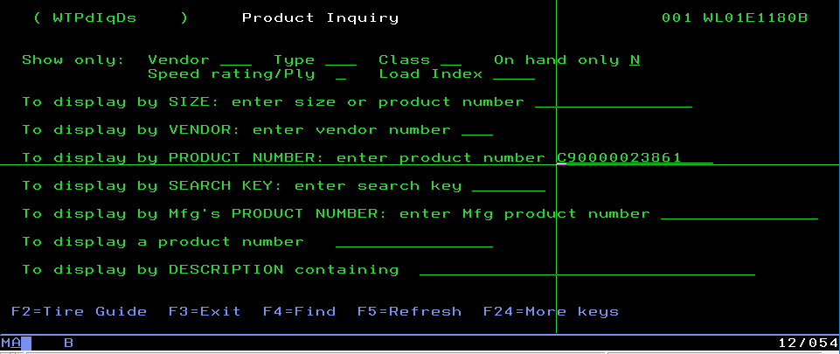
●Press “enter” the following screen will show the part number
-Place the letter “c” on the quantity line to view history: press “enter”

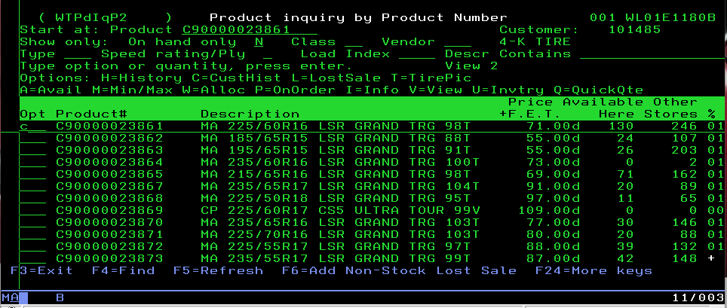

●This shows any purchase history this customer made on this specific tire
-History will be displayed from most recent (top) to oldest (bottom)
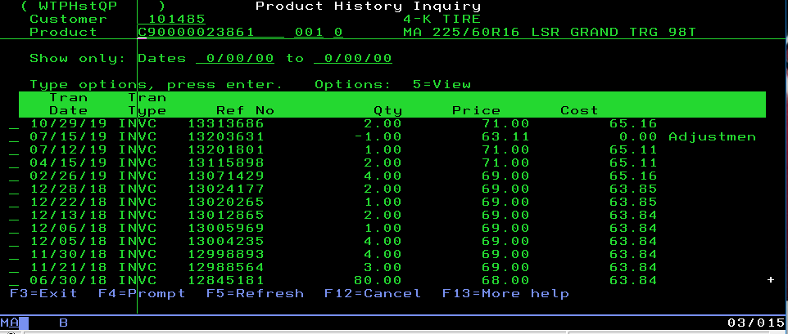

Looking up Returns & Credits
- From the order entry menu, select your customer either by searching for the customer or by typing in the customer number.
- Once the customer is selected, press SHIFT + F2. You can narrow the search by putting the cursor on the vendor line, and either typing in your vendor number, or selecting from the list by pressing F4.
  - You can search for RAR’s by using product class 24.
- Another way to check history is to do as above, except from the body of the order entry screen, select the tire either by size or product number, and put a “C” on the option line. This will bring up the history of the product.
  - From this screen you can check all locations by changing the location number at the top of the screen. Again, you are looking for a negative inventory quantity.

NET State Orders
This special pricing enables us to bill government entities at the discounted price provided by the tire manufacturers.

*Only G3X dealers can process class 1,2,3 Goodyear tires*

●There are two ways to find state pricing

- Vendor websites browsing by state/part number: Access will be given
https://www.tire-hq.com/ (Goodyear)
https://www.batogovtires.com/ (Bridgestone)
https://www.contilink.com/cite/servlet/page/cite-plt-en-us (Continental)

-If you need help or have trouble finding pricing on a website, reach out to our National Accounts Department.

●Once the price has been obtained you need to place the order for the quantity desired

Once completed you will see the following: Now we need to edit the price to the state price
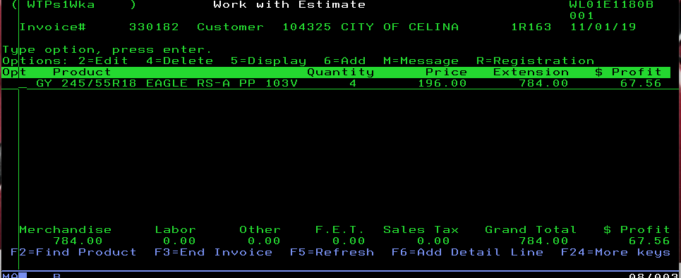

●To complete this step, you need to input “2” and press enter twice on the line item to modify
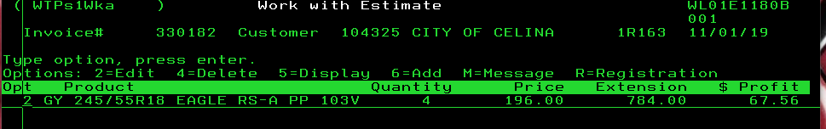

Once this step is completed, tab over to the line that says “price” and insert the state price given. Press “enter”
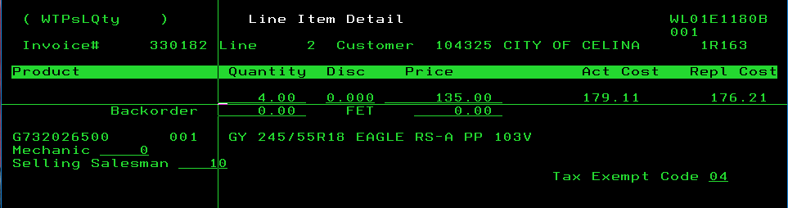

●You will now see the price has been adjusted. The next step is to add the Net state line.

-Press “F2” to get to the search menu and insert “nst1” on the product line shown below “press enter”:
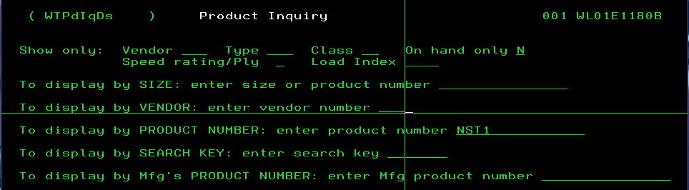

●The quantity of the NST1 line must match that of the tires being sold but negative.
-Place “2” on the NST1 line item to edit
-To apply this, enter the quantity of the tires and the “minus sign”

● Next adjust the actual cost and replacement cost on the product line.
-To do this, subtract NET state price from PL5 obtained.
-To find PL5 search tire and select “I” for info on the line item
-Place the difference of the PL5(192.00) and NET State (135.00) on the actual and replacement cost lines
-Place customer number as the “claim number”

Once completed this will show as the following:
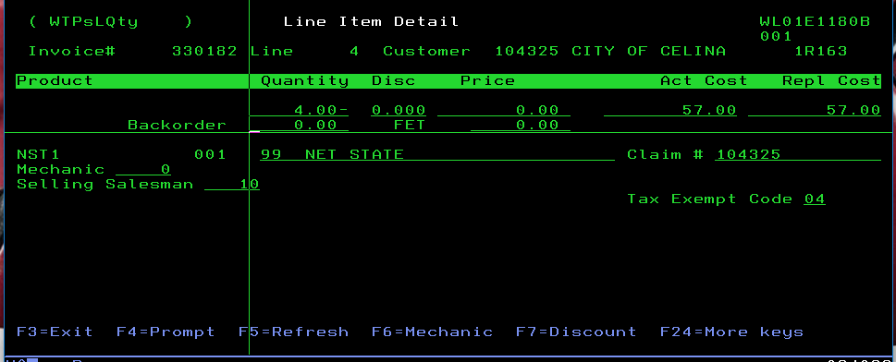

Press enter twice, the net state is complete and will show as below:
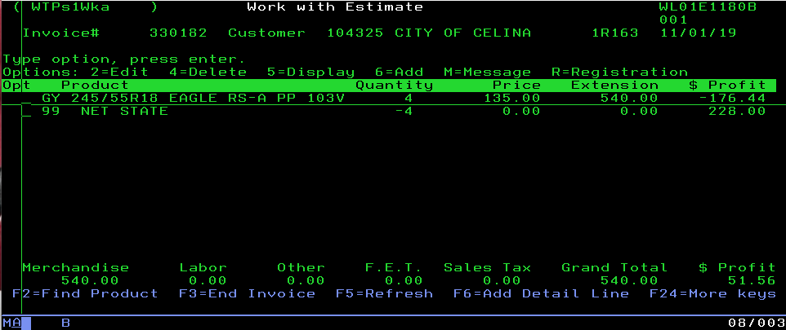

Credit Authorization
In order to authorize an invoice credit request, the sales person must perform the following steps.
- If a customer is sent to credit authorization while the credit department is available (8:00-5:30 Eastern Time) their department will handle the request.
- If it is after hours go to Intranet and type authorize in the search box and select CC/SA- Authorize Credit Holds

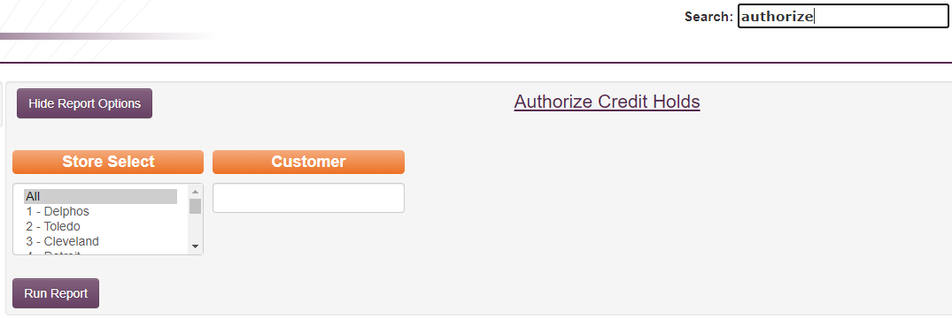

- You can either run by an individual store or select all and click run report.
- Any customer in Green has an invoice that needs authorized.
- Click on the customer number and it will show you all the invoices in for that customer.

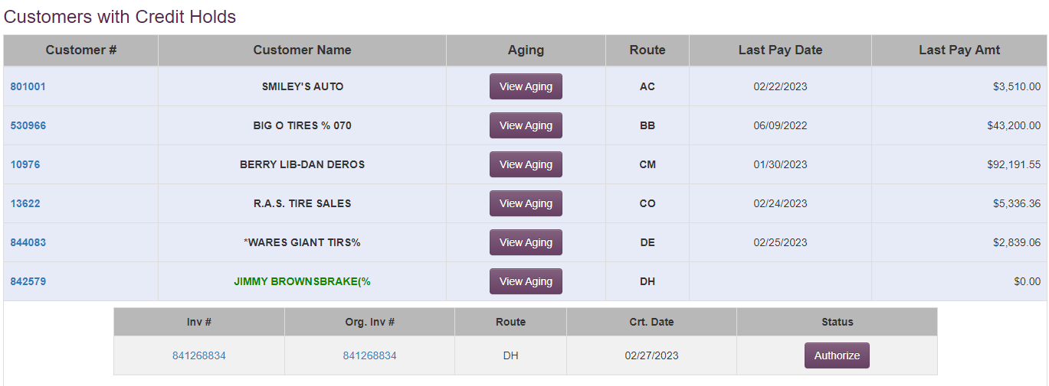

- If the amount to be authorized is less than $5,000 then you are good to authorize. All you would need to do to authorize it is click the Authorize button.

- If the amount is over $5,000, please call or text Asst. Inside Sales Manager or the Inside Sales Manager and they will either give you the OK to authorize or tell you not to authorize it.

- If a customer is sent to credit authorization and the credit department and/or management is not available, please text the Asst. Inside Sales Manager and the Inside Sales Manager and do not authorize. They will look over and approve it if needed.

Credit Card Authorization
The credit card authorization process is done through three different outlets. It begins on the Intranet, a credit card is processed through the Merchant Partners’ website, then the order is finalized in MaddenCo. The full process can be followed using these steps:

- Log into the Intranet: http://intranet.kmtire.local/index.php
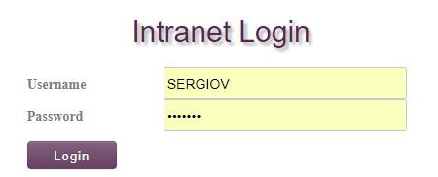

- Click + to open Department List.

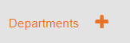

- Click + to open Open Sales – Inside.
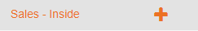

- Click on SA – Credit Card Orders Report to open the program.
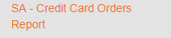

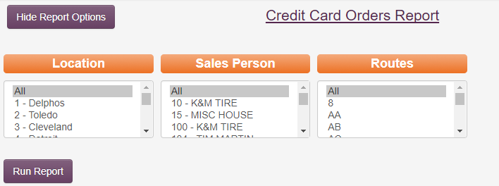
- Keep all options set to “All” and click “Run Report

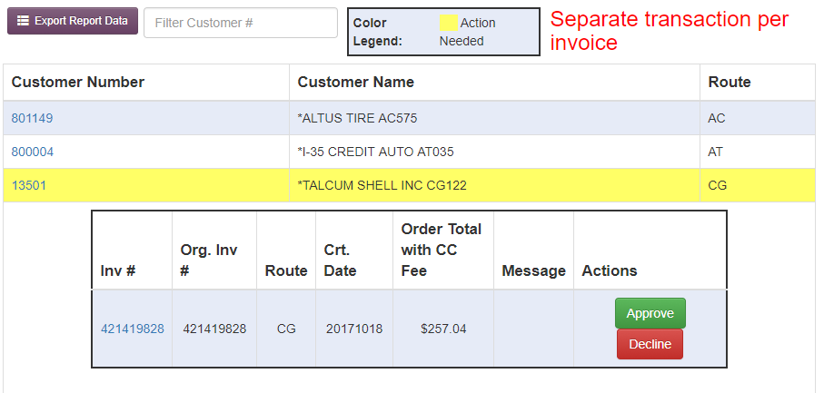
- Highlighted accounts are cards that need to be ran. If you are looking for a specific customer, select them by clicking on their customer number.

- Look up the work order in Madden Co to make sure that there are not any backorder items. We are no longer allowed to approve an order if there are backordered items on the ticket. If there are, split the order on to another invoice so that there are not any backordered items on the order. Please make sure the new order has the correct PO number and Ship to if necessary. Then refresh the report so that it reflects any changes that were made.
- Run the purchase amount on Merchant Partners: https://www.onlinemerchantcenter.com/admin/login.taf
- If the card was approved, click the 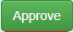 button. If the card was declined, call the customer and explain that the credit card payment did not go through. Ask them if they would like to set up other payment arrangements. If they tell you that they would like to pay check or cash hit the 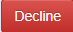 button. Every invoice for the rest of the day will automatically change from credit card payment to COD.

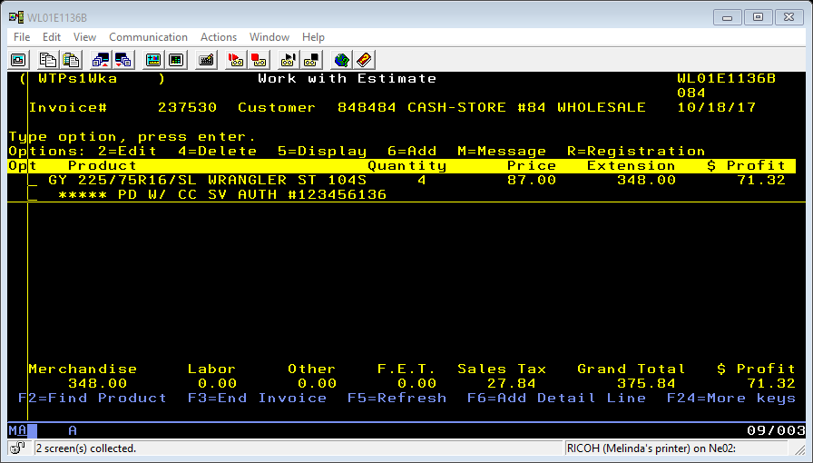
- If the order was approved, add a memo line with the “Order ID” number on the merchant partner’s approval page as the authorization number to the work order in Madden Co.

Invoicing
Much like some other processes within this binder, the Invoicing process entails multiple steps taken through different systems. The full invoicing process will be outlined in this procedure with those steps using MaddenCo highlighted.

Step 1—Transfer Audit Report
Using the K & M Intranet; run the transfer audit report for each location that you are invoicing.
On the intranet go to Departments-->Sales-->Sales Transfer Audit
Move any orders that are available in a closer location as needed, or correct any orders that are placed in the wrong location.

Step 2--Credit Authorization
At the order entry screen that shows all open orders, in the field, “show only status of” type in a $ to check for any invoices that need to be authorized for credit. If any need to be authorized for credit follow the credit authorization procedure guidelines press the ESC key and select “credit authorization” by typing a 1 on the line. Enter location __. Find the specific invoice needing authorized and type a 2 (edit/authorize) and only authorize the amount needed. Make sure the invoice needing credit is NOT a back order.

If you have a will call order that requires credit authorization, please make sure credit is authorized and invoice is printed prior to invoicing at 5:30 PM. If it is a partial order, backorder the product and add a message line to release complete and how many areas already there.

Step 3—Credit Card Report
Using the K & M Intranet; run the credit card order report.
On the intranet go to Departments-->Sales-->Credit Card Orders Report
Charge Credit cards for any orders that require it, and mark them approved or declined as needed. (See intranet credit card procedure)

Step 4—Check Back Order Report
Using the K & M intranet site run a Back-Order Report for all locations that you are invoicing. Go back into MaddenCo and do any necessary transfers, or moving of any orders for items that are available. Reprint any transfers or orders that were moved if they are shippable.

Step 5--Open Invoices
At the order entry screen that shows all open orders, in the field, “show only status of” type in a U to show invoices that may be “in use”. If any show in use, reset by typing a @ to reset the invoice prior to running the final load sheet. (Using a @ symbol for this procedure will only work if you are authorized by the IT dept. to have access to it.)

Step 6--Print the final load sheet
On the Intranet use the “Process Load Sheets”
Select the location and your “from/to” route codes. Run codes based on day.

Step 7--Close and Print the invoices:
From the order entry menu, select 5 (close invoices)
Enter Store # __
Route codes - Run codes based on the day according to your print log.

Step 8—Checking Open Orders
Using the K &M intranet site run an open order report in location __. Go back into MaddenCo and check these orders to see what the reason was that they did not ship. If you have any orders that need to close just release the backorder, reprint that route in that location, and send an email to the shipping and delivering warehouse to let them know there was an add on order.

Ex. If location 42 has an add on order in Delphos, you need to make sure you send the email to DelphosEmail@kmtire.com and ChicagoEmail@kmtire.com. In your email include invoice number, product number, and quantity.

Step 9—Copy Open Order Report - (MTZ Printer’s Responsibility)
Run the open order report for ALL stores and routes. Copy entire report and email to Call center Manager and assistant manager (this step is not taken when printing same-day load sheets).

Will-Call Printing (WISE)
- Open MaddenCo.
- Login with your username and password.
- Select option (1) Tire dealer system and hit “enter” key.
- Select option (7) warehouse order entry menu and hit “enter” key.
- Select option (1) order entry and hit the “enter” key.
- Enter the location Number to be used: (ex. 45 for Des Moines).
  - After putting down the location number hit the + sign on the number pad (right side of key board) and hit the “enter” key.
- Enter customer number: (ex. “000000”) and hit the “enter” key.
  - If you don’t know the customer number, hit F-4 to find, and then type in the name of the account. You can also type in the city name only or customer name only.
  - When you find the customer that you need to print the invoice for, place a (1) on the option line to select customer, and then hit enter.
- When the information pops up, tab down to the most recent order, or the order you want to print, (should be the bottom order) and put a 5 on the option line to view the order.
- Check to ensure the “CUSTOMER PICKUP AT WAREHOUSE” line is on the order.
- Check to ensure products are not backordered (hit F8 to change view to see backorder amount)
- Hit the “F3” key to get back to the account screen.
- Put a (2) on the line to enter the order.
- Tab down to the route code and change it to “PU” from whatever is currently on the line and hit the “enter” key.
- Hit the “F3” key to back out of the order.
- Open the K&M Tire Intranet.
- In the top search bar type “process” and click on the option that says “SA – PROCESS LOAD SHEETS”.
- Select the location of your order (1 – Delphos).
- In the “From Route” box and the “To Route” box enter “PU”.
- Click the “Generate Load Sheets” button.
- In MaddenCo hit the “enter” key to refresh the screen. The order should now show in an “S” or “PICKING” Status. If not, try processing the load sheets again until the order status changes (Do NOT close invoice if the order is not in an “S” or “PICKING” status).
- If your order has changed to the correct status, put an “S” on the option line on the order you want to print, and hit the “enter” key.
- Now, hit the “F3” key to proceed.
- You should now see “Is INVOICE to be closed Y/N Y”
  - To close the invoice hit the “enter” key.
- You should now see a “CHARGE ON ACCOUNT” line.
  - Hit the “enter” key to finish closing the order.
- Hit the “F5” or “enter” key to refresh the screen.
- The invoice is now closed, and will now print on the assigned printer.
- If the order needs delivered please change the route code to its designated route code so the invoice will print.

Will-Call Printing (non-WISE)
- Open Madden Co
- Login with your username and password
- Select option (1) Tire dealer system and hit “enter” key.
- Select option (7) warehouse order entry menu and hit “enter” key.
- Select option (1) order entry and hit the “enter” key.
- Enter the location Number to be used: (ex. 45 for Des Moines).
  - After putting down the location number hit the + sign on the number pad (right side of key board) and hit the “enter” key.
- Enter customer number: (ex. “000000”) and hit the “enter” key.
  - If you don’t know the customer number, hit F-4 to find, and then type in the name of the account. You can also type in the city name only or customer name only.
  - When you find the customer that you need to print the invoice for, place a (1) on the option line to select customer, and then hit enter
- When the information pops up, tab down to the most recent order (should be the bottom order) and put a 5 on the option line to view the order.
- Check to make sure the “CUSTOMER PICKUP AT WAREHOUSE” line is on the order.
- Check to see if products are not backordered (hit F8 to change view to see backorder amount), then hit the “F3” key to get back to the account screen.
- Put an “S” on the option line, and hit the “enter” key.
- Hit the “F3” key to proceed.
- You should not see “Is INVOICE to be closed Y/N Y”
  - To close the invoice hit the “enter” key.
- You should now see a “CHARGE ON ACCOUNT” line.
  - Hit the “enter” key to finish closing the order.
- Hit the “F5” or “enter” key to refresh the screen.
- The invoice will now print on the assigned printer.

Dashboard

Dashboard Best Practices Video
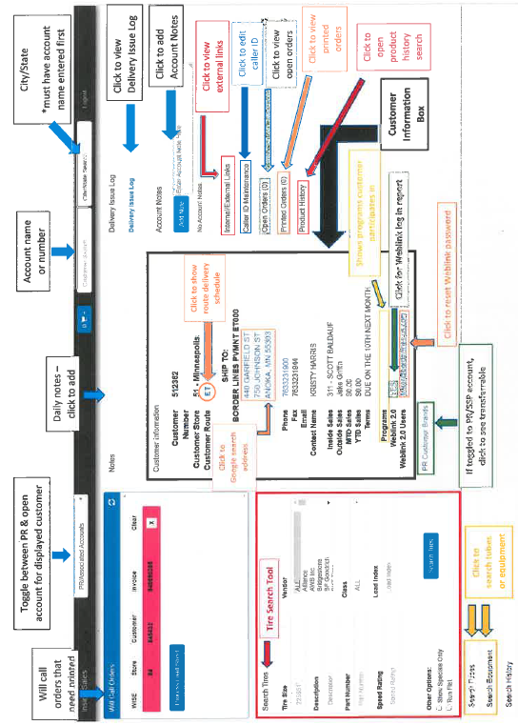
A video outlining the best practices for the Dashboard can be viewed by clicking this link: https://kmtire.vids.io/videos/d49fd5bb1f17eac65c/sop-intranet-dashboard

Dashboard Outline Sheet
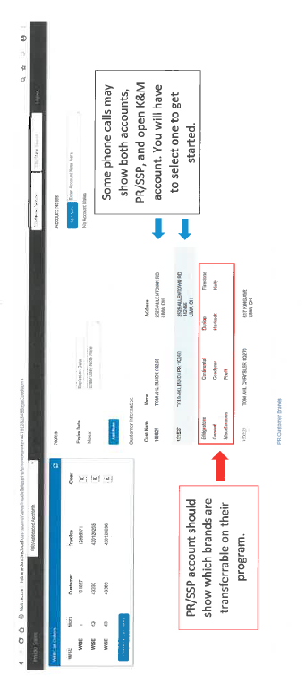

- The dashboard now displays customer class under a customer’s information. Our particular focus here lies with Government and PR/National accounts.
  - Customer Class 4: GOVERNMENT = customer is part of a government entity, and therefore will receive state/government pricing on products that allow. Pricing must be modified to reflect this.
  - Customer Class 6: PR/NATIONAL ACCT = Both new orders and returns must be separated by brand.
    - When processing returns, every individual invoice must have its own return estimate, even if, for example, a customer purchased tires coming from multiple warehouses. Additionally, multiple brands cannot be place on the same return estimate.

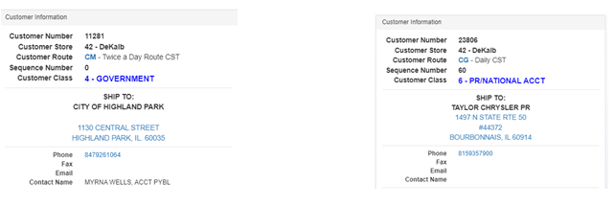

Looking up Customer
- You can look up a Customer by name on the Dashboard by going to the top right corner where you see:
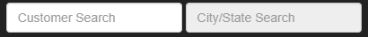
  - If you know the customer number, you can enter that in the “Customer Search” field.
  - If you don’t know the customer number, you can start typing the customer’s name and a drop down box will appear showing customer names that match your search:
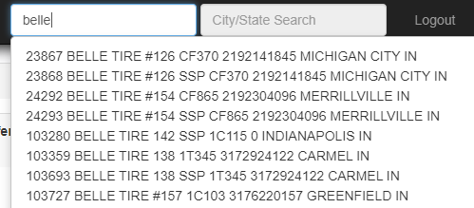
  - If you know the city the customer is located in, you can now type that in the “City/State Search” box to narrow your search:
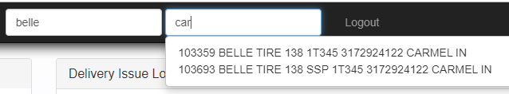
  - As you can see, this narrows your search to only customers that match both your Customer Name and City/State entries.

Placing Orders
- On the left side of the Dashboard there are sections titled “Search Tires/Search Tubes/Search Equipment”. You can look up Tires/Tubes/Wheels & Equipment then place an order directly from this section:
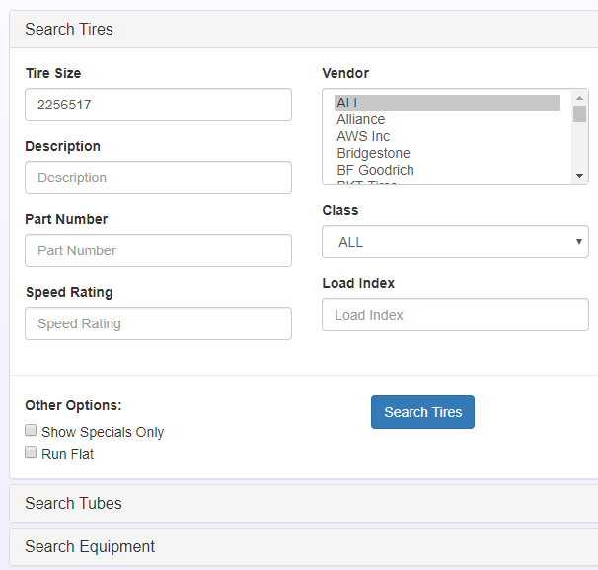

  - Orders can be placed directly from this section, so be sure to have the correct customer selected on the dashboard before proceeding.

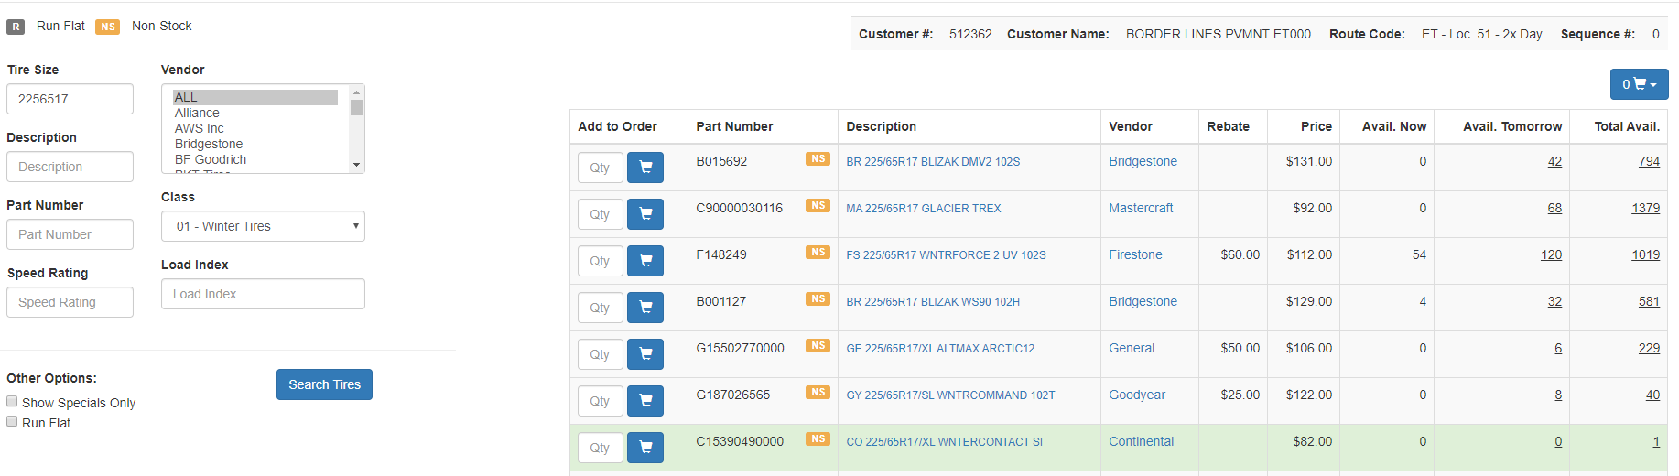
  - Enter in your search information and click Search. You will now see this screen:

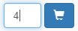
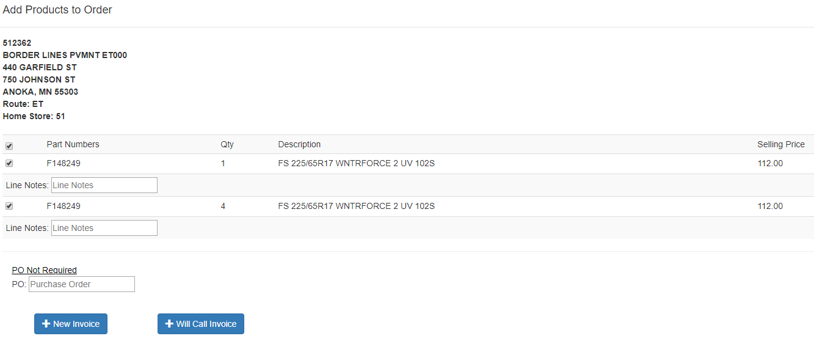
  - From here, you can select the quantity and add it to the order. You add the product to an order by clicking the shopping cart. Then you will be brought to this page:
  - From here, you can choose what type of invoice to create (New invoice, which is for delivery, or a Will Call invoice, which is for pick-up). If the customer has existing orders, you will also have an option to add to existing invoice. Once you
  - select which type of invoice you’d like to add to, the order will be confirmed and an invoice number will be provided for reference.
  - These steps can be taken for Tire orders, Tube orders or Equipment orders.

Looking up Product History

Basic Product History
- On the Dashboard, once you have a customer 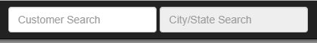selected by searching in the top right corner, you can search their product history at the bottom right side:
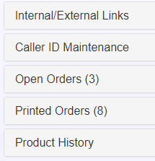
- Once “Product History” has been selected, you can breakdown your search by multiple categories to narrow your search:
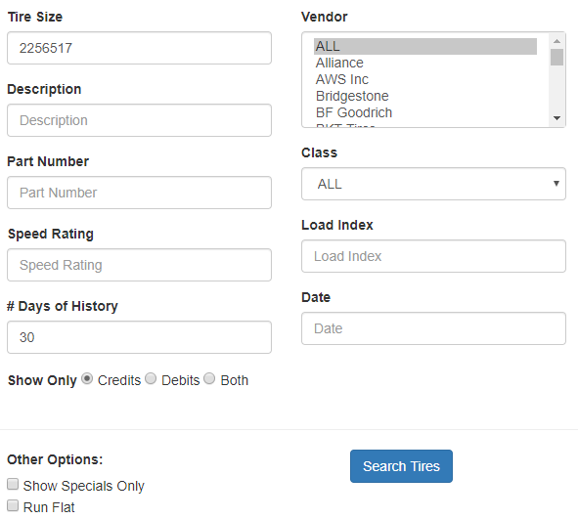

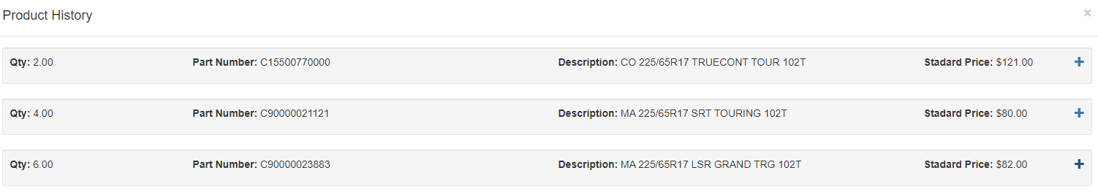
- Once your Categories have been enterred, click . A screen will pop up with all sales history matching your enterred search criteria:
- You are able to click the (+) at the right end to see all invoices the product showed up on:

Looking up Returns & Credits
- The Product History section has the ability to show only: Credits, Debits, or Both based on the selections you choose. 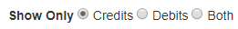 This section is located towards the bottom left side of the Product History box (directly under “# Days of History”).

- When you have “Credits” selected, you can narrow your search by all of the categories, or leave all categories blank broadening your search results.

- This would likely be most used if a customer calls in questioning if they were given credit for a return. Aside from that, you will typically look up product history for return purposes in MaddenCo (because that is the only place you can actually process a return).

Notes
Daily Notes
- This section is located in the center of the Dashboard at the top. Notes listed in the section are generalized notes that affect multiple customers.

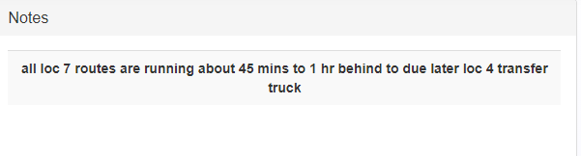
Account Notes
- These notes are located in the top right sections of the Dashboard (directly under “Delivery Issue Log”.
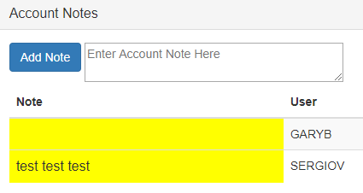
- This section is used to provide important information to everyone at a glance when a customer calls in. In many cases, the notes may be in regards to NOT price matching due to previous issues/concerns.
Add Notes
- This is only used by authorized persons. Notes are typically added by Customer Service or Management.
  - To add a note, it is as simple as typing the note out in the provided box, then clicking “Add Note”.

Delivery Issue Log
- When on the Dashboard, there is a section in the upper right-hand corner titled “Delivery Issue Log”.
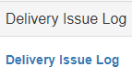
- When you click the blue link, it will take you to the Intranet Delivery Issue Log report. That full job description can be found HERE.

Purchasing Log
The purchasing Log is a tool for communicating with our Purchasing and Pricing department for the purchase of the purpose of checking product availability with vendors and other distributors, as well as placing special orders on non-stock and out-of-stock items. It can be accessed in one of two places, on the K&M Intranet and on the Sales Dashboard.

- On the K&M Intranet, it is located under the Purchasing and Pricing subset:

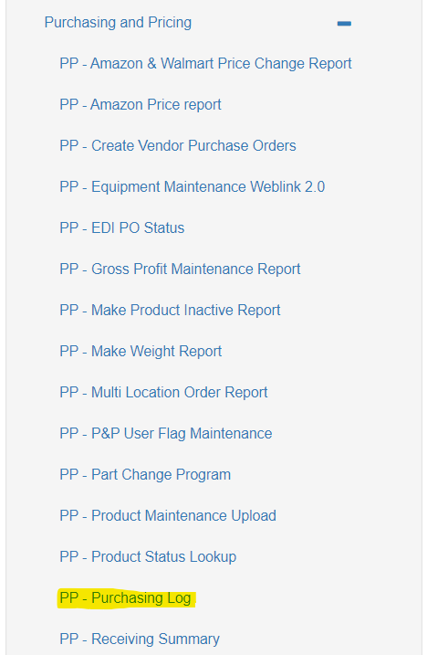

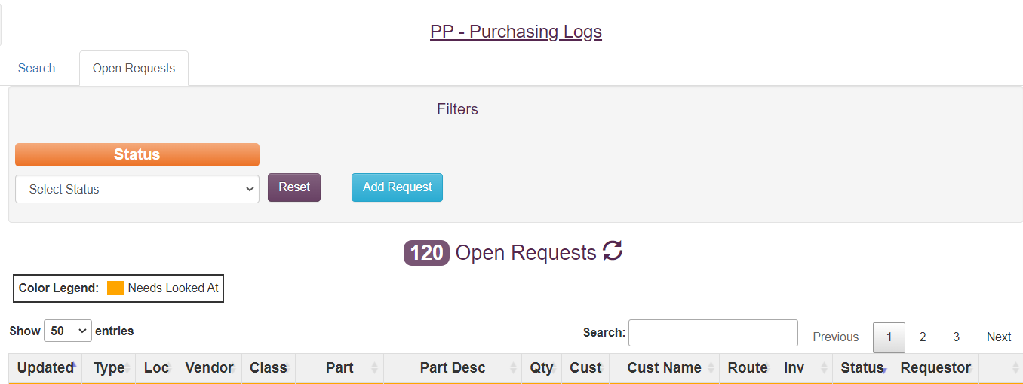

- Accessing this defaults to the Open Requests tab, where any pending requests are located. The headers at the top of each column can be toggled to display results in ascending or descending order. Requests that are colorless (white) will either have a status of “Open” or “In Progress,” while orange highlighted requests will have a “Pending Complete” status.

- To start a new inquiry/special order, click “Add Request” to make the following menu appear:
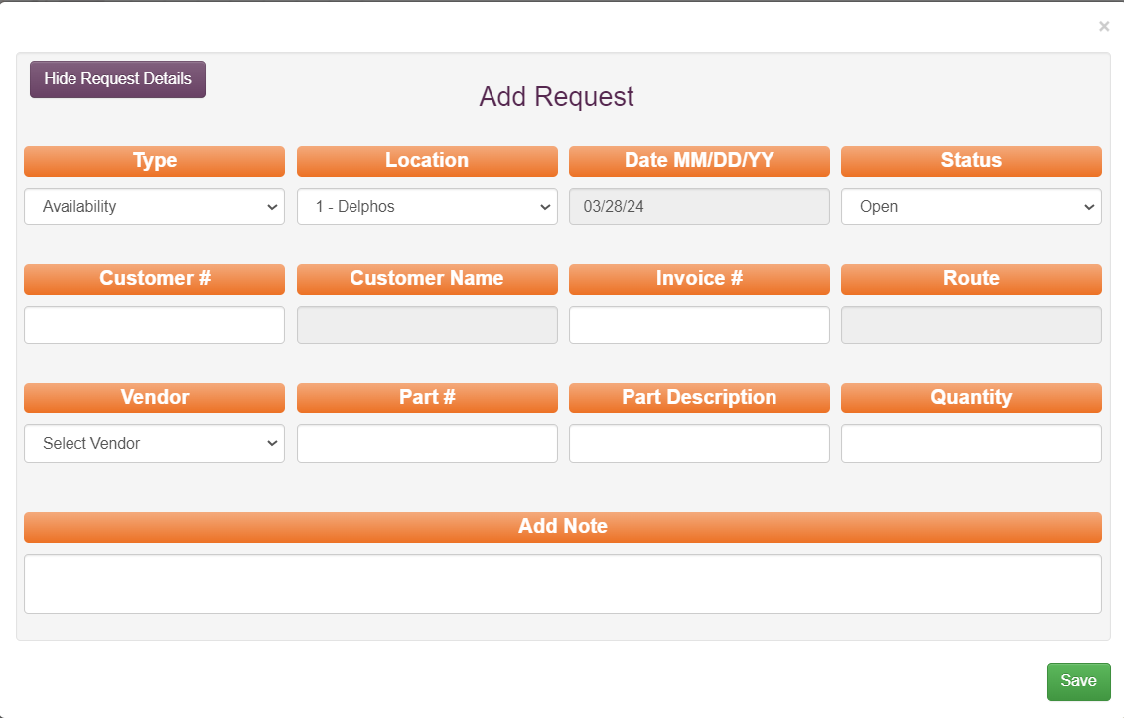

- Proceed by filling out the necessary fields for whatever type of request being made.
  - The four types of requests are Availability, Will Call, Order, and cancel.
    - Note: Will Call pulls products directly from the target source and is picked up on site by K&M, whereas Order places the product on a stock order and delivered by the manufacturer, which typically takes longer. Be sure to coordinate with the customer and Purchasing to ensure the correct requests is being made.

  - If a product is being ordered from an outside vendor, please ensure vendor 999-OSV is selected under the Vendor field.
  - Use the Add Note field to put useful information (customer contact name and phone number) or questions directed to Purchasing for assistance.

- Occasionally, customers may request availability on items to which K&M has access but are not present in MaddenCo with a product code and pricing. When the occurs, type “NS” in the part # field and, by scrolling down the list that automatically populates, locate the “99 Non Stock” part. Then, proceed as normal with the request, making sure to provide product details in the Add Note field; this allows Purchasing to gather the necessary information to add the product into MaddenCo.
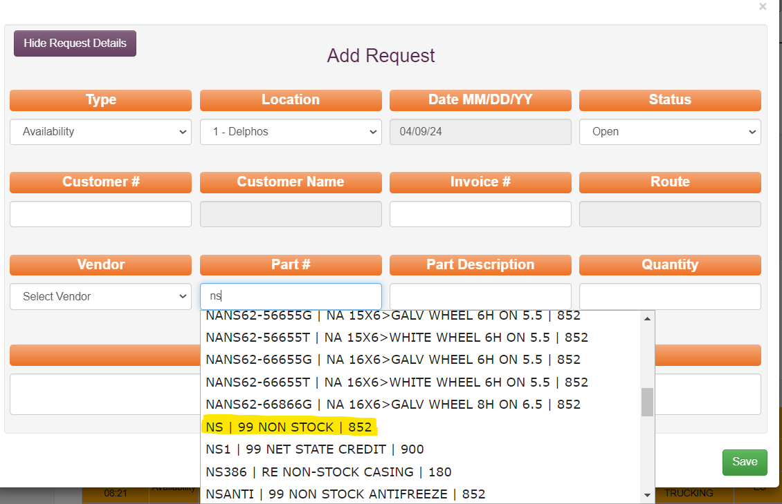

- Similarly, the “NSUM” product code denotes a request to check availability or order a non-stock-and possibly custom built -Unverferth product, such as a tractor wheel (reminder: When ordering this product, there is an additional 20% charge added to its final price).

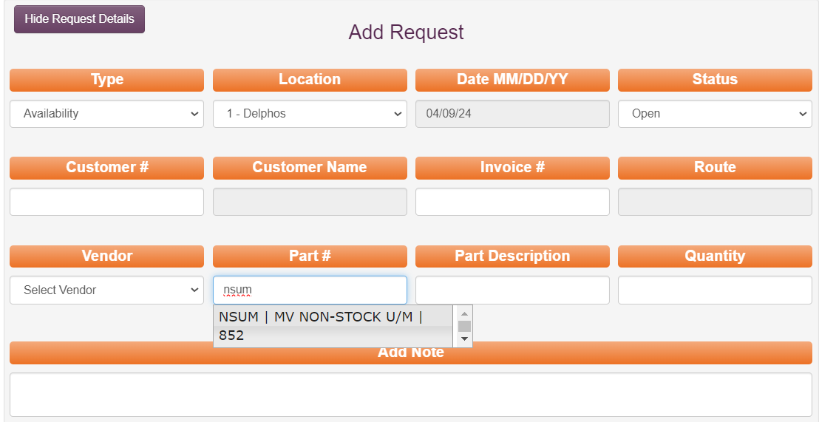

  - Below is an example of a completed request:

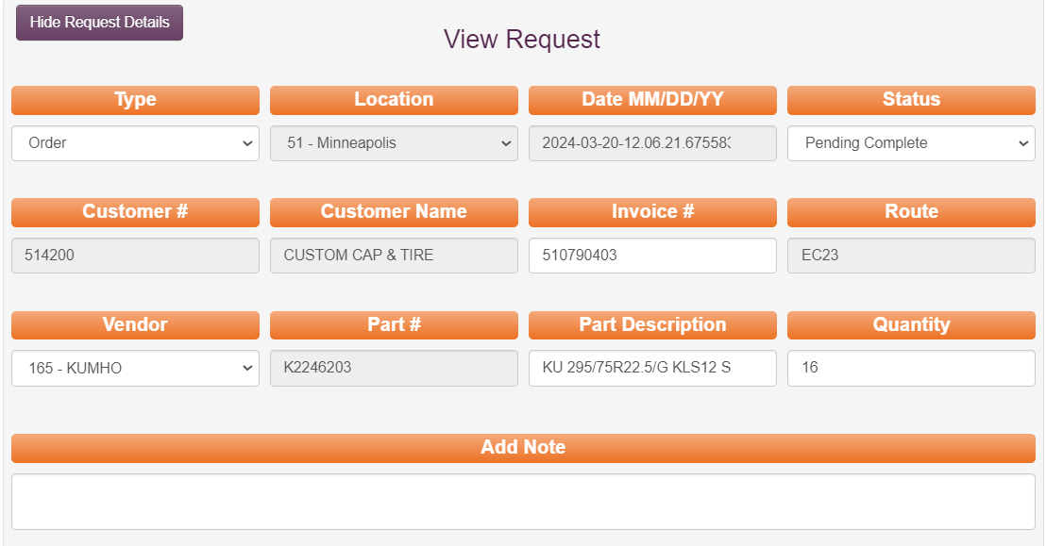

- When purchasing completes/updates a request in the log, an automated email will be sent to the requester to notify a change in the request status:

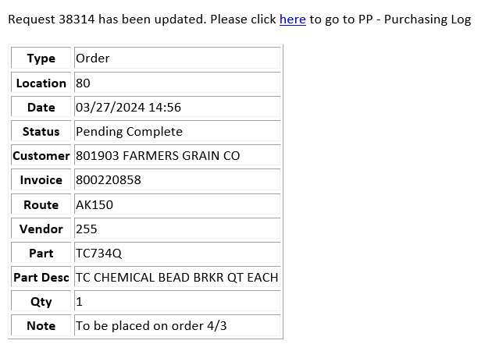

- Completing a request for availability can resemble something like this:
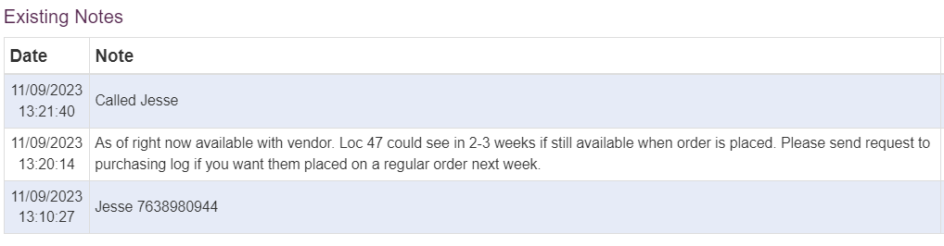

- Alternatively, a completed request for a Will Call/ Order can look like this:
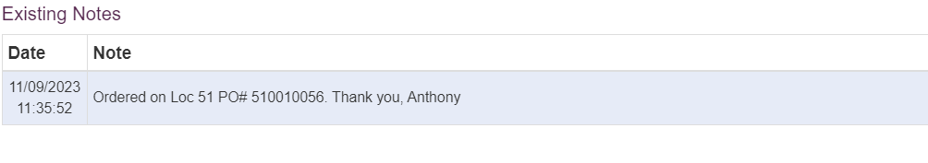

- In either scenario, please toggle the Status of the request to Complete.
  - Please ensure that all individual requests are followed up/ completed in a timely manner and the request log is cleared of requests in the “Pending Complete” status by the end of each business day. Doing so reduces clutter on the list and makes searching for requests more streamlined.
- Any completed request is moved into an archive that can be accessed via the search tab on the main menu:

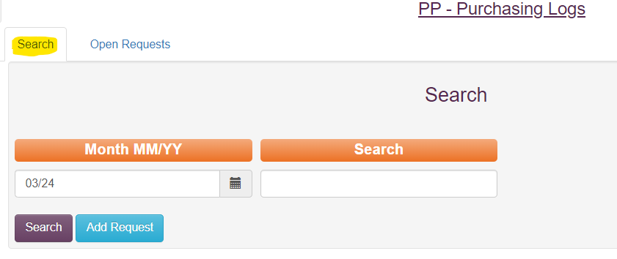

- Typing in the customer number in this menu will populate a list of all requests made for said customer, and can then be sorted by request date, product, etc.

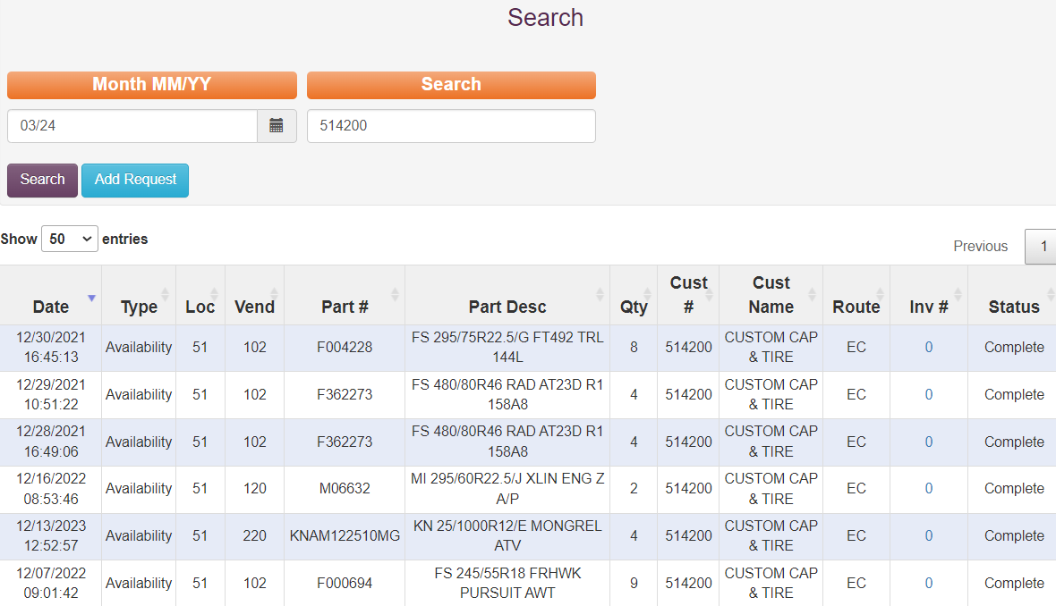
- Similarly, a truncated version of the Purchasing Log is accessible via the Sale Dashboard.
  - By clicking on the “0” in the Total Available column for any out of/non-stock product, the following menu will appear:

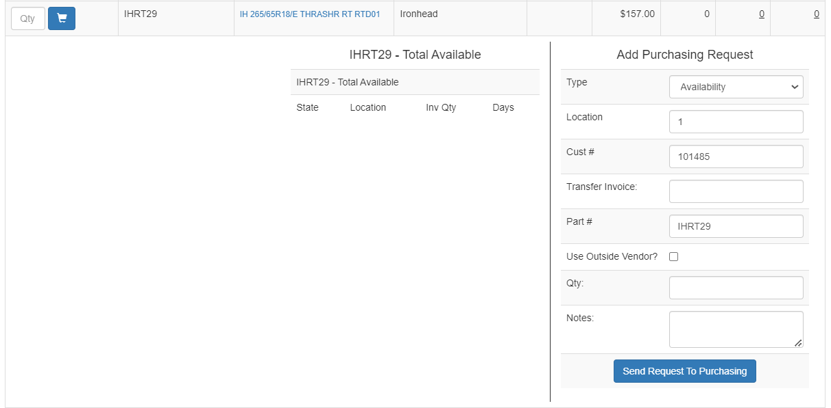

Weblink Usage
- On the Dashboard towards the bottom of the Customer Information section, there is a line titled “Weblink 2.0”. If the customer has Weblink 2.0 set up, it will say “YES” . If you click “YES” it will redirect you to the Intranet report which shows you dates the customer has logged in to their Weblink account.

- This is mostly utilized by Customer Service when making the initial welcome call to a new customer. If the customer has Weblink, but has not logged in, Customer Service will mention it during the phone call to address any questions about the Weblink process.

Reset Weblink
- Sometimes, a customer might call and say they forgot their password for their Weblink account. The fix for this is simple. At the bottom of the Customer Information section there is a line stating “Weblink 2.0 Users”. Next to it will be all email addresses with logins for the customer Weblink account. Verify which email address needs the password reset, then simply click that email address. A prompt will pop up asking if you would like to reset the password, click yes. This will generate a temporary password and send an automated email to the email address listed and a link to follow to change their password to something of their choice.

Looking up Routes
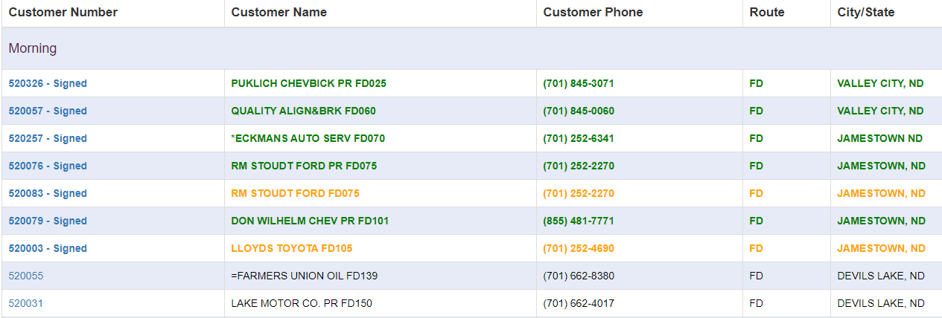
- Under the Customer Information section, there is a lint (third from the top) Customer Route. Directly to the right of that is a route code in BLUE. By clicking on the blue route code, you will be redirected to the Intranet “Closed Order Report” This allows you to see what stops have/have not been completed on a specific route.

- Customer listed in GREEN have received their delivery as planned. Customer in YELLOW have received their delivery with something out of the norm involved (may times it was delivered out of sequence). Customer listed in BLACK have not received their delivery yet.

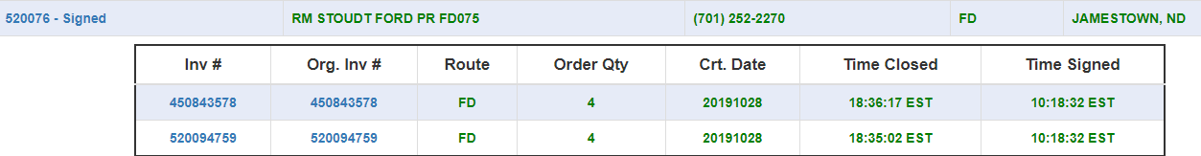
- If you click on the customer number, it will drop down to show you what invoices have been delivered/are to be delivered that day.
- If the delivery was already made, the drop-down box will show you what time it was signed (suggesting delivery time). You can also click on the invoice number to see the signed copy of the invoice.

Will-Call Order
- There is a box in the top left corner of on the Dashboard called “Will Call Orders”.
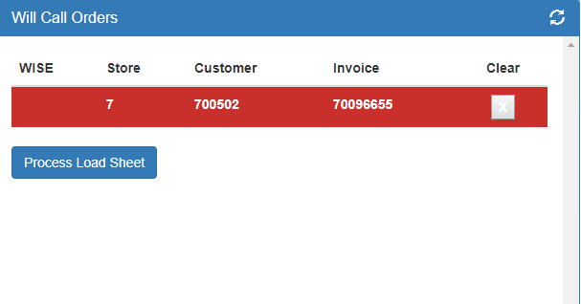
- In this section, you can see ALL Will Call orders. Depending on the location, you will need to follow one of the following “Will Call Printing” procedures. Some locations use the WISE system, and some do not. Choose which procedure to use accordingly:

Will call colors.
Red = credit card customer – must process card before printing.
Orange = over credit line . credit needs to approve before printing. ( check with credit if not printed after a few minutes )
Yellow= back ordered tires. if the invoice is not 100% available call customer and ask if they want to wait until all are on hand before printing
Pink = missing will call part number. Must add before printing or will not hit signature capture ( phone )

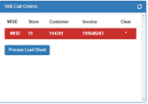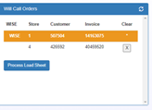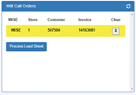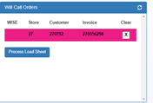

WISE locations
NON-WISE location

Open Orders
- On the right side of the Dashboard there is a section titled “Open Orders”. By clicking this, it will open the dialog box and show all current open orders for the customer’s account that you are on:
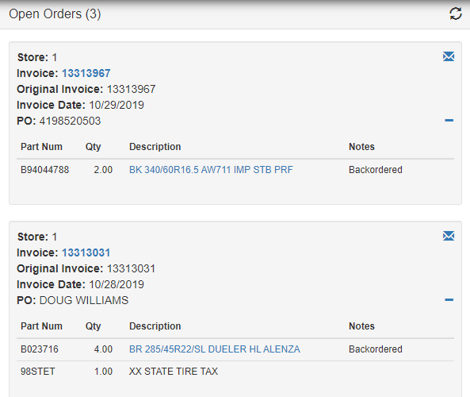
- You can click on invoice number to pull up a copy of the invoice. You can click on the product description and be redirected to the Weblink Datasheet. This provides you with detailed info on the product as well as other tires in the same product line.

Printed Orders
- On the right side of the Dashboard there is a section titled “Printed Orders”. By clicking on this, it will show a semi-detailed list of all invoice for the customer that have closed for the day.
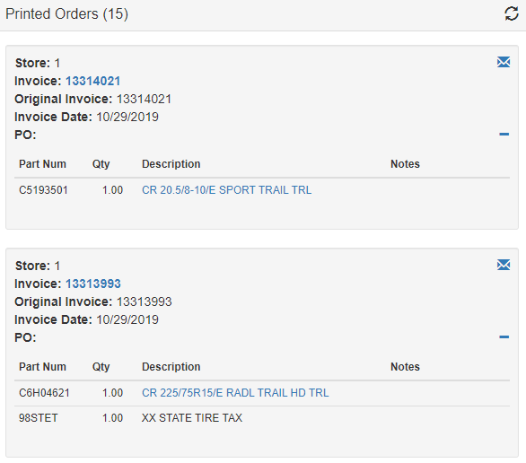
- You can click on the invoice number and it will show you a signed copy allowing you to see who received the product(s). You can also click on the product description and be redirected to the Weblink Datasheet. This provides you with detailed info on the product as well as other tires in the same product line.

Intranet

Credit Card Orders Report
- Log into the Intranet: http://intranet.kmtire.local/index.php

- Click + to open Department List. 

- Click “+” to open “Sales – Inside” 

- Click on SA – Credit Card Orders Report to open the program.

- Keep all options set to “All” and click “Run Report

- Highlighted accounts are cards that need to be ran. If you are looking for a specific customer, select them by clicking on their customer number.

- Look up the work order in Madden Co to make sure that there are not any backorder items. We are no longer allowed to approve an order if there are backordered items on the ticket. If there are, split the order on to another invoice so that there are not any backordered items on the order. Please make sure the new order has the correct PO number and Ship to if necessary. Then refresh the report so that it reflects any changes that were made.

- Run the purchase amount on Merchant Partners: https://www.onlinemerchantcenter.com/admin/login.taf
- If the card was approved, click the  button. If the card was declined, call the customer and explain that the credit card payment did not go through. Ask them if they would like to set up other payment arrangements. If they tell you that they would like to pay check or cash hit the  button. Every invoice for the rest of the day will automatically change from credit card payment to COD.

- If the order was approved, add a memo line with the “Order ID” number on the merchant partner’s approval page as the authorization number to the work order in Madden Co.

Merchant Partners
- Go to: https://www.onlinemerchantcenter.com/admin/login.taf
- Log in using your unique credentials.
  - Account ID is always MPTDM
- In the left side of the page under transactions, click on “Transaction Search.”
- Scroll to the bottom of the page and enter the customer number in the “Customer Number” field.
- If history does not load, click on “Process Online Charge” in the left column under Virtual Terminal and skip to step 10.
- If history does load, scroll to the very bottom. Verify with the customer the last 4 digits of the card that is to be used. Once the card is decided on, click the “Order ID” which is the box to the right of the amount of the charge.
- Click on “Issue New Sale” and then submit.
- Select “Continue to Issue New Sale”
- Verify that the card information is still loaded on the form.
- Fill in the following fields:
  - Amount
  - If the card history did not load fill in the following as well:
    - Cardholder’s Name
    - Card Number
    - CVV2 Value
    - Expiration Date
  - Invoice Number
  - Customer Number (Only fill out this box if the customer would like to keep their card on file)
    - If the customer would not like to keep their card on file, format the customer number as follows: CUSTOMER NUMBER-INVOICE NUMBER (ex. 571821-570182451)
  - Purchase Order Number (Invoice number again)
  - Check mark the “Tax Exempt” box
  - Name
  - Address
  - City, State, Zip
  - Country
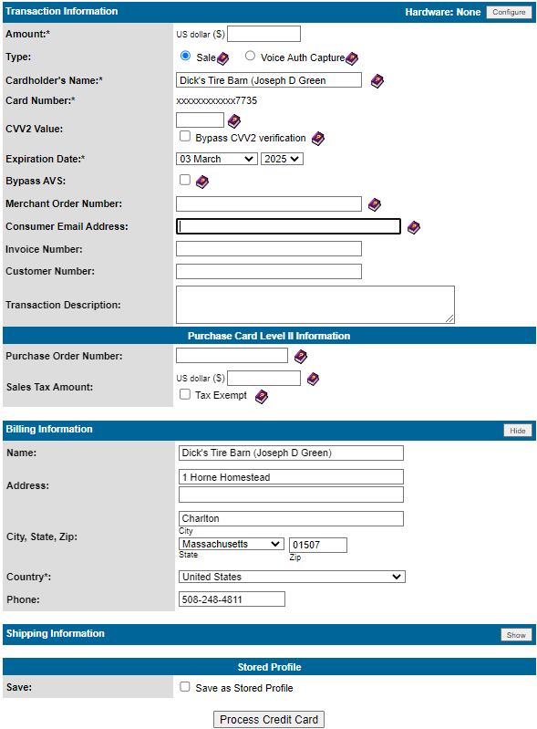

Back Order Report
This report is used to view orders that are on back order, and lets you know whether or not those back orders can be filled.
- Go to: http://intranet.kmtire.local/ to access the Intranet
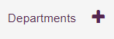
- On the left-hand side, select “Departments”
- Click “Sales – Inside”
- Scroll down to find and select “SA – Back Order Report”
You will then see the screen below:
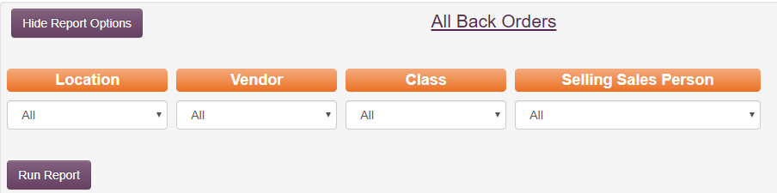
- Click “Run Report” after selecting the location you wish to check; leave vendor, class and salesperson on “All”
This will display the following screen:
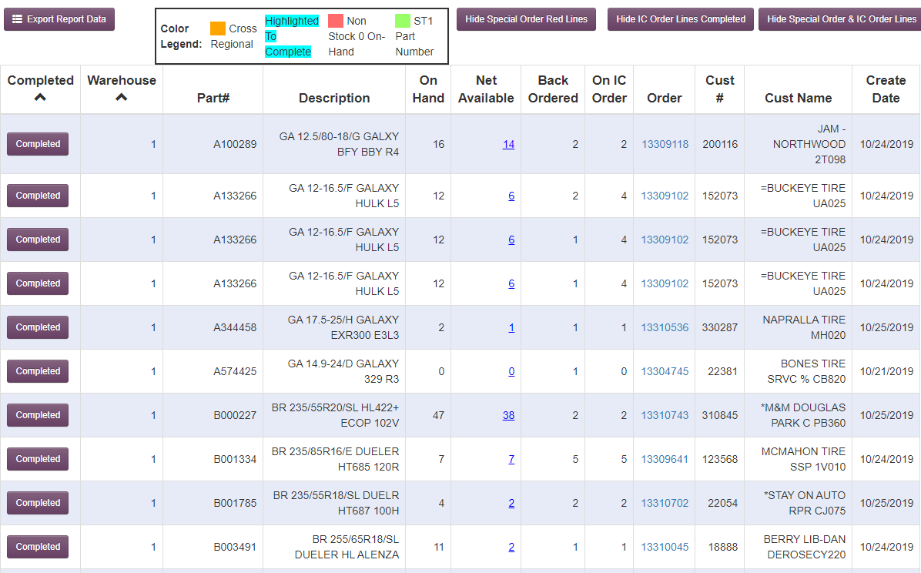
- To begin, click on the three purple boxes shown below, toggling them from “Hide” to “Show”; this will filter out orders already being moved within the company

- Next, click the 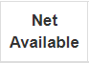 tab twice; doing so will filter the tires from most to least available.

- After completing these two steps, your screen should look like this:

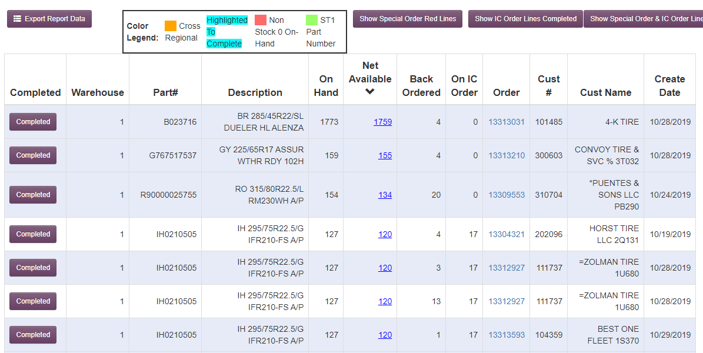

- This color legend helps show us which products we can transfer within the warehouses.
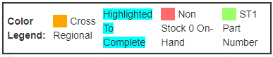
- Cross regional means you can transfer the tire anywhere within the company
- A cross regional tire will be highlighted as such below:

● Non-Stock means we do not stock this tire and it needs to be special ordered-please call customer (preferably the same day it appears on the back order report)
- A non-stock tire will be highlighted as such below:

The purpose of running this report is to tie any possible tires we have within the company to the customer’s order. There exist customer accounts that have their orders, when placed through Weblink, default to their home warehouse. If those tires are not in that home warehouse, the tires are backordered; therefore, we need to manually move those orders into a correct location so tires can be transferred. Doing so ensures the customer receives the tires he/she ordered in a timely manner or in the time frame that was shown on Weblink.

When doing backorders, remember the same rules apply as placing orders:
● Tires located in either Loc 43 or 45 can ship to any location within the company
● “East” locations can only transfer to “East” locations – (1 thru 43/45)
●”West”locations can only transfer to “West” location- (43/45 thru 88)

On the screenshot below, you can see the customer’s account number, invoice number, how many tires are backordered and the amount of total tires available. Hovering the mouse over the blue underlined number in the “Net Available” column will display a box that shows all the company warehouses and a numeric quanitity of that specifc tire in each location.


Clicking on the blue underlined invoice number under the “Order” column will open a new tab, displaying that invoice as it will appear to the customer. Look for any messages on the invoice that indicate why the tire is on back order, for example:
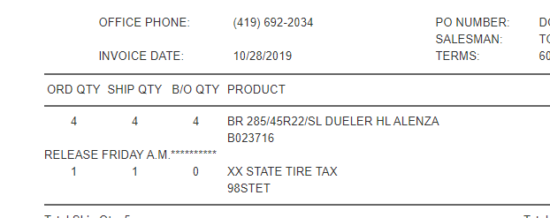

If there is no explanation as to why the tire is on backorder, please pull tires from the closest location that has stock to fill the invoice. Bear in mind that to do this, sometimes you have to have to move the original order into a secondary location.
● Example: a location 42 customer could have a back order with tires showing available in loc 1. This order would be moved to location 1, as an order from loc 1 to loc 42 is next day delivery order in loc 1.
● Example: a location 6 customer shows to have a back order on tires that show available in loc 1. This order would need to be place in loc 4, with a transfer from loc 1 to loc 4 (the same as placing a normal order).

● After completing the steps above, please delete the original invoice so another team member does not mistakenly duplicate the order and send out more tires than what was originally ordered. To clear the completed line, click anywhere once in the row to highlight it blue:

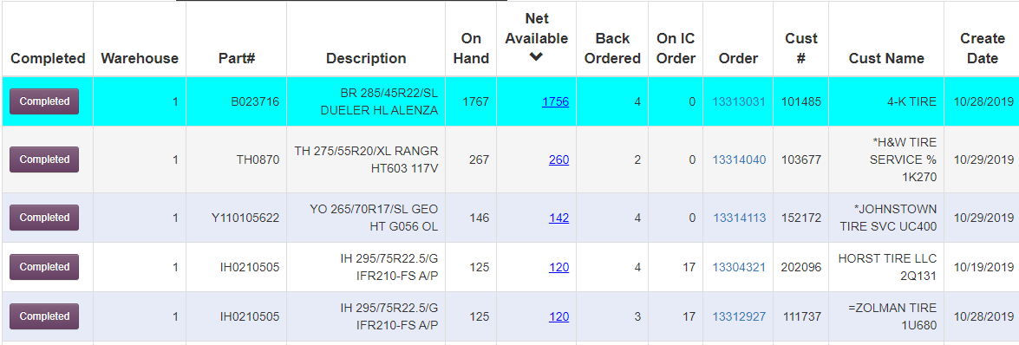

● By clicking the button, this will clear the finished order from the report.
-Repeat these steps over until all tires showing available are completed.

If any orders have a “Create Date” older than 30 days, are still on the back order report, and are still not available, we must call customer to update them on the availability of the tire. Upon updating them, we will need to determine if the customer still wants the tire on order or if it should be cancelled.
After speaking with the customer, notate the following on the invoice:
- Name of the person spoken to
- ETA of tire at the time of calling
- Date of when you spoke to said person

Closed Order Search
This is used to determine where a driver has been already for the day allowing sales to give customers an idea of when the driver will be arriving to them for the day.
- Go to: http://intranet.kmtire.local/ to access the Intranet
- On the left-hand side, select “Departments” 
- Click “Sales – Inside”
- Scroll down to find and select “SA – Display Signed Invoice”
This will bring you to this screen:
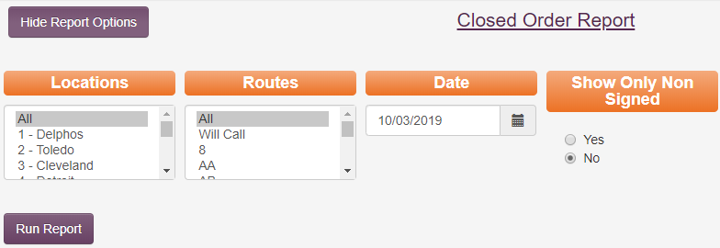
Here, you can search all routes company wide, all routes by location the invoice came from, or a specific route on its own. The date will automatically populate with yesterday’s date, so be sure to change it accordingly. We will use “Oklahoma City” route “AC” for an example.
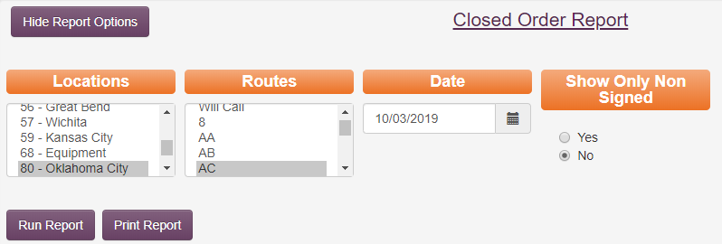

Click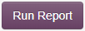 and it will pull up this information:

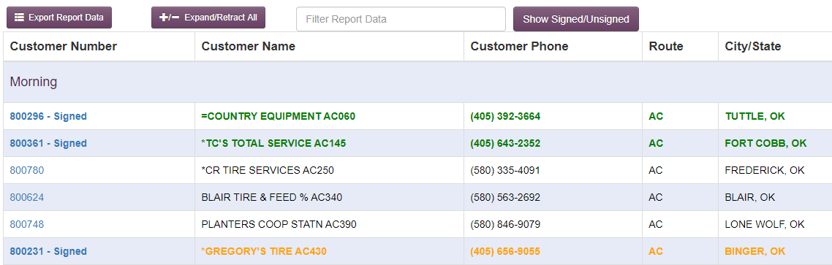

The GREEN customers have already received their deliveries, and they were delivered in the correct order. Any customer in ORANGE has received their deliver, but it was received out of sequence. Customers in BLACK have not yet received their deliveries.
You can click the customer number to view the invoice number(s) being delivered.

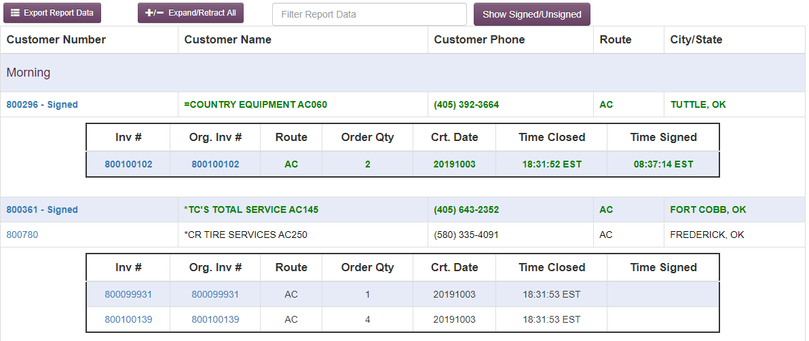

Whether the invoice has been delivered or not, you can click on the invoice number to pull up the full invoice copy. You then have the option to print the invoice if desired. If the invoice has already been delivered, you will be able to see the signature of who signed when receiving the delivery.

Customer Caller ID Maintenance
You will use this to update and add to the TOAST system (the system that links a phone number to a customer account).
- Go to: http://intranet.kmtire.local/ to access the Intranet
- On the left-hand side, select “Departments” 
- Click “Sales – Inside”
- Scroll down to find and select “SA – Customer Caller ID Maintenance”

You should now see this screen: 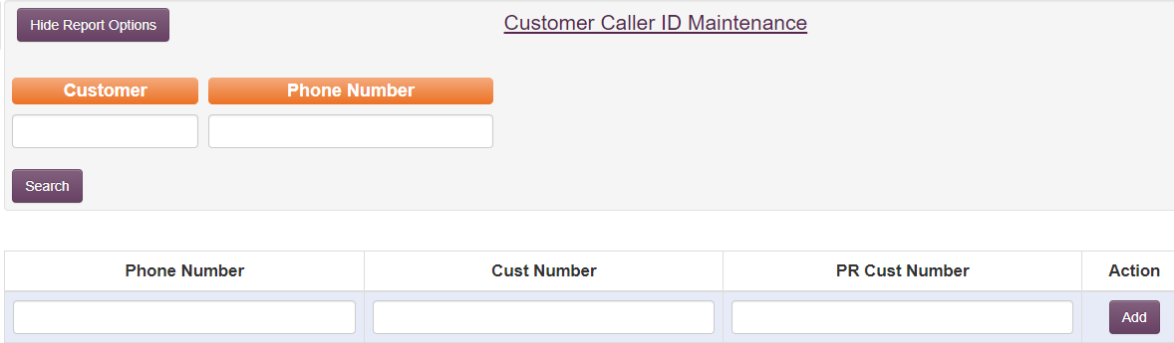
From this screen, you can search through what currently exists in the TOAST system, or you can add a new entry. Let’s start with searching through what currently exists. If you have a customer number or customer name and need to see what phone number(s) is linked to the account, enter the customer number/customer name here:
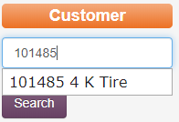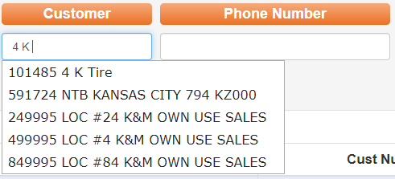
As you type, options that match your search will populate below to choose from. If you are typing out the name, keep in mind the system will only recognize the name exactly as it is saved. For example, if “4K” would have been typed instead of “4 K” it would not have pulled the customer number 101485 because there was no space between the characters.
Once you have the customer number/name you desire, click 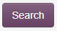and you will see any phone numbers linked to that customer number:
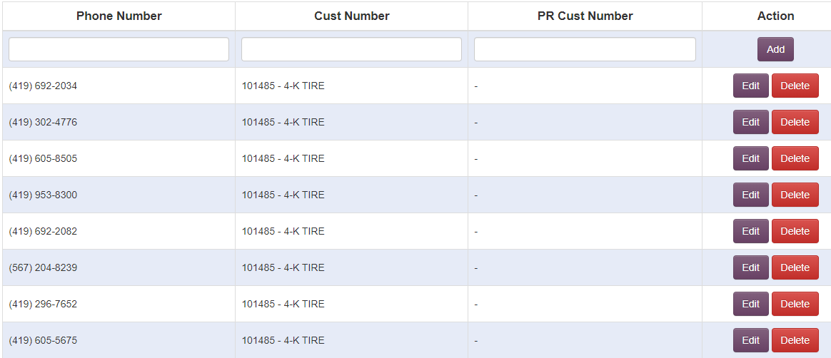
If you have a phone number, but you are unsure of the customer number/name, you can search by the phone number. This could also be used to determine if a specific phone number is already linked to a customer number. Enter the phone number and click “search”:
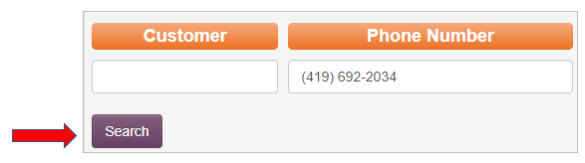
If you need to link a new phone number to a customer number type the phone number and customer number in their corresponding boxes. If the customer also has a PR/SSP account for the specific location, add that account number as well. Click “add”
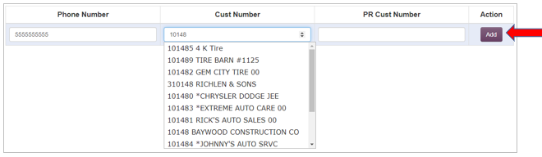
If a phone number that is linked to an account is no longer accurate, pull it up by either searching the customer number or the phone number, and click delete:
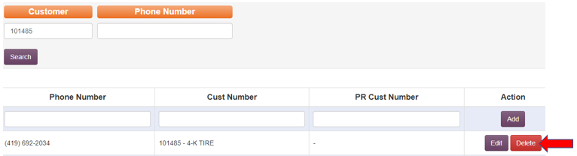

Customer Information
- Go to: http://intranet.kmtire.local/ to access the Intranet
- On the left-hand side, select “Departments” 
- Click “Sales – Inside”
- Scroll down to find and select “SA – Customer Information”

This should bring you to this page:
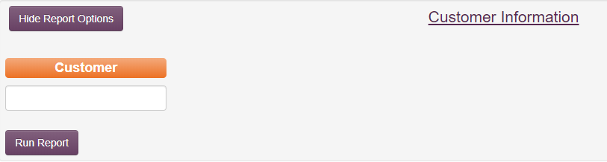
Enter the customer name or number and click “run report”. This section of the Intranet is strictly for information. You are not able to make any changes from this page.
Once you hit “run report” the screen will populate with the following information:

Customer Number
Bill-To Customer
Customer Name
Address
Contact Name
Phone Number
Fax Number
Email

A list of Programs the customer takes part in

A notation regarding if the customer has a Weblink1.0 or Weblink 2.0 account

Inside Sales Person assigned to the account
Outside Sales Person assigned to the account
API Connection
If there is anything besides “none” listed in the “API Connections” section, it means the customer has been approved to work with our IT department in order to have K&M information exported to their database or system. The VP of Sales has to approve any addition of an API.

Customer Ranking Report
This report would be used to see who bought the most/least sorted by vendor/and or location.
- Go to: http://intranet.kmtire.local/ to access the Intranet
- On the left-hand side, select “Departments” 
- Click “Sales – Inside”
- Scroll down to find and select “SA – Customer Ranking Report”

You should now see this screen: 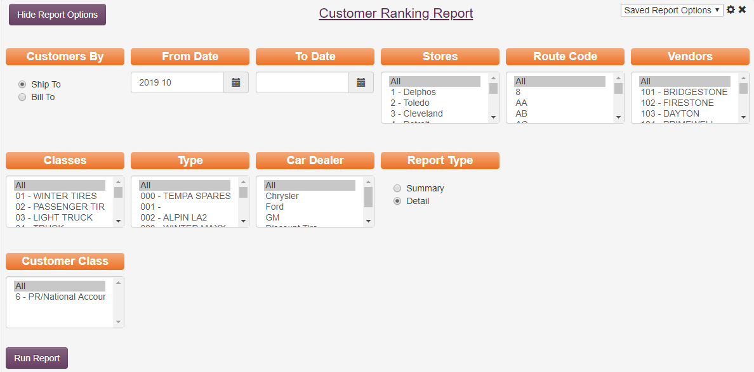
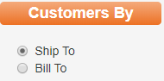 The first category to narrow the search is where you can choose either ship to or bill to. A ship to account physically receives deliveries. A bill to account will have all invoices pulled to its customer number for accounting purposes. A bill to can also receive deliveries.
Next, you will need to enter the date range you are looking into. For this example, the report will be pulled for the dates from October 2018 - December 2018. 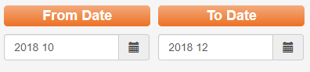

From this point, you are able to narrow the search by “Stores” the product was shipped from, “Route Code” the product was delivered on, “Vendor”, “Classes”, “Type”, “Car Dealer” and “Customer Class”. For our example, we will be pulling a report to see how many winter tires were sold in location 1 in 2018.
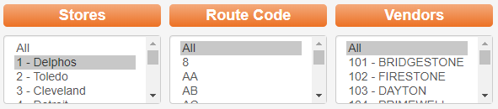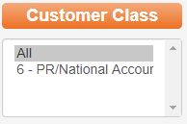
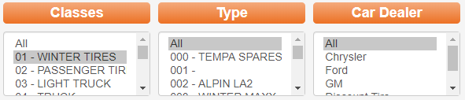

Once you have these options how you want them, you can decide how you want the information pulled (as a summary or detailed).
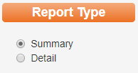

A summary will give you one line of summarized information:
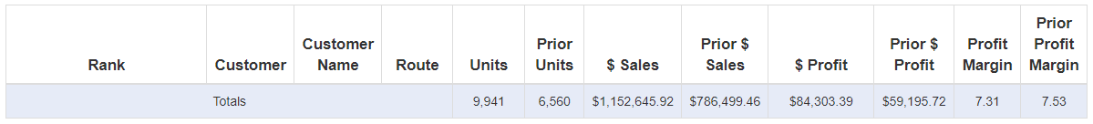
Selecting “Detail” will give you a full report showing all customers that have puchased tires fitting your search within your selected timeframe. This report will include the rank, customer number, customer name, route, how many units were sold, how many units were sold the prior year for the selected timeframe, sales in dollar amounts for your selected timeframe, sales in dollar amounts for the prior year for the selected timeframe, profit in dollars for your selected timeframe, profit in dollars for the prior year for the selected timeframe, profit margin in a percent for your selected timeframe, and profit margin in a percent for the prior year for your selected timeframe. 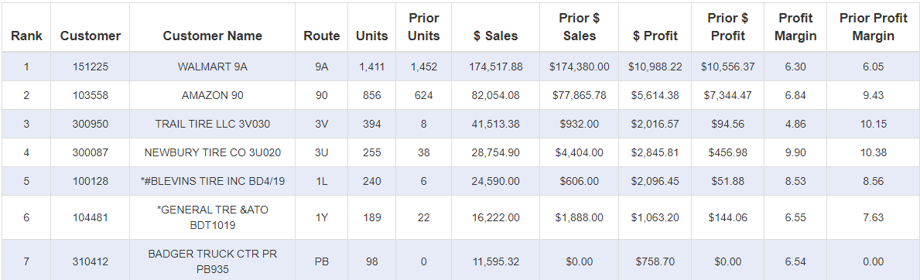
You are able to sort the report by any of the column titles by simply clicking on the title. Clicking the title once will put things in order a-z for letters, and smallest to largest for numbers. By clicking a second time, it will sort in the reverse ways (z-a and highest to lowest).

Delivery Issue Log
This report would be used to see why an order was not left with a customer. This could be due to the customer refusing the order at delivery, a mistake resulting in the tires not being on the truck (or the wrong tires being on the truck) or tires being mislabeled from vendor among other possible reasons.

- Go to: http://intranet.kmtire.local/ to access the Intranet

- On the left-hand side, select “Departments” 

- Click “Sales – Inside”

- Scroll down to find and select “SA – Delivery Issue Log”
This will bring you to this screen: 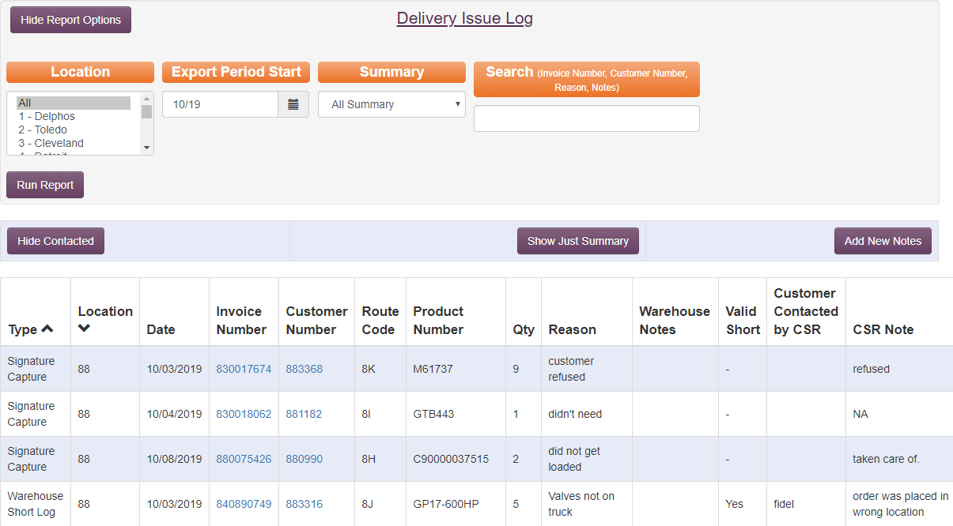
You are able to break down your search by warehouse location, month of occurrence, summary type (all summary, valid shorts summary or summary notes only), or you can search by specific invoice, customer reason or notes.

If you only want to see delivery issues for customers that have NOT yet been contacted, click 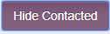 and this will show you only issues still needing to be addressed:
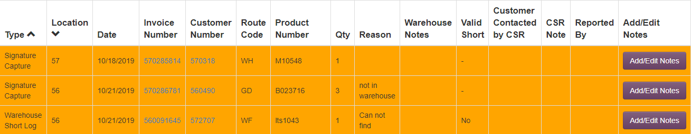
If you want to only see a summary of the report, click 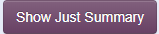and it will show you how many units were not delivered in each location:
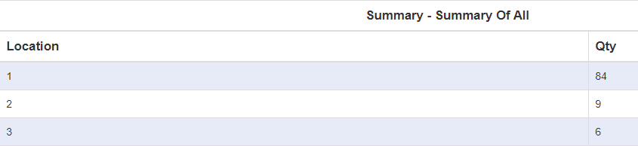
If you need to add a delivery log issue, click in the upper right-hand corner of the screen.
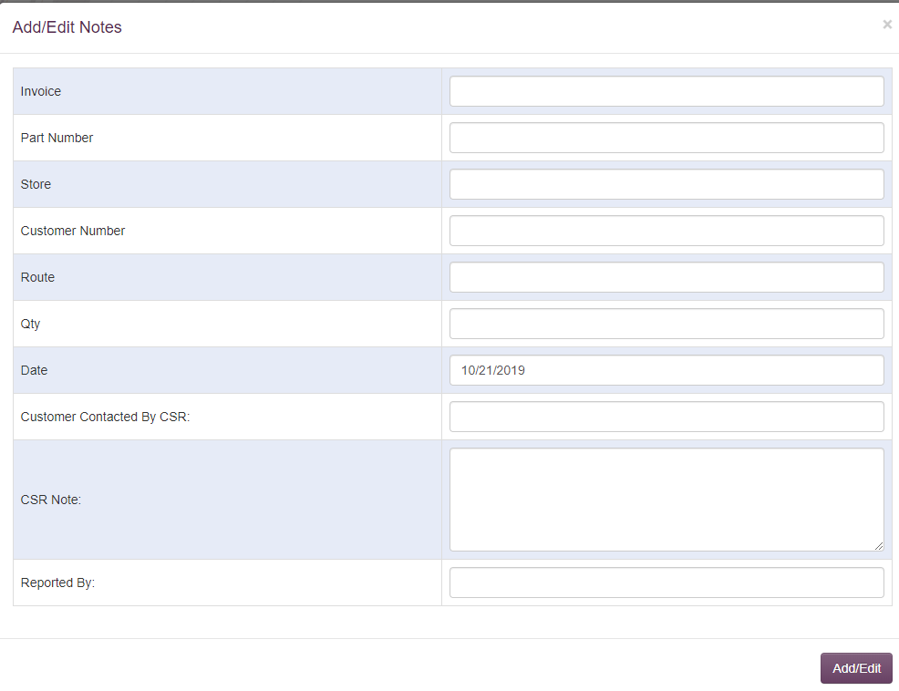
The date will always show today’s date automatically unless it is manually changed. If you enter the invoice number, then the part number, store, customer number, and route will automatically populate. From here, enter the number of unites effected by the issue in the “Qty” box, whether the customer has been contacted or not by a CSR (if yes, enter the CSR’s name), and who reported the issue. If the CSR is entering the information, they may also enter the note explaining what we are doing to fix the issue. Click .

If an issue is showing on the report and the customer still needs contacted, it will be highlighted in yellow. Once the customer has been contacted, click to enter the CSR’s name and a note on what we are doing to correct the issue.
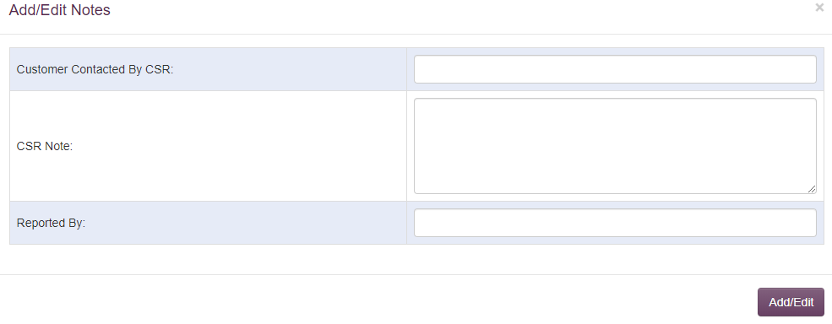

Enter the Customer Service Rep’s name and a note on what we are doing to correct the issue. Click .

Display Invoice
- Go to: http://intranet.kmtire.local/ to access the Intranet

- On the left-hand side, select “Departments” 

- Click “Sales – Inside”

- Scroll down to find and select “SA – Display Invoice”

You should now see this screen:
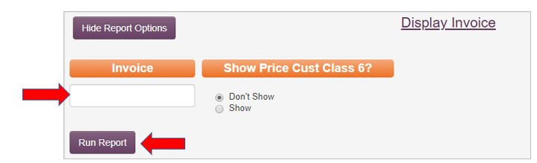
Enter the invoice number in the box below “Invoice” then click “Run Report” (or hit enter on the keyboard). This will display the invoice as it appears in the Signature Capture system. From here, you are able to print the invoice if desired by clicking “Print Report”. This will bring you to a new window with the displayed invoice. Right click anywhere on the page and select “print”.
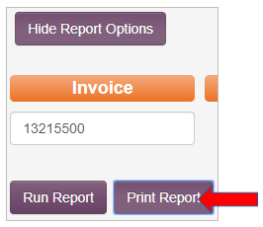

Display Signed Invoice
- Go to: http://intranet.kmtire.local/ to access the Intranet
- On the left-hand side, select “Departments” 

- Click “Sales – Inside”

- Scroll down to find and select “SA – Display Signed Invoice”

You should now see this screen:
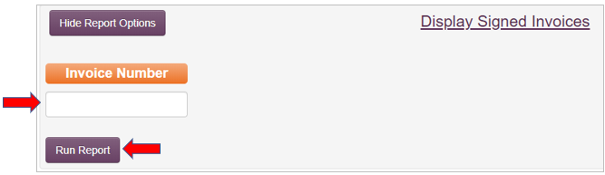
Enter the invoice number in the box below “Invoice” then click “Run Report” (or hit enter on the keyboard). This will display general information about the invoice:
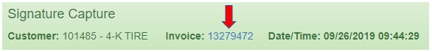
If you would like to see the full invoice, click the invoice number in blue and it will bring you to the “Display Invoice” screen where you can print a copy if desired.

Inside Sales Commission
- Go to: http://intranet.kmtire.local/ to access the Intranet
- On the left-hand side, select “Departments” 
- Click “Sales – Inside”
- Scroll down to find and select “SA – Inside Sales Commission”

This will bring you to this page:
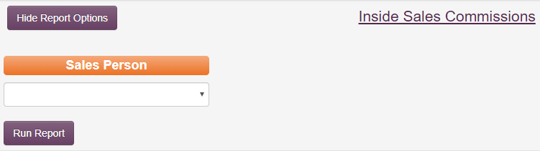
You will only be able to see your own name in the Sales Person drop-down box. Click “Run Report”. Below is what you will see, and it will be populated with your results: 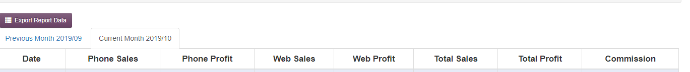

The information is available for the current month and the previous month.

Inventory Control Tool
This report would predominantly be used to help a customer determine what they should be purchasing to stock. Customers that this might benefit would be car dealers and large businesses that stock a decent amount of product on a regular basis.
- Go to: http://intranet.kmtire.local/ to access the Intranet
- On the left-hand side, select “Departments” 
- Click “Sales – Inside”
- Scroll down to find and select “SA – Inventory Control Tool”
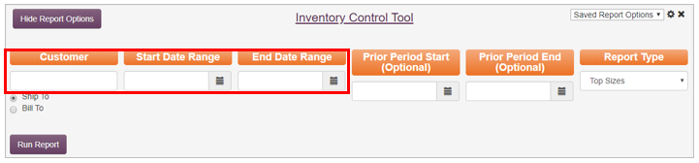
First, enter the customer number and the date range you are researching. Next, select the “Report Type” you’d like to view. The Report Type options are listed below:
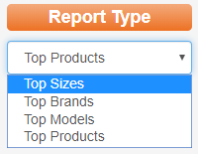
Top Size will show only tire sizes and the number of units that were purchased in the size (not brand or model):

Top Brands will show Brand Name and Units sold of that brand only:

Top Model will show Model, Brand, and Units sold of that specific model:

Top Products will show the full Product Code, Description, and Units sold of that Product Code:

If a customer wanted to see what the change in trend has been from a certain time period to now, you may want to pull a report including “Prior Period Start/End” dates. The only change this is going to make to any of the previous examples will be an additional column at the end showing “Prior Units”:

Invoicing Sequences
Invoicing Sequences is the program that chooses which routes print on any individual day. This is where we make changes to a locations invoicing when we add/subtract routes or make changes to the frequency that a route runs(going from once a day to twice a day etc.).
- Go to: http://intranet.kmtire.local/ to access the intranet
- On the left-hand side, select 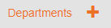
- Click on
- Scroll down to find and select
  - You should see this screen
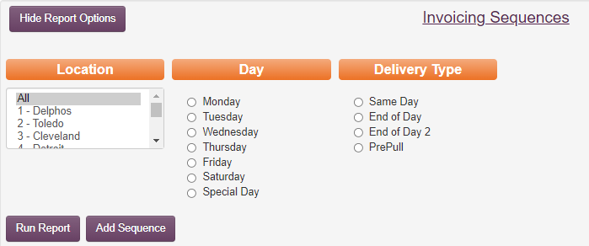
  - From here you should choose the Location(warehouse), day of the week, and delivery type that you wish to change. Same day for twice a day route, End of day for final print, End of day 2 if it is a route that is in a location with multiple ends of day prints (Loc 1 for EST and CST or loc 47 for CST and MTZ). “PrePull” is an option only used in Loc 6 and 49. Operations uses this to set up pre-pulls so they can pull product without putting the invoices in picking. Once you have all criteria chosen you can hit “Run Report” or “Add Sequence”.
    - If it is a new route that with the same first character(1J) then you would click “Run Report”
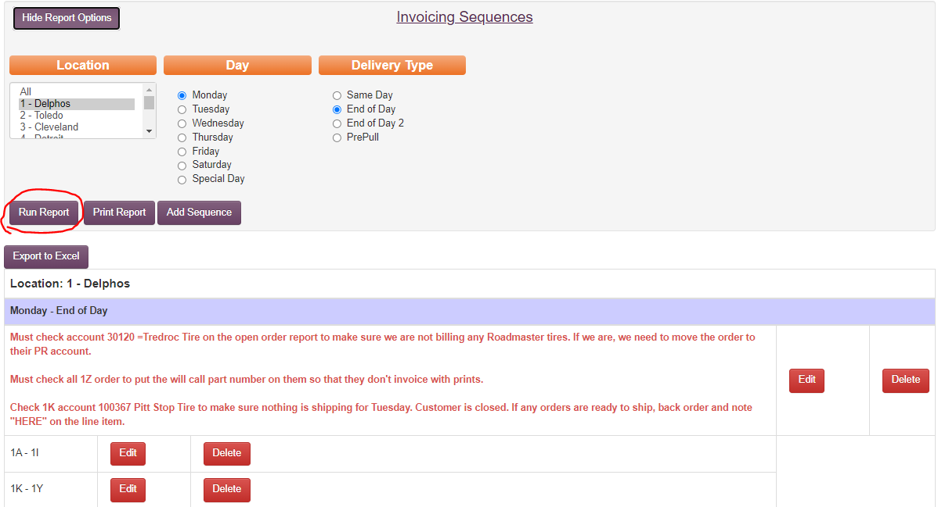
  - So, in the example of 1J being added we would be able to click “EDIT” and add 1J to the sequencing. The sequences pull in numerical and alphabetical order so we would be able to make the new sequences 1A-1Y and delete the second sequence(1K-1Y) because the sequencing would be in complete order from 1A-1Y with nothing being skipped.
    - If it is a brand new first character that isn’t currently used in this location you would click “Add Sequence”
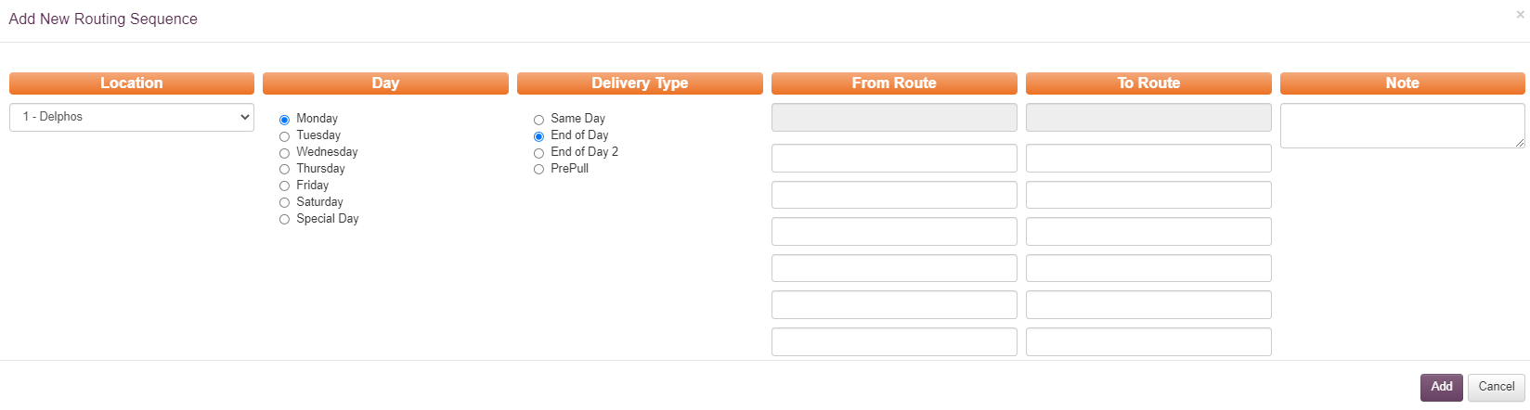
- An example of needing to do it this way would be if we were adding a BA route in location 1. Because there aren’t currently any B routes run out of the location, we would have to add the sequence. Once we get to the above screen you would put BA in both the From Route box and To Route box and click “Add” at the bottom right.
- Also, it is important to remember that MaddenCo reads alphabetically first then numerically. So, for example if we are setting a location up to print everything that is not E-Commerce, we would currently run A – 88. We start at A because that is our first alphabetical route and stop at 88 because that is currently our highest warehouse number. All route codes after 88 are currently used for E-Commerce.

Open Order Report
This report should be pulled AFTER invoicing has been done (mid-day and end of the day). Items showing up on this report are orders that did not close during normal invoicing.
- Go to: http://intranet.kmtire.local/ to access the Intranet
- On the left-hand side, select “Departments” 
- Click “Sales – Inside”
- Scroll down to find and select “SA – Open Order Report”

You should see this screen: 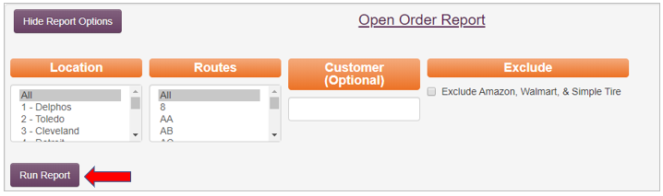
From here, you can choose a specific location, a specific route, or a specific customer. You also have the option to exclude Amazon, Walmart & Simple Tire because they have special invoicing requirements, so they show up almost every time. Once you have your criteria entered, hit “run report”.

The top of the report will contain customers who have credit holds. During regular business hours, the Credit Department is responsible for reviewing these orders and deciding if they will or will not be approved to close.

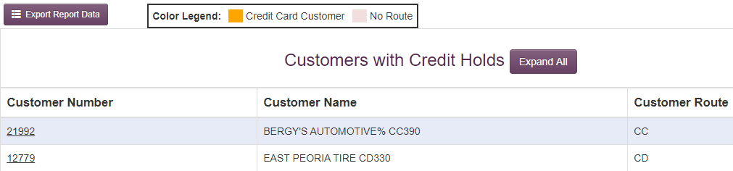

The next section will contain customers with non-credit hold related reasons for remaining open. There are a number of reasons an order might remain open. Some examples may be the customer is on a route that is not delivered daily, there’s no route code on the invoice, a credit card wasn’t ran for a credit card customer or an order was placed after invoicing.
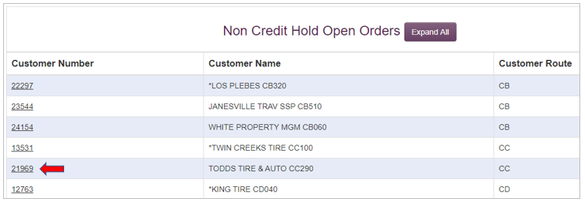
You can click directly on the customer number and this will expand to show all orders for this customer that are open, the original invoice number, the route the customer is on, the date and time the order was created, and the last time it was changed and any known issues with the invoice.
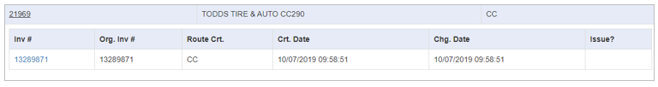
From here, you can click directly on the invoice number and pull up a copy of the invoice to investigate why it did not close with the rest.

Pre-Closing Tasks
This should be done immediately before closing invoices.
- Go to: http://intranet.kmtire.local/ to access the Intranet
- On the left-hand side, select “Departments” 
- Click “Sales – Inside”
- Scroll down to find and select “SA – Pre-Closing Tasks”

That will bring you to this message displayed on your screen: 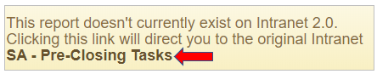
Click the link “SA – Pre-Closing Tasks”.

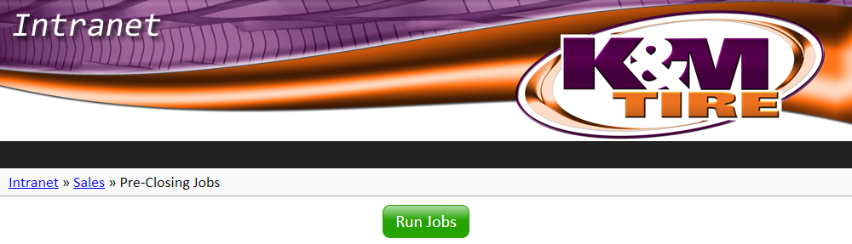

Process Load Sheet
Load Sheets are lists of products (and their corresponding invoice numbers) that need to be loaded on the trucks for delivery. The load sheets are printed in their matching warehouses.
- Go to: http://intranet.kmtire.local/ to access the Intranet

- On the left-hand side, select “Departments” 

- Click “Sales – Inside”

- Scroll down to find and select “SA – Process Load Sheets”

This will bring you to this page: 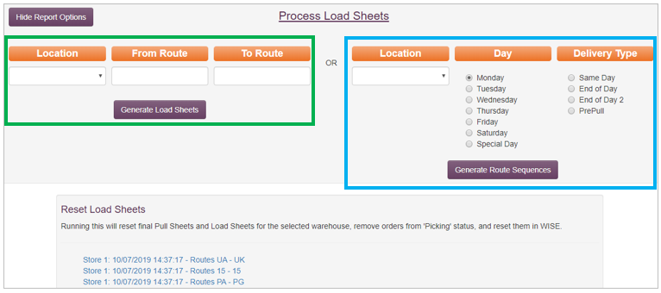

The section outlined in GREEN is used to process will-call orders. The section outlined in BLUE is used to process daily route load sheets.

When processing for a will-call, select the location and enter “PU” in the “From Route” and “To Route” sections.

For the daily route load sheets, the Intranet is pre-loaded in the “From” and “To” routes based on what location/day/delivery type you select. Daily route load sheets are to be ran at specified times for specified locations. Invoicing and processing load sheets will run hand-in-hand. You will be responsible for processing load sheets whenever you are responsible for invoicing.

Product History Inquiry
- Go to: http://intranet.kmtire.local/ to access the Intranet

- On the left-hand side, select “Departments” 

- Click “Sales – Inside”

- Scroll down to find and select “SA – Product History Inquiry” 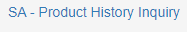

This Inquiry has not been updated to our new Intranet, so at this time you will be instructed to follow a link to the older version of the Intranet to access this system:
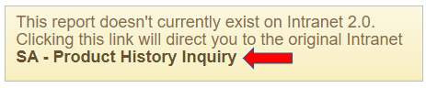

This will bring you to the following screen:
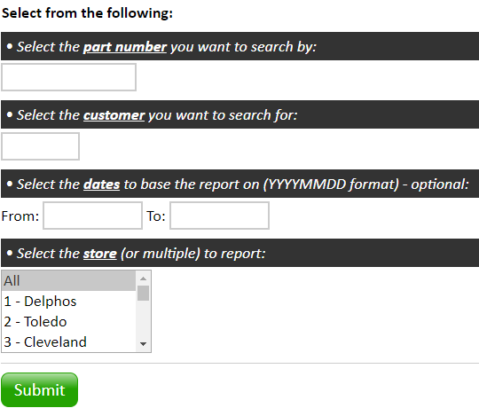

Here, you will need to enter the part number (can be found on an invoice or in MaddenCo):
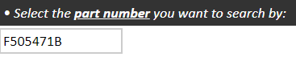
If you do not know the customer the part was sold to, you can click submit without a customer number and the report will provide all invoices this part number shows up on.

If you are searching for the part for a specific customer, enter the customer number:
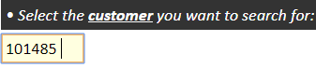
This will pull all invoices that the entered part number shows up on for this specific customer only.

If you have a date range to narrow the search even more, enter here:
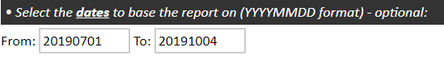
You can click in the empty box, and a calendar will pop up to select your dates.
If you know what warehouse the part was shipped from, select from this area:
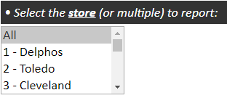
If you don’t know what warehouse the part came from, leave “All” selected.

Once you have all of the information provided, click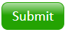 or enter on the keyboard.

A summary or your entered information will be provided along with your search results: 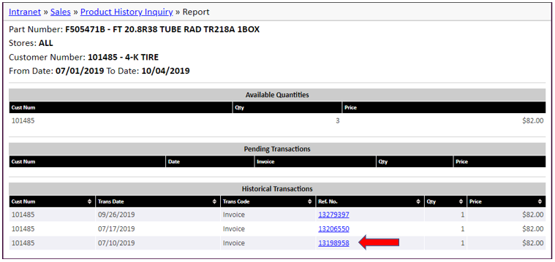
If you want to view the full invoice, click on the blue invoice number. A new window will pop up with the invoice displayed. This will show the date the invoice was signed for, and who signed for it.

Sales Analysis/Product History Report
This report is used to view the sales history for a specific customer for a selected period of time.
- Go to: http://intranet.kmtire.local/ to access the Intranet

- On the left-hand side, select “Departments” 

- Click “Sales – Inside”

- Scroll down to find and select “SA-Sales Analysis/Product History”
You should see this screen: 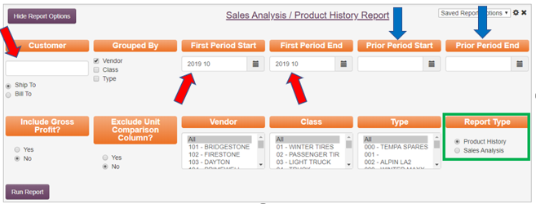

First, you will enter a customer name or number in the customer field. As you type, a dropdown box will populate with customers matching your search. Select the correct customer. Once you have your customer selected, you will need to select the “First Period Start/End” dates. Entering something in the “Prior Period Start/End” section is option. This would allow you to compare two timeframes vs. reviewing one timeframe. The remaining sections (Include Gross Profit, Exclude Unit Comparison Column, Vendor, Class, Type) are additional ways to narrow down the information that will show up on the report. The Report Type will change what information is generated slightly, so be sure to pull the correct report.
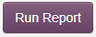
If you hit without entering or changing any other information, a report will generate containing a list of this customer’s purchase history for the period of time you selected. The report provides the Vendor type, # of units purchased of that vendor type (minus any product(s) purchased for government/national account billing), the customer’s total sales in dollars for that vendor type, and the % of sales based on dollars for that vendor type.
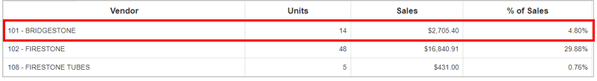
Using this as an example of a “Product History” report, it’s showing that the customer has purchased 14 Bridgestones at a total cost of $2,705.40, and that $2,705.40 represents 4.80% of their total amount of sales for the selected time period.

Now, for the same customer, we’ll look at an example of the “Sales Analysis” report using the exact same information we used for the Product History report.
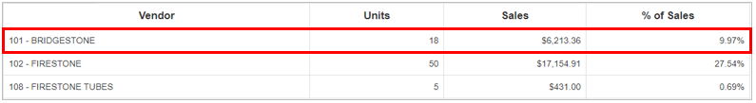
As you can see, the sales analysis shows 4 additional units for Bridgestone, sales have increased by $3,507.96 and the % of sales has increased by 5.17%. The difference comes from the fact that the Sales Analysis report represents ALL sales for the customer, regardless of government/national account billing.

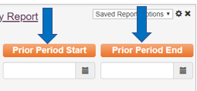
If you want to compare sales for certain periods of time, then in addition to the “First Period Start/End” dates, add dates in the “Prior Period Start/End” section.

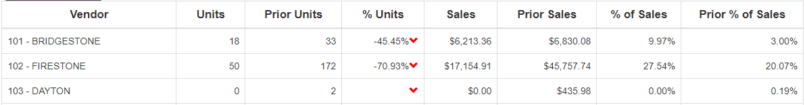

In addition to comparing First Period to Prior Period stats, it also provides a column titled “% Units”. This column represents the number of units sold in the “First Period” compared to the number of units sold in the “Prior Period” as a percentage.

Sales Summary (3 Period Comparison)
This report will show the sales history (typically used for a specified customer) for up to three different timeframes. This might be helpful if a customer wants to compare the past 3 years of sales, or to see if they are/are not meeting numbers to remain on certain programs. It might also be used to determine if we are on track to meet/exceed the prior years’ sales.
- Go to: http://intranet.kmtire.local/ to access the Intranet
- On the left-hand side, select “Departments” 
- Click “Sales – Inside”
- Scroll down to find and select “SA–Sales Summary (3 Period Comparison)”

This will bring you here: 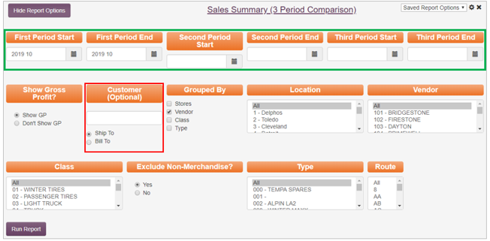
As you can see, there is a lot of information to pick and choose through for this report. The top row is where you can select the date range for up to three different timeframes. The remaining sections are different ways to narrow down your search results allowing you to pull the right information for your search purposes.

While the Customer field is optional, in almost all scenarios you will be pulling this report on a specific customer, so you will need to enter the customer name or number in this field.

For this example, I am going to determine if sales for a specific customer are projecting to be lower, the same, or higher than last year’s sales. To ensure the reason for using the dates I chose make sense, it is important to state that today’s current date is 10/8/2019. To start the report, in the “First Period Start/End” dates, I entered January 2019 - December 2019 (current year). In the “Second Period Start/End” dates, I entered January 2018 – December 2018. In the “Third Period Start/End” dates, I entered October 2018 – December 2018.
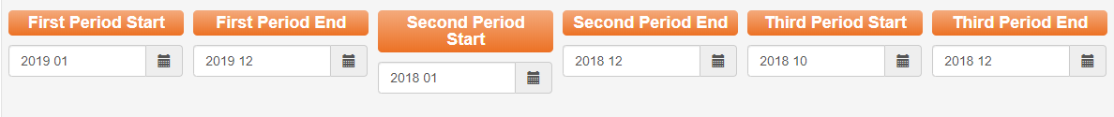
The only other changes made to the available fields were changing “Show Gross Profit?” to “don’t Show GP” and entering a customer number:
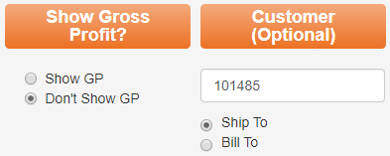
Then I clicked 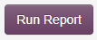.
Here is how the report looks once (there are many additional lines between Fuzion and Totals, it was condensed to fit on this sheet).
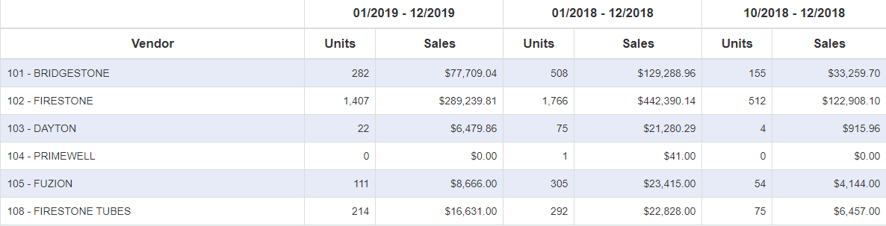
By looking at the results, we are able to determine that last year’s total sales in units were 17,928 and $2,350,128.70 in dollars. So far this year, sales in units totals 12,287 and in dollars is $1,637,791.40. The last column shows that in October – December last year unit totals were 4,966 and sales in dollars were $649,742.44. If we add the totals for this year so far to the total sales for October 2018 – December 2018 this should give a good estimate as to what our yearend sales might be (12,287 + 4,966 = 17,253; $1,637,791.40 + $649,742.44 = $2,287,533.80). Once we have those numbers, we can compare them to the totals for 2018 (17,928; $2,350,128.70). By doing this, we can determine that our sales projection for this customer is showing a decrease by about 500 units and about $62,000. This may prompt more research as to why to see if we can rectify things before the end of the year.

Sales Transfer Audit
This report allows us to view orders that may be placed in the incorrect locations or shows us if the tires are in a closer location to the customer than where the order is placed.
- Go to: http://intranet.kmtire.local/ to access the Intranet

- On the left-hand side, select “Departments” 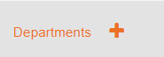

- Click “Sales – Inside” 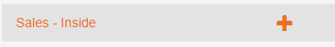

- Scroll down to find and select “SA – Sales Transfer Audit” 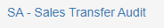

You will then see the screen below:
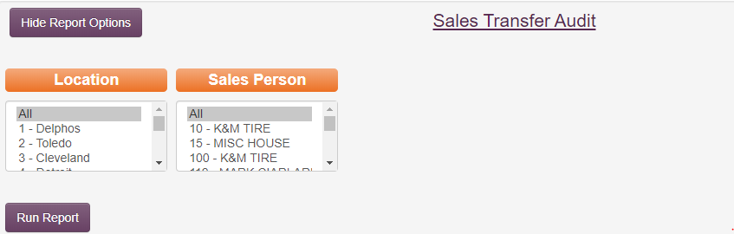

● Click “Run Report” after selecting the location you wish to check; leave salesperson on “All”

This will display the following screen:
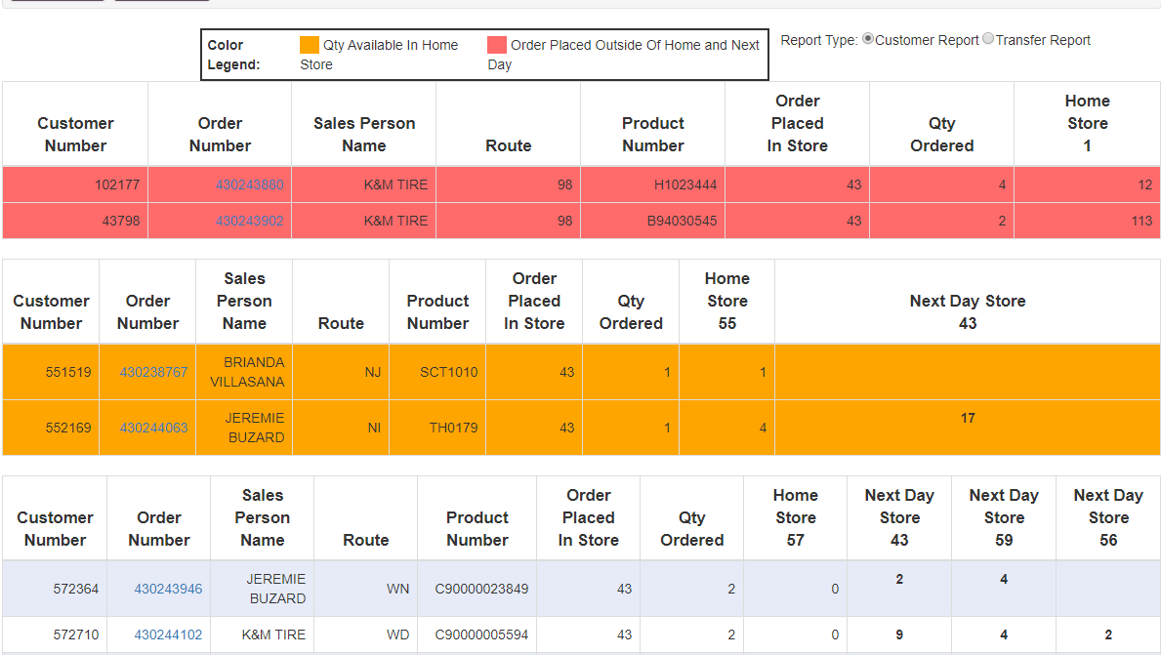

●Looking at the color legend the orange and the red highlighted areas are the invoices that need to be looked at. (don’t move any orders with route 98 or PU) only orders from inside sales members or K&M Tire *this can be found under sales person’s name*

-Orange indicates the order is placed out of the home store and tires are available in their local warehouse. This helps us prevent transferring unnecessary tire.

- Move the order into the home store and delete order showing on transfer audit

● Red on the color legend shows order that the order is placed outside the home store and next day warehouse.

- Check to see if these orders are placed in the wrong location, if so move them to the correct location

Weblink Login Report
The Weblink Login Report provides you all dates in the past 30 days that a specific customer has logged on to their Weblink account. This is mostly utilized by Customer Service when making the initial welcome call to a new customer. If the customer has Weblink, but has not logged in, Customer Service will mention it during the phone call to address any questions about the Weblink process.

- Go to: http://intranet.kmtire.local/ to access the Intranet

- On the left-hand side, select “Departments” 

- Click “Sales – Inside”

- Scroll down to find and select “SA-Weblink Login Report”

You will be brought to this message:
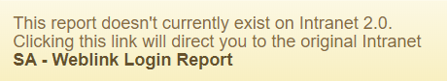
Some of our Intranet programs are not used on version 2.0 of the Intranet. You can click “SA – Weblink Login Report” on the message and it will redirect you to the older version of the Intranet where you can complete the steps to run the report.

Once redirected to the old version of the Intranet, this is what you should see:
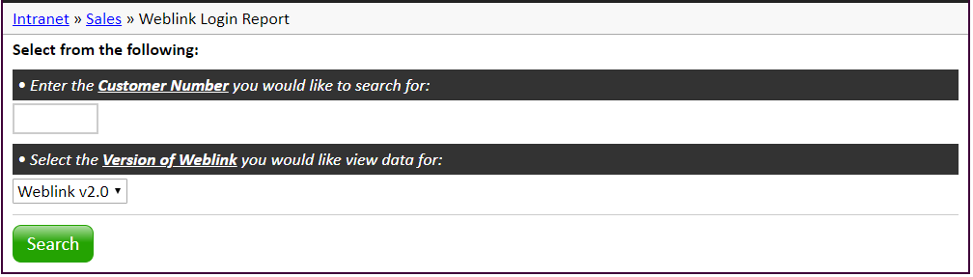
Here, all you need to do is enter the customer number in the designated field and click “Search” or hit enter. The report will look like this:
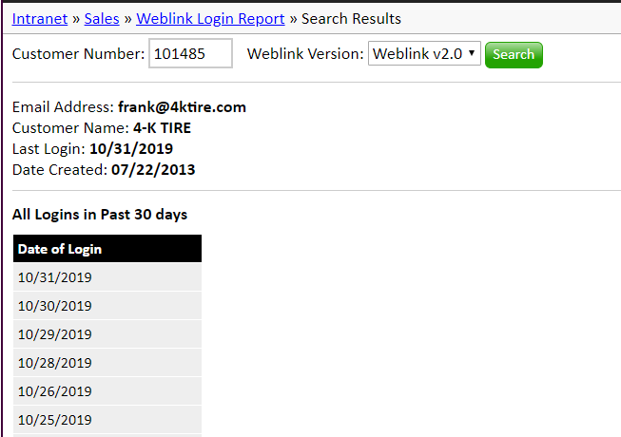

7. Weblink

Set-up
If a customer does not currently have a weblink account set up and they would like one, the process if very simple from a sales position.
- Ask the customer what email address they would like to use as their login.
- Confirm if the customer has an SSP/PR account in addition to their regular account.
- Send an email to weblink2@kmtire.com containing the customer’s email as well as the customer number (and SSP/PR account number if they have one).

Basics
If a customer has questions about their weblink, you will generally direct them to talk with their outside sales rep. Basics are covered in the video below:
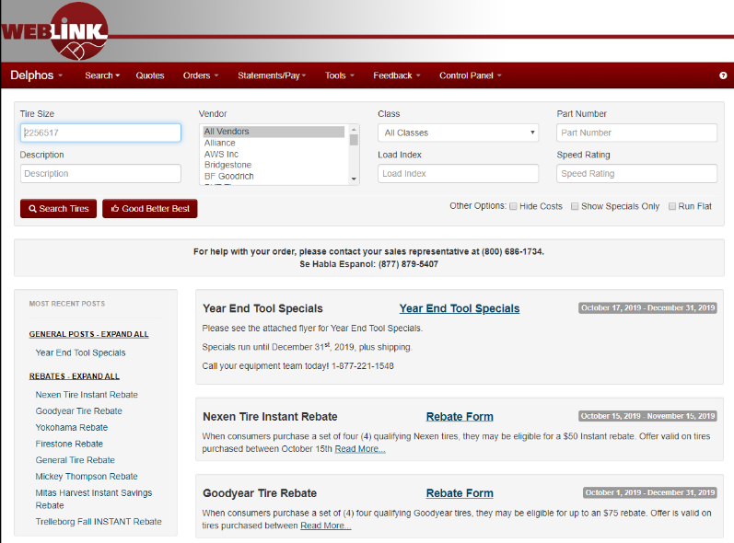
Home Screen

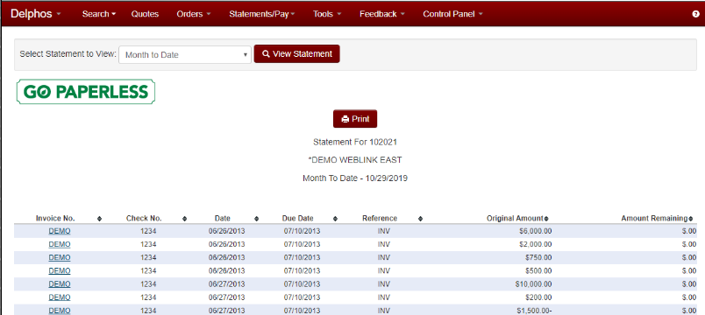
Statements

Programs

Dealer Programs

Goodyear G3X
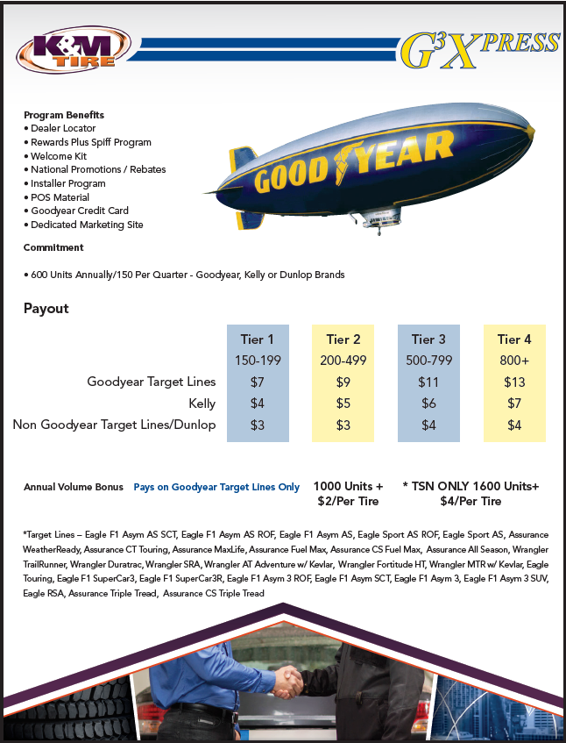

Goodyear Tire & Service Network
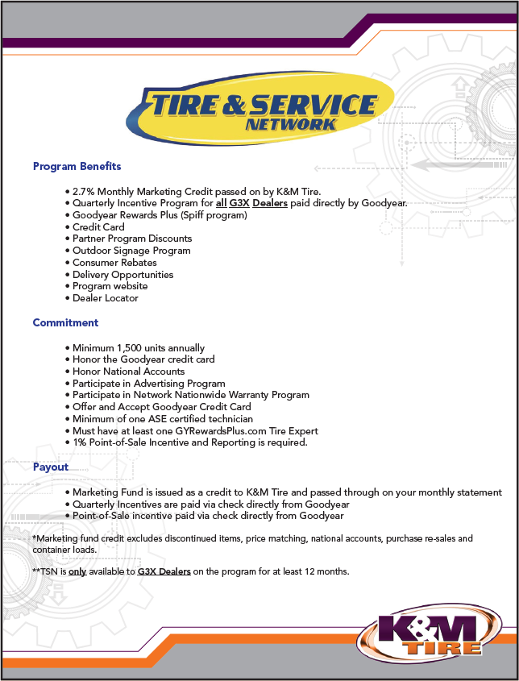

Bridgestone BARNN
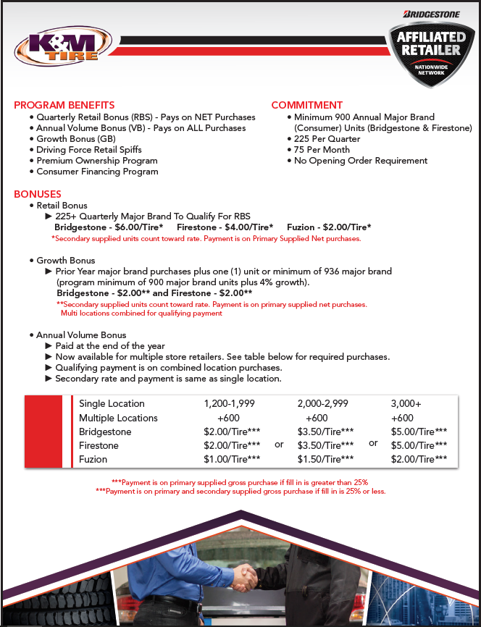

Bridgestone Associate
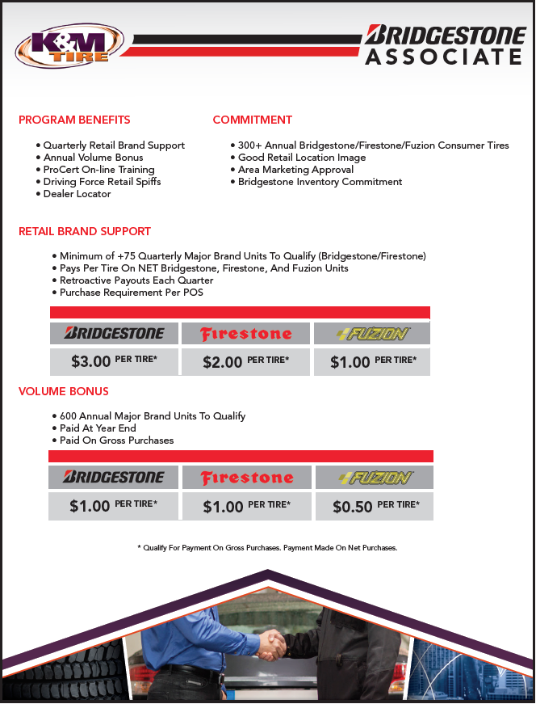

Continental Gold
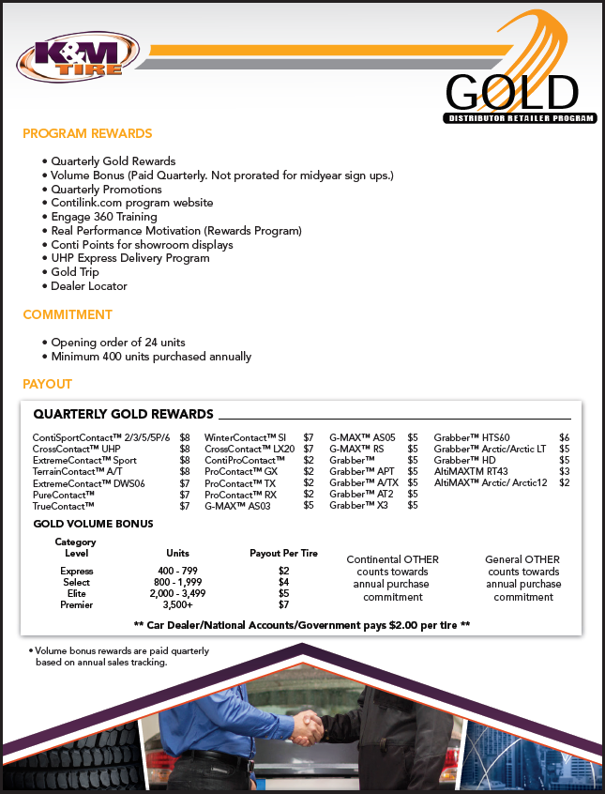

Yokohama Advantage
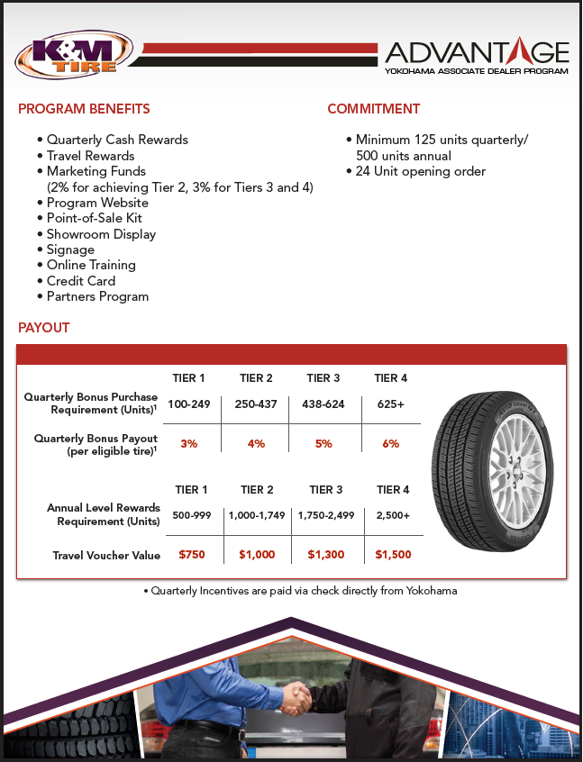

Cooper Medallion
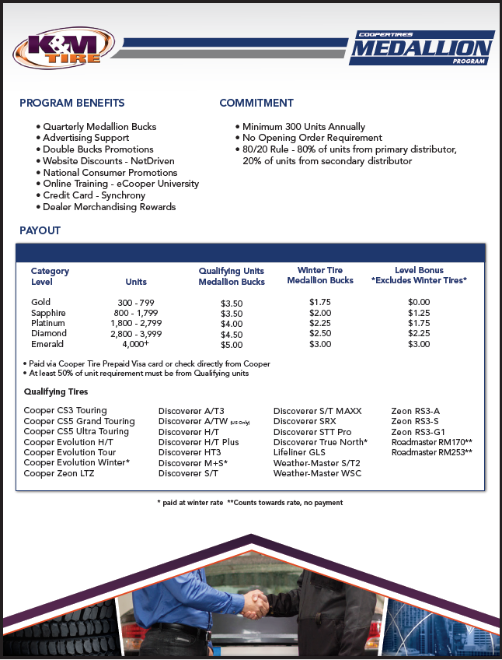

Mastercraft Century
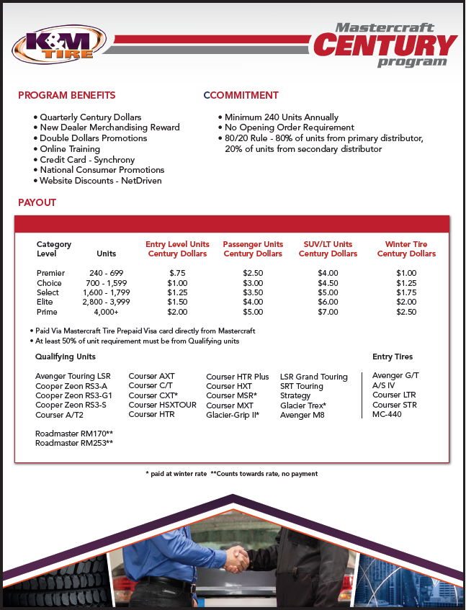

Kumho Premium Fuel
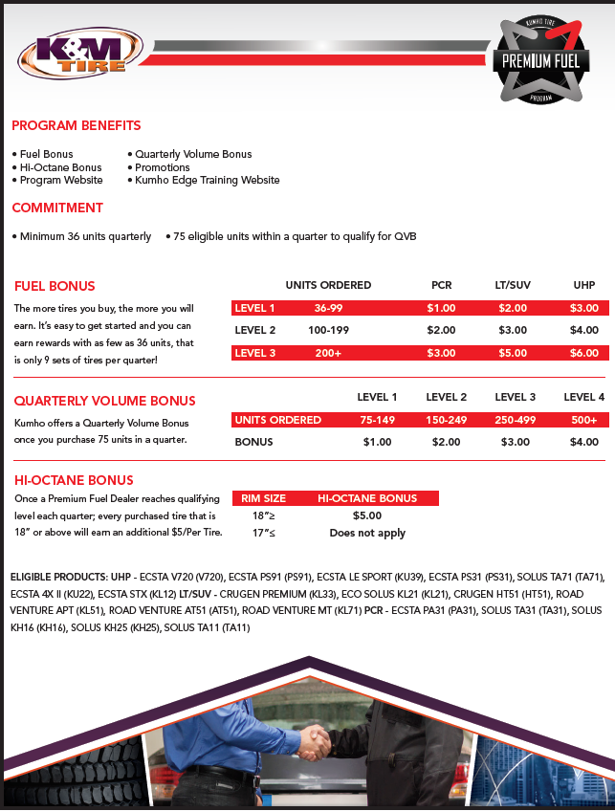

Hankook ONE
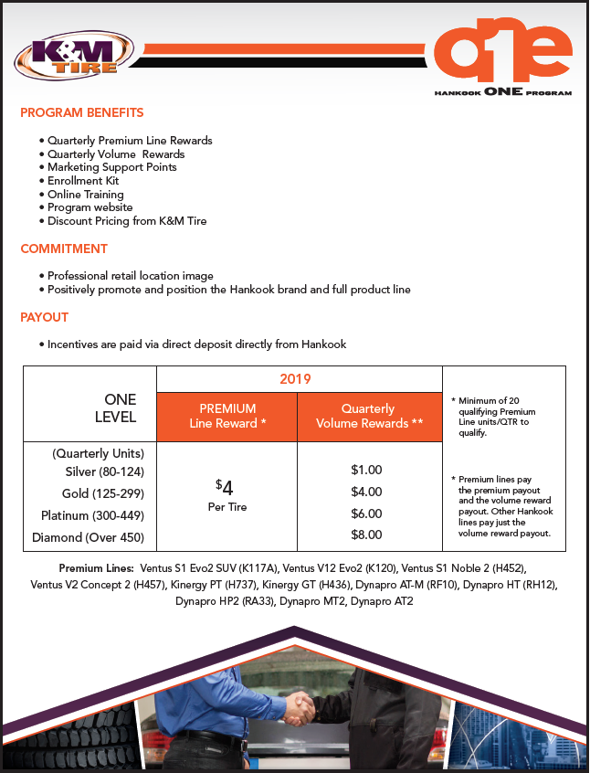

Falken Fanatic
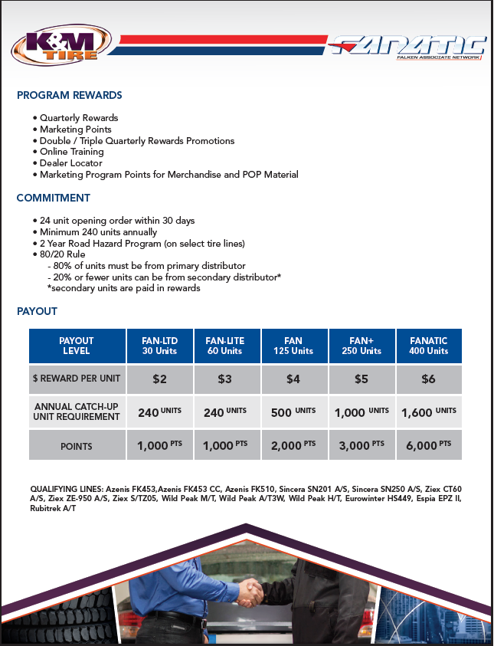

Pirelli FasTrack
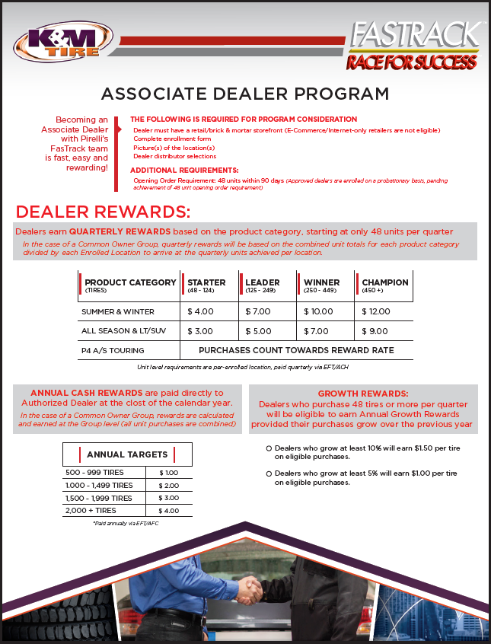

Mickey Thompson MTMA
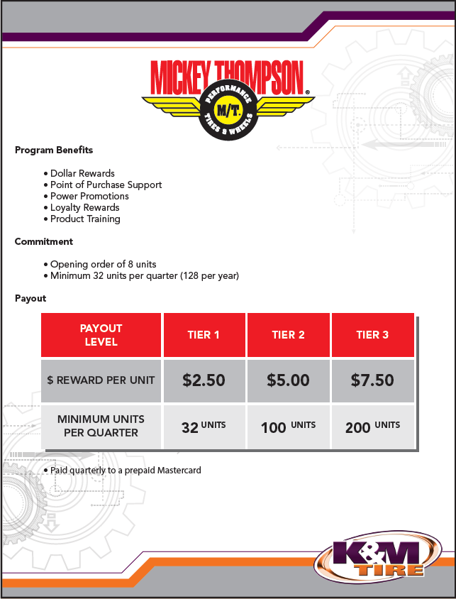

Nexen Next Level
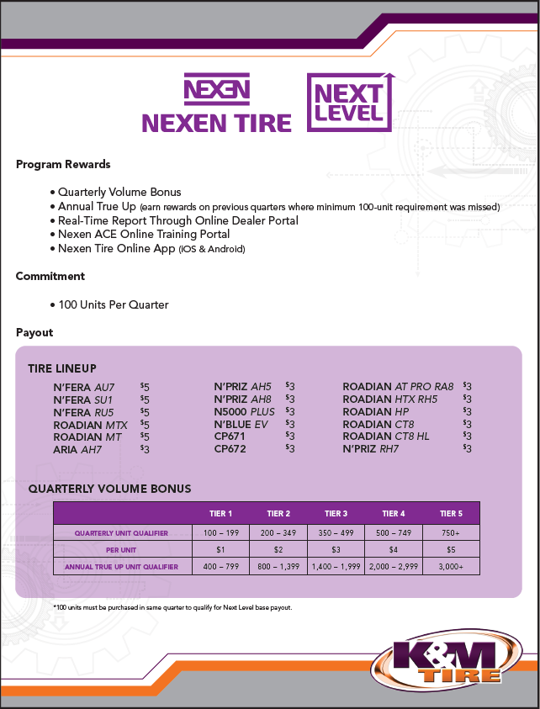

Trelleborg Associate
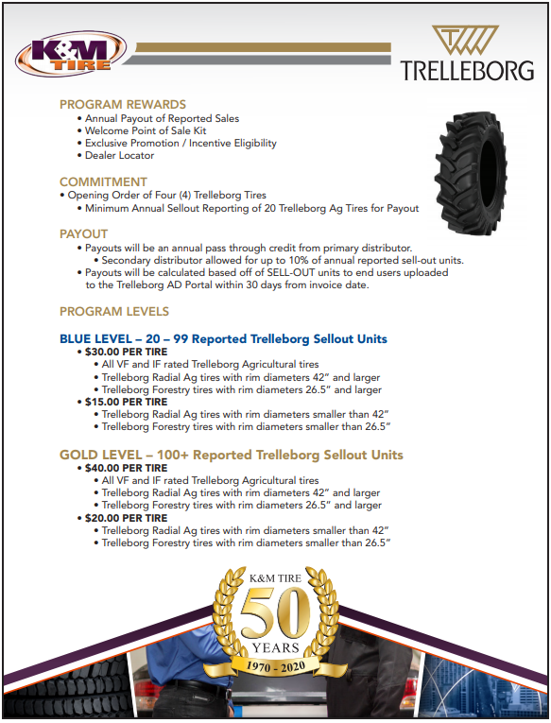

BKT Growing Together
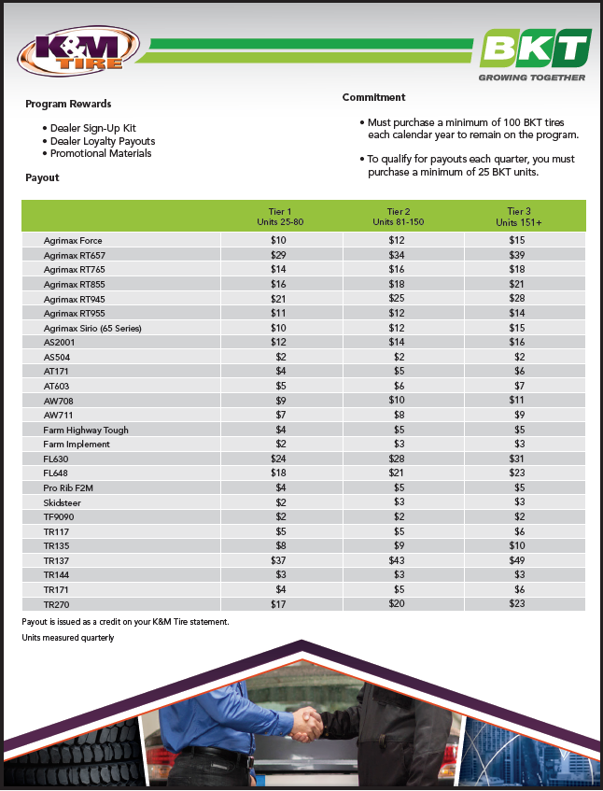

Firestone Certified AG
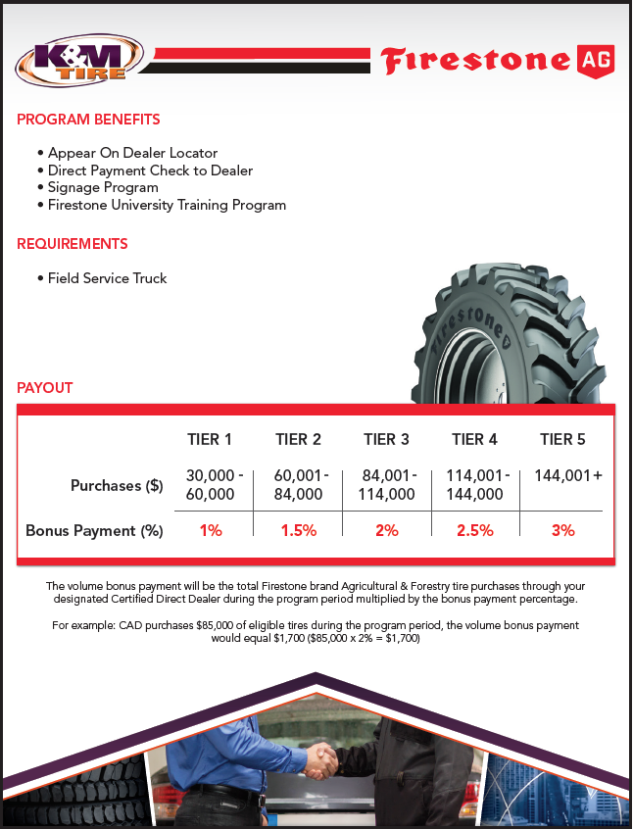

Goodyear G3X Commercial
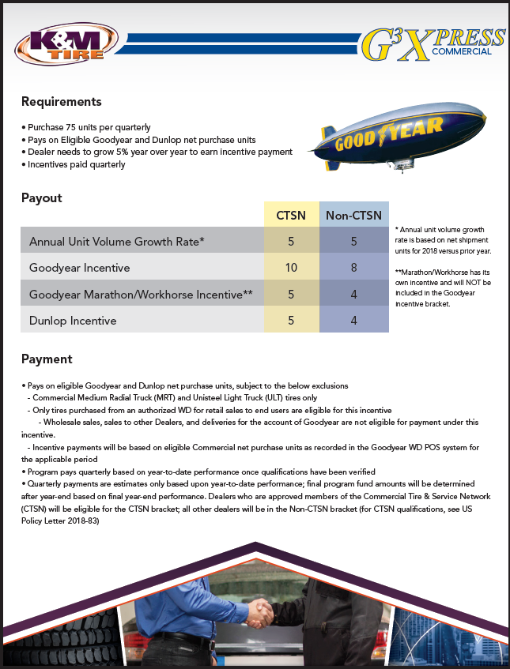

Yokohama Commercial Advantage
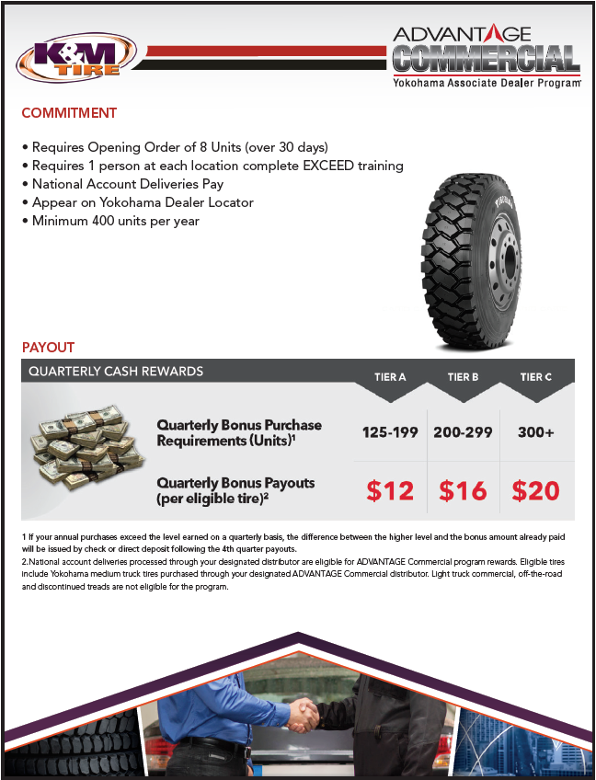

K&M’s Special Program Requests

Mr. Tire/Big 3 Tire
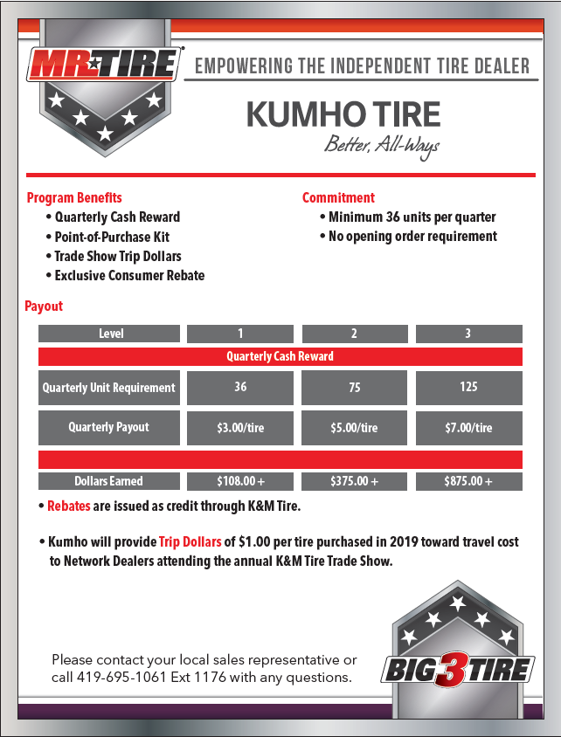

End of the Day

Invoicing Procedure
Invoicing should be done according to the schedule. Same-day invoicing times are 11:30a, 12:30p and 1:30p (depending on location/time zone).
End of the Day invoicing should be done at 5:30p, 6:30p and 7:30p (depending on location/time zone).
Saturday invoicing should be done at 12:00p, 1:00p and 1:30p (depending on location/time zone).
Good practice is to wait an extra 5 minutes after the listed invoicing times before actually invoicing anything to make sure nothing gets missed.

Step 1—Transfer Audit Report
Using the K & M Intranet; run the transfer audit report for each location that you are invoicing.
On the intranet go to Departments-->Sales-->Sales Transfer Audit
Move any orders that are available in a closer location as needed, or correct any orders that are placed in the wrong location.
Full Transfer Audit Report procedure available HERE

Step 2--Credit Authorization
At the order entry screen that shows all open orders, in the field, “show only status of” type in a $ to check for any invoices that need to be authorized for credit. If any need to be authorized for credit follow the credit authorization procedure guidelines (F-drive-sales-shared-procedures-credit authorization procedure), press the ESC key and select “credit authorization” by typing a 1 on the line. Enter location __. Find the specific invoice needing authorized and type a 2 (edit/authorize) and only authorize the amount needed. Make sure the invoice needing credit is NOT a back order.

DO NOT LEAVE ANY ORDERS UNAUTHORIZED WITHOUT CALLING INSIDE SALES MANAGER (JAMIE’S CELL 419-303-5746) TO MAKE A FINAL DECISION

If you have a will call order that requires credit authorization, please make sure credit is authorized and invoice is printed prior to invoicing at 5:30 PM. If it is a partial order, backorder the product and add a message line to release complete and how many are already there.

Full Credit Authorization Procedure available HERE.

Step 3—Credit Card Report
Using the K & M Intranet; run the credit card order report.
On the intranet go to Departments-->Sales-->Credit Card Orders Report
Charge Credit cards for any orders that require it, and mark them approved or declined as needed.

Full Credit Card Report Procedure available HERE.

Step 4—Check Back Order Report
Using the K & M intranet site run a Back-Order Report for all locations that you are invoicing. Go back into MaddenCo and do any necessary transfers, or moving of any orders for items that are available. Reprint any transfers or orders that were moved if they are shippable.

Full Back Order Report Procedure available HERE.

Step 5--Open Invoices
At the order entry screen that shows all open orders, in the field, “show only status of” type in a U to show invoices that may be “in use”. If any show in use, reset by typing a @ to reset the invoice prior to running the final load sheet. (Using the @ symbol for this procedure will only work if you are authorized by the IT dept. to have access to it.)

Step 6 – Pre-Closing Tasks
On the Intranet use the “Pre-Closing Tasks”
Simply click “Run Jobs” to automatically have the tasks completed.

Step 7--Print the final load sheet
On the Intranet use the “Process Load Sheets”
Select the location, day and delivery type.
Click “Generate Route Sequences”.

Full Print Load Sheets Procedure available HERE.

Step 8--Close and Print the invoices:
From the order entry menu, select 5 (close invoices)
Enter Store # __
Route codes - Run codes based on the day according to your print log.

Step 9—Checking Open Orders
Using the K &M intranet site run an open order report in location __. Go back into MaddenCo and check these orders to see what the reason was that they did not ship. If you have any orders that need to close just release the backorder, reprint that route in that location, and send an email to the shipping and delivering warehouse to let them know there was an add on order.

Full Open Order Procedure available HERE.

Ex. If location 42 has an add on order in Delphos, you need to make sure you send the email to DelphosEmail@kmtire.com and ChicagoEmail@kmtire.com.

In your email include invoice number, product number, and quantity.

Step 10—Copy Open Order Report - (MTZ Printer’s Responsibility)

Run the open order report for ALL stores and routes. Copy entire report and email to Inside Sales Manager and Assistant Inside Sales Manager for the End of the Day Invoicing.

*** If there are any questions on open orders, the Inside Sales Manager or the Assistant Inside Sales Manager should be contacted (on their cell phones if they are not in the office) ****

Forms

Price Level Change Request Form
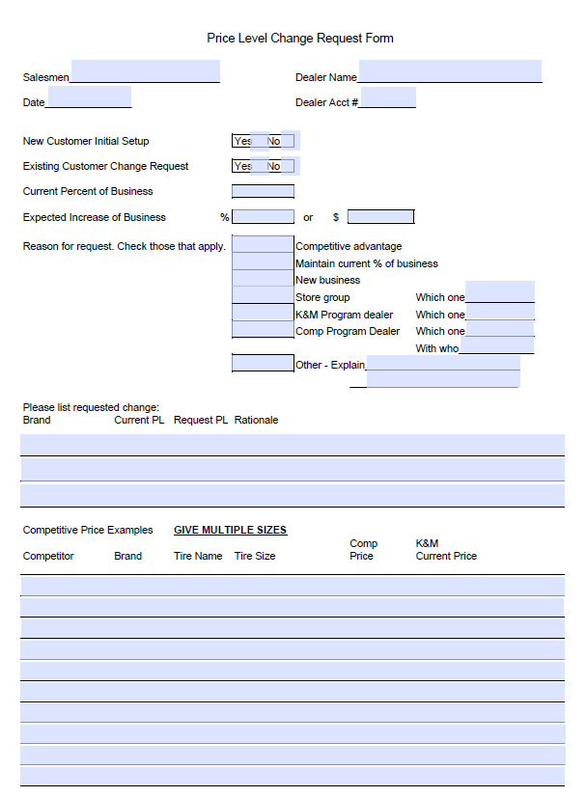
By clicking the link above, you will be brought to a fillable PDF version of this form:

Order Point Request Form
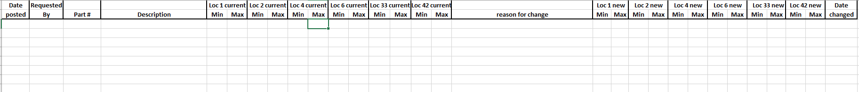
By clicking the link above, you will be able to pull up the Excel Sheet

Product Set-Up Form

By Clicking the link above, you will be able to pull up the Excel Sheet.
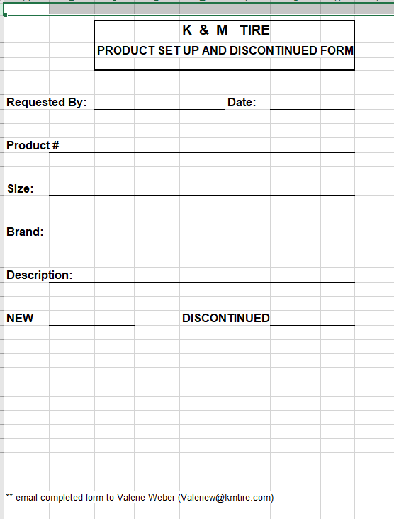

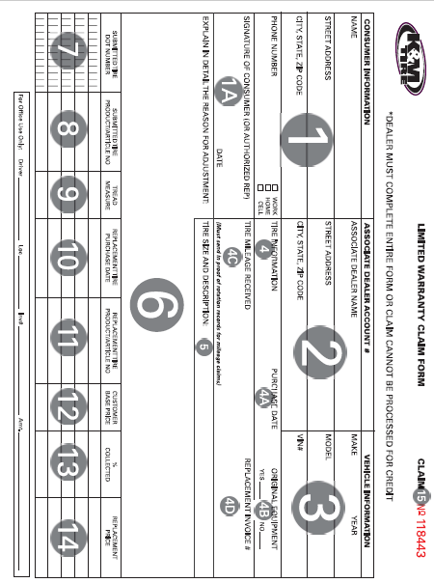
Limited Warranty Claims & “How To”
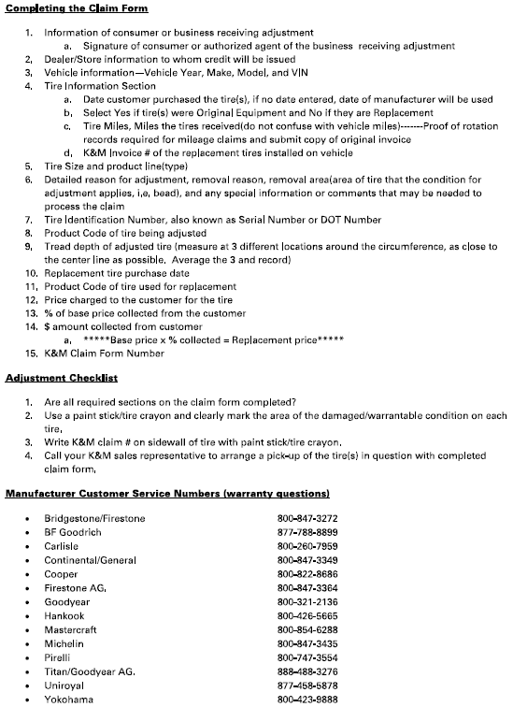

Release of Liability
LIMITED RELEASE OF LIABILITY

I, ______________________ acting as authorized agent for the business of:
(Printed Name)

Company Name:

Address:

City,State,Zip:

Do hereby release K&M Tire Inc. and its representatives from any liability that arises from leaving the products at the following listed location:

I/we further agree to pay according to my terms set up with K&M Tire for such deliveries and will hold harmless K&M Tire and it’s representatives for any deliveries that are lost or stolen in my absence.

I, ____________________ have read and agree to the above mentioned Limited
(Printed Name)

Release of Liability.

Signature:

Job Title:

Date:

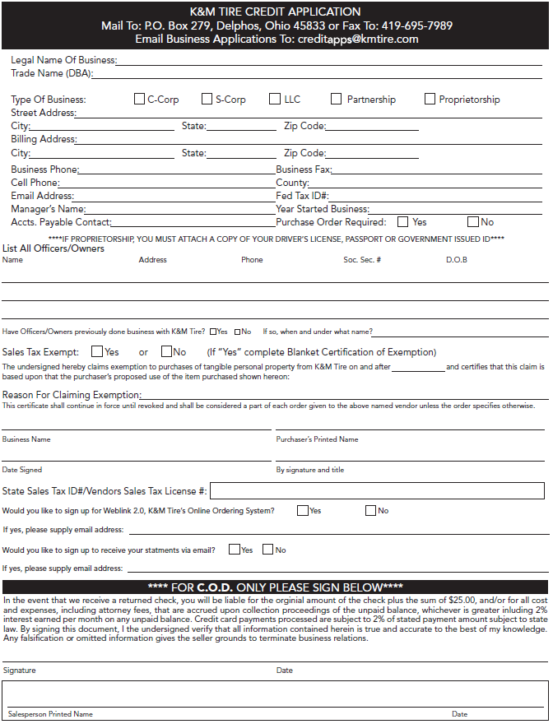
Credit Application
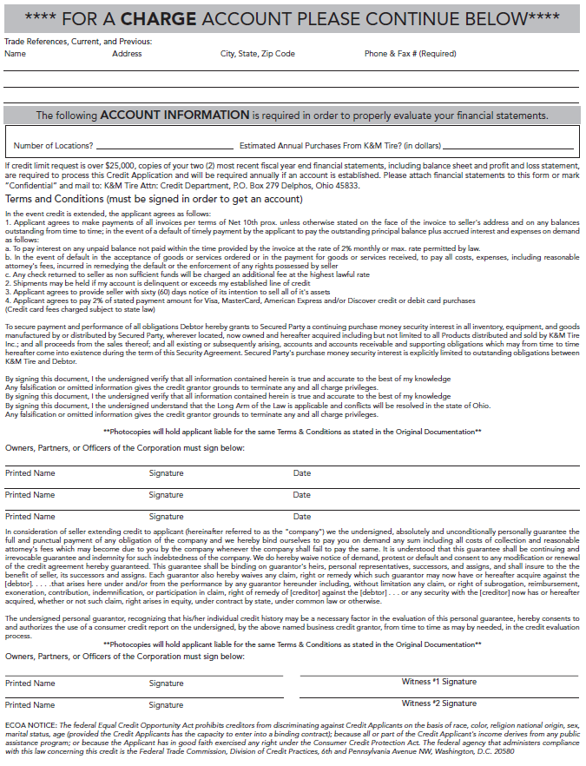

Common Ownership Form
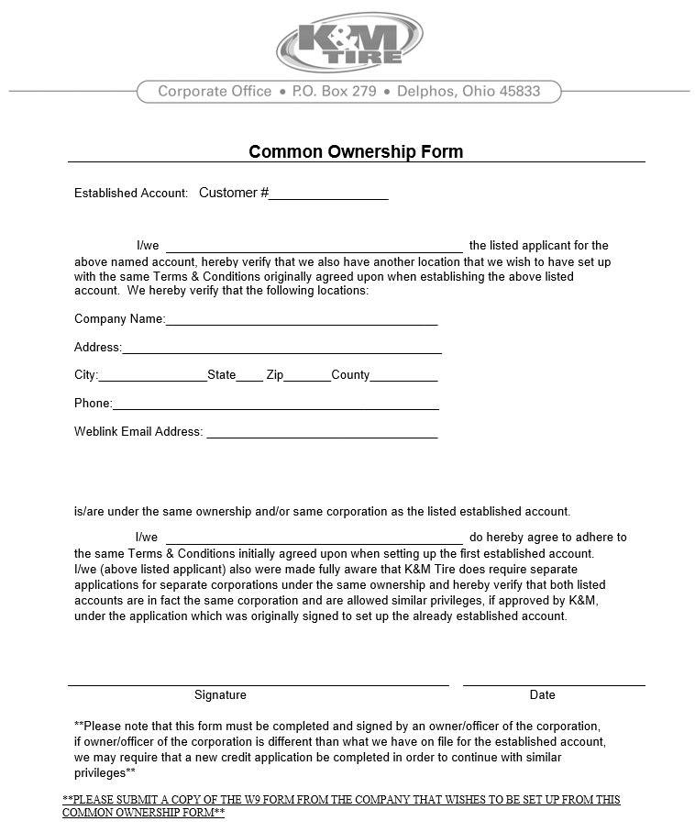

Dealer Request Form
By clicking the link above, you will be brought to a fillable PDF version of this form:
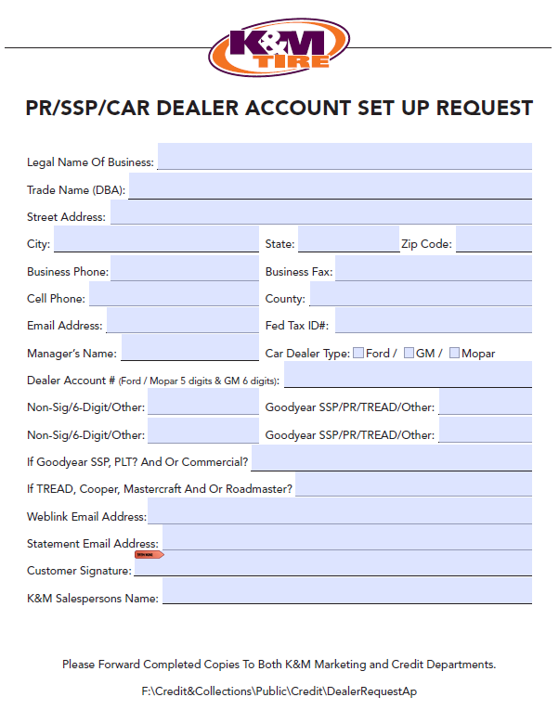

Training Plan
By clicking the link above, you will see the actual Excel sheet:
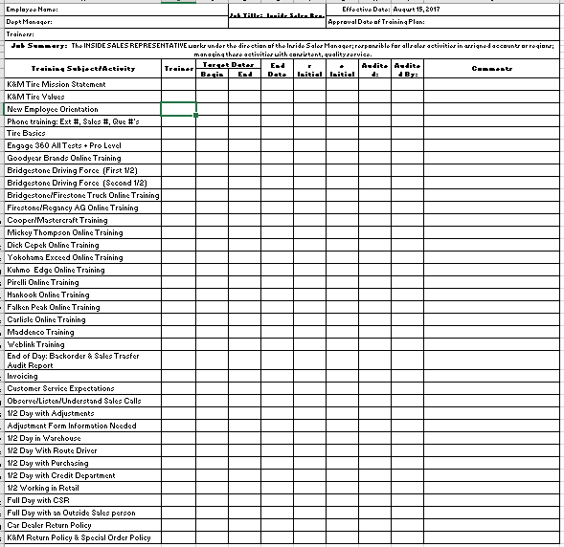

Customer Service – Additional Procedures

Telenotes
Telenotes is used as a central location to allow encounters with the customer to be tracked. This helps to alleviate the situations where the customer has to explain things multiple times. It is also helpful because our Outside Sales team also utilizes this system. They are able to view notes on conversations their customers had with someone else to be up-to-date on customer requests/questions before walking into their shop.

- Log on to Telenotes @ telenotes.com
- If you are just adding a note and the company is already saved with the customer number, put the customer number or customer name in here on the top left of the screen (if you just use the name the drop-down arrow can be clicked and look through all customer options to match which one you need.
- Hit enter
- It should then bring up the customer name right below
- Click load company to the right side of the customer name and all info (ex: address phone number ext.) should all fill in for you.
- Click add call note at the top left beside the company name 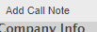
- Under call type choose what the nature of your call was. Then type your notes in the narrative box
- Hit save
If the customer is not saved and you have to add a new customer do the following
- Click Add Company at the top left 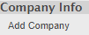
- Fill in all areas you can with customer info
- Hit save
- See above and repeat steps 6-8

New Customer Call-Outs
- Open up the Account List in excel
    - Found in Sales F-Drive (Eric Wannemacher)
  - On the location Tabs find the location you are ready to call.

- Log on to Dashboard
  - Search the Customer’s Account Number on Dash & pull up the customer’s account.

- Calling Out to Customers:

  - 1st Time Calling to Customer Look at the Customer’s information:
    - What Location are they serviced out of?
    - What Route are they? Once or Twice Daily.
    - See if they have a bill to or ship to address.
    - Click on Address and view the building. (Helps with phone call and you can see how they are operating.
    - Look for the Contact Name and ask for that person during phone call or ask who is in charge of buying the tires are your store.
    - Look at their Outside Sales Rep to know who to follow up with after the call if major questions need answered.
    - Have they bought from us? MTD Sales & YTD Sales.
      - Are they set up with Credit or are they COD?
    - Then look to see if they have logged on to weblink:
      - Weblink 2.0 =YES they have logged on, click YES to see when they have an how often.
      - Weblink 2.0 = NO they have never logged on the Weblink.
        - That is when I can help them get set up.
        - Get an email address from them and a name of contact.
        - Send a screenshot of their information and their email address to the K&M Email address: Weblink2@kmtire.com
    - Call the customer and talk to them about their business.
      - Explain to them who we are and what K&M does.
      - Explain the route and how we can get them tires.
      - Re-introduce them to Weblink and ask if they got on to check the site out and answer their questions about the site and help promote them using the site more.
      - If they need set up on weblink then get their information over to Weblink2@kmtire.com
      - Leave them with your name and number and ALWAYS get the name of the person you talked to add to Telenotes.
      - Update spreadsheet with notes and then add that information to Telenotes.

  - 2nd Phone Call:
    - Same as above. Look up customer and get all the information before calling.
    - Check Telenotes or the Spreadsheet to see how your previous call went.
    - Check to see if they have been on Weblink since the last time you talked and explain that you got their account set up with the email they provided.
      - Answer any questions for them and help them out. Explain what weblink can do and walk them through all the steps of Weblink
        - If needed, ask if they would like an outside sales rep to stop back out to show them Weblink 1v1.

  - 3rd Phone Call:
    - Same as above. Look up customer and get all the information before calling.
    - Check Telenotes or the Spreadsheet to see how your previous call went.
    - Check to see if they have been on Weblink since the last time you talked and explain that you got their account set up with the email they provided.
        - Ask if there is anything, they need from us and what we can do for them.

OE Connections
- Log on to https://portal.oeconnection.com/#!/Login

  - All locations usernames are kmtire (and then the location number for loc 1 it is 01 exp kmtire01)

  - Password for every location is kmtire1970

- Any outstanding orders will show on first screen.

  - Double click on one of the customer names

  - Go to MaddenCo and start to put the order in but look at purchase history before you actually order. If they have ordered the same product code and the same qty within 2 business days don’t process order again. Just ignore.

  - After order is placed in MaddenCo go back to OEC website and click on the 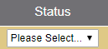
and select completed in the drop-down box

  - Then click complete from the drop-down box above 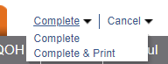

  - This will clear the order out.

Video Library
All of the following videos are located on K&M Tire’s very own Video Website. Click HERE to be directed to the webpage. From this point, you will see multiple videos. Each video will require a password to view it. The password for all of the following videos is: kmtire1970

How To’s

MaddenCo

https://kmtire.vids.io/videos/d49fd5bb1f16efc25c/sop-maddenco

Dashboard

https://kmtire.vids.io/videos/d49fd5bb1f17eac65c/sop-intranet-dashboard

Price Level Request

https://kmtire.vids.io/videos/a49fd5bb1f1de0c22c/sop-plr

Program Request

https://kmtire.vids.io/videos/1c9fd5bb1f1de6ca94/sop-program-requests

Spot Opportunities
https://kmtire.vids.io/videos/1c9fd5bb1f1ae1ca94/sop-spotting-opportunities

Credit Application

https://kmtire.vids.io/videos/189fd5bb1f1be3c490/sop-credit-app

Dealer Request Form

https://kmtire.vids.io/videos/489fd5bb1f1be0c3c0/sop-dealer-request-form

Common Ownership Form

https://kmtire.vids.io/videos/a09fd5bb1f18e4c628/sop-common-ownership-form

Release of Liability
https://kmtire.vids.io/videos/489fd5bb1f18e6c6c0/sop-release-of-liability

Intranet

Customer Information

https://kmtire.vids.io/videos/a49fd5bb1f18e7c02c/sop-intranet-customer-information

Sales Analysis
https://kmtire.vids.io/videos/489fd5bb1f18e2c2c0/sop-intranet-sales-analysis

Ranking Report

https://kmtire.vids.io/videos/e89fd5bb1f19e7ce60/sop-intranet-ranking-report

Inventory Control

https://kmtire.vids.io/videos/a09fd5bb1f19e2c128/sop-intranet-inventory-control-report

Open Closed Order
https://kmtire.vids.io/videos/a09fd5bb1f16ebc728/sop-intranet- open-closed-order-report

Weblink

Weblink Login
https://kmtire.vids.io/videos/189fd5bb1f19e1c490/sop-intranet-weblink-login-report

Conclusion

K&M takes great pride in upholding its Core Values; those values have sustained the company for 50 years, after all! Utilizing this SOP manual to your advantage, aside from providing a constant reference point for the tasks you will perform in this department, will also help you along the path to carrying out Core Value #4, “Commit to the pursuit of perfection”. Mistakes will be made; of that we have no doubt, because it is human to do so. However, it is our sincere hope that having this indispensable tool in your arsenal will inch you—every day—closer to fully realizing that pursuit. Always remember that your fellow team members strive to carry out this Core Value themselves, and achieving that involves working as a team, which they will make sure you always feel a part of that team! We wish you the best of luck during your time here at K&M Tire!

Shipping & Receiving Clerk

How to Release Backorders from Order Entry

- Log in to MaddenCo and type 1 for “Tire Dealer System” and hit enter.

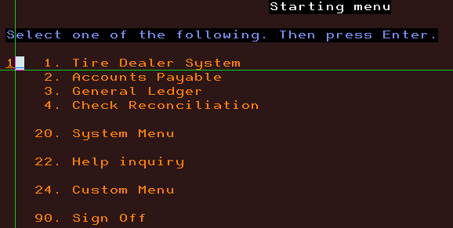

- Type 7 for “Warehouse Order Entry Menu” and hit enter.

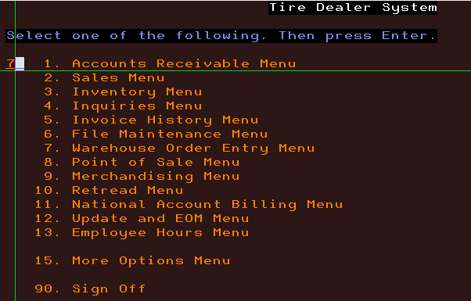

3. Type 1 for “Order Entry” and hit enter.
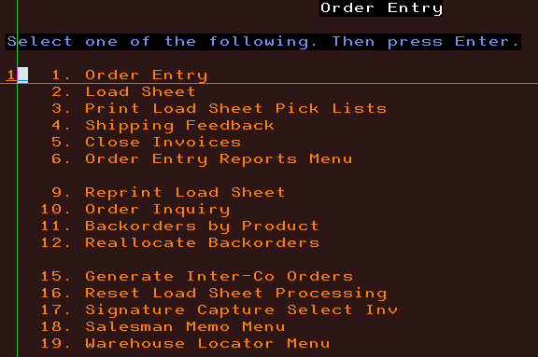

4. Enter the Store Number (Warehouse Number) to be used. Hit Field Tab (+key on far right) and hit Enter to go to the location you are working in.

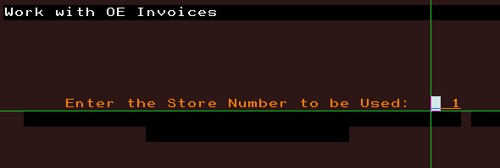

5. Type in the Customer Number for the order you would like to release, Field Tab, then hit Enter.

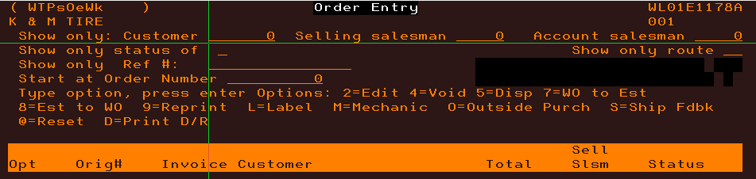

6. Use the Up and Down arrows to navigate to the order you are releasing. Put a 2 on the OPT line to edit the order and hit Enter.

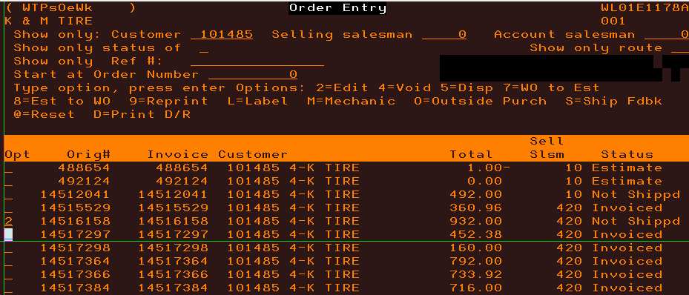

7. Enter through the screen that shows customer information.

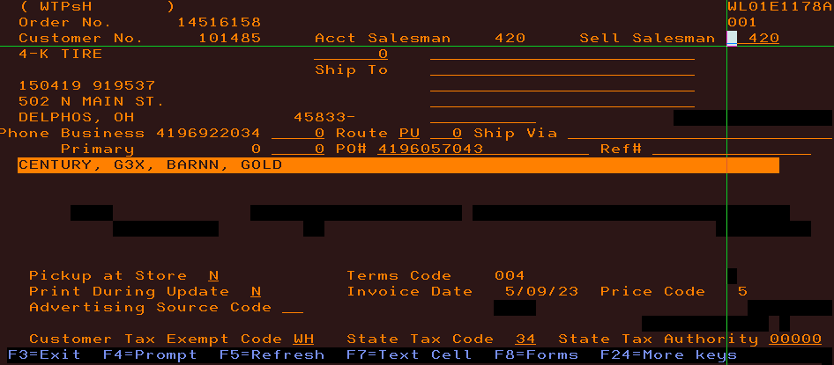

8. Arrow down to the line item that you are removing the backorder on. Put a 2 on the line and hit Enter.

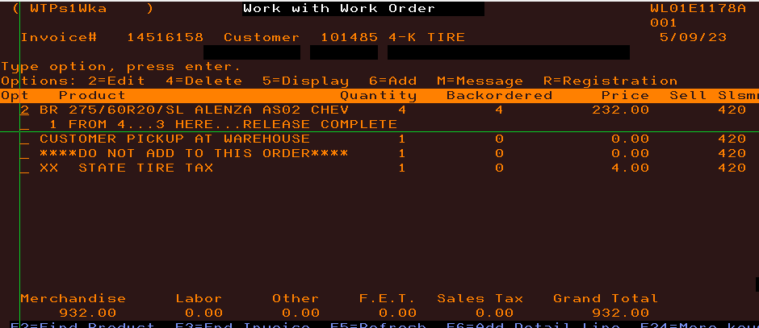

9. Enter through the Line-Item Detail screen.

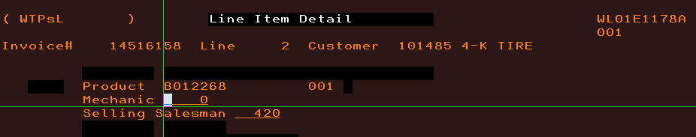

10. Arrow down to the Backorder line and hit the field tab to clear out the backorder. Then hit Enter.

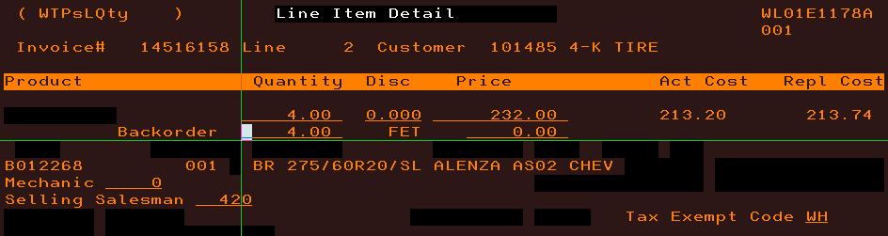

11. If the below warning screen pops up Enter through it.

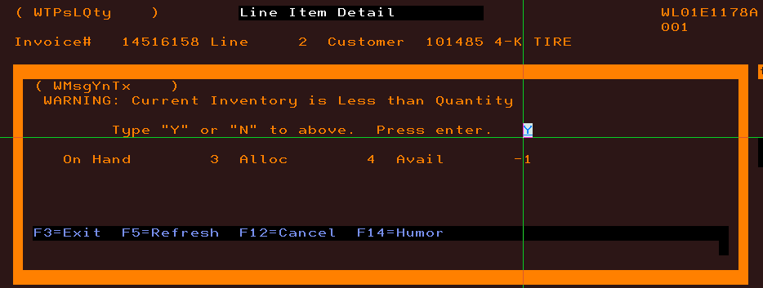

12. You should now be at the Work with Work Order screen showing no backorder and can hit F3 to exit the order.

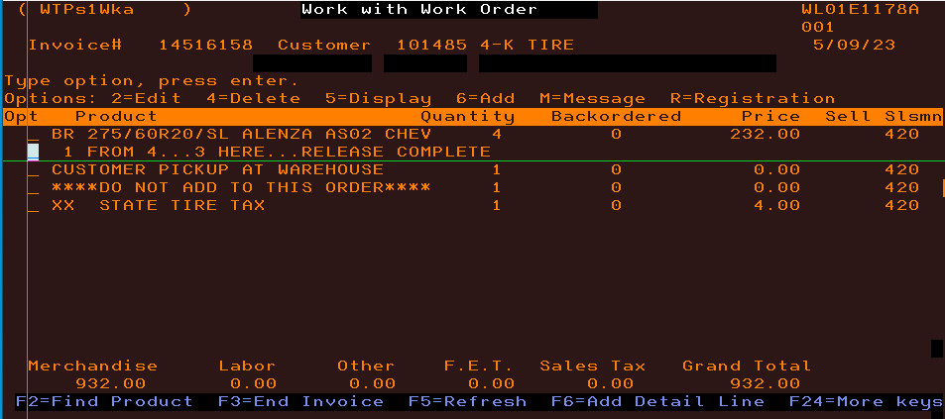

How to release Backorders from Inventory Receivers menu

1. Log into MaddenCo and Type 1 for “Tire Dealer Systems” and hit enter.
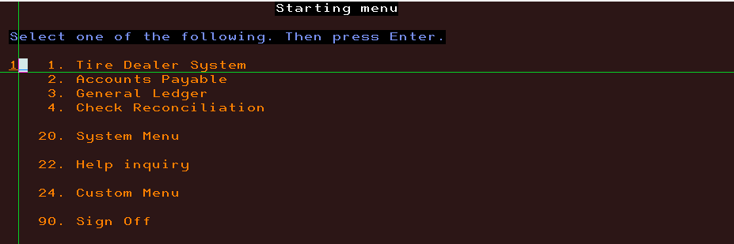

2. Type 3 for “Inventory Menu” and hit enter.
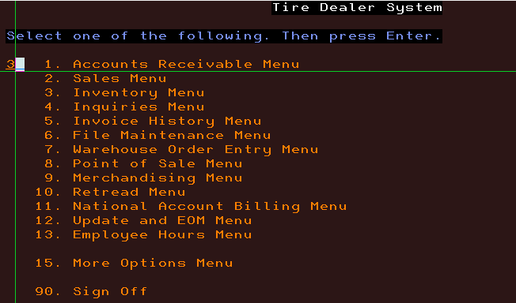

3. Type 3 for “Inventory Receivers” and hit enter.
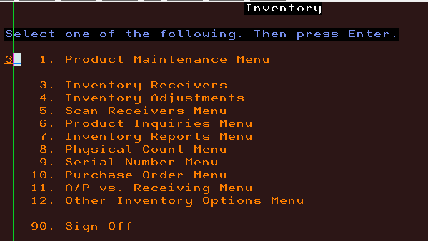

4. Put the store number (warehouse number) that you are receiving in and Field tab (+ key on far right) and hit enter.
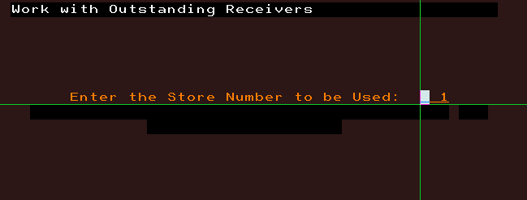

5. You should now be on the “Work with Outstanding Receivers” screen. In this menu you will be looking at all receivers (transfer invoices) for the warehouse you choose. To release the product on the transfer you would just put a 6 on the OPT line and hit enter. The status of the invoice on the far right will change to Ready indicating that the product is now in your inventory.
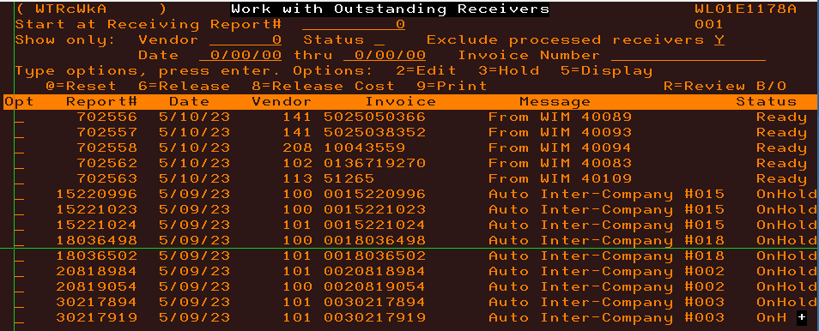

6. From here you put an R on the line of the receiver you wish to review for backorders and hit Enter.
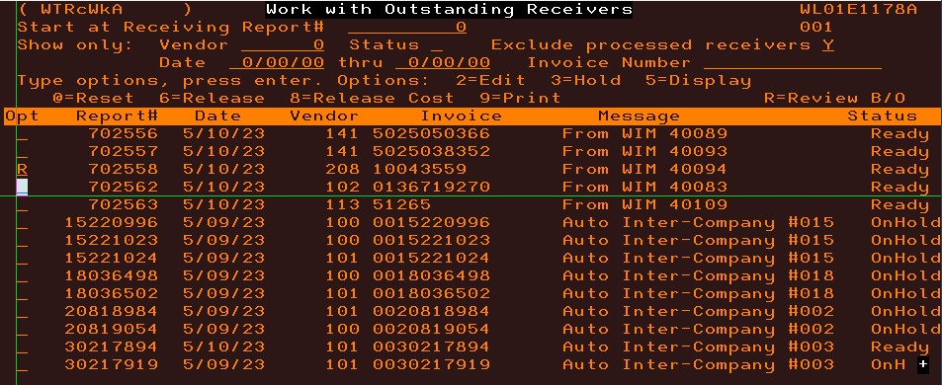

7. This will take you to the Work with a Receiver Screen. From here you will put an O on the line that shows “Backorder Exist” highlighted on the right side and hit Enter.

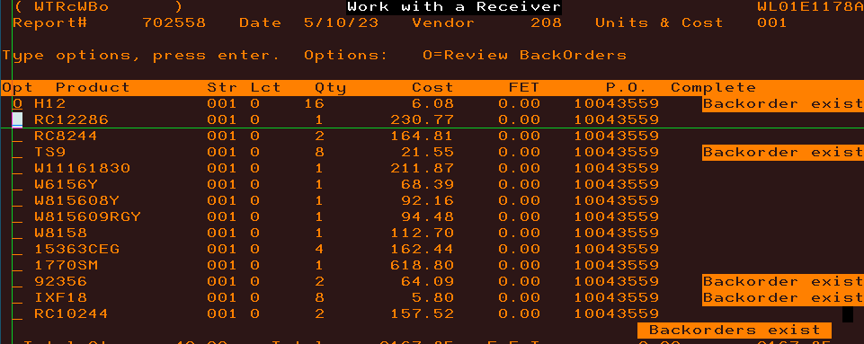

8. This takes you to the “Back Order by Product” screen which is where you will look at the on hand Qty and compare it to the Allocated Qty. If the on hand Qty is = to or greater than the Allocated Qty you can put a 6 on the line to release the backorder (You will first want to put a 5 on the line to view the invoice to make sure there isn’t a not on it asking to have it released on a specific day) and hit Enter.
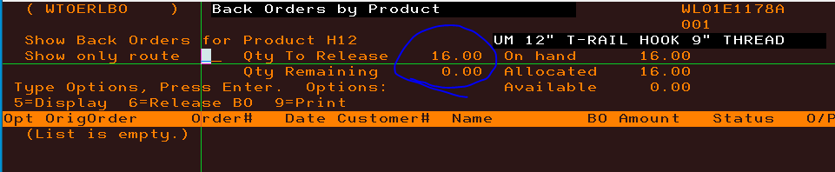
9. You continue doing step 8 until all backorders are cleared.

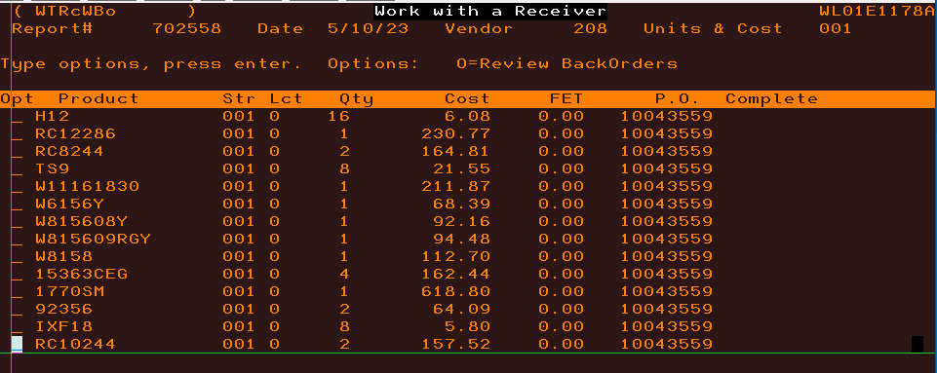

How to do a credit /Rebill

- Go to K&M Tire Intranet

- Click on SA- Product History Inquiry. Enter the Part Number, Customer Number, and Start and End Date (if you know it), and hit Run Repot. This will show us whether or not the credit/ rebill has already been completed. If it has not you would continue to MaddenCo to complete.

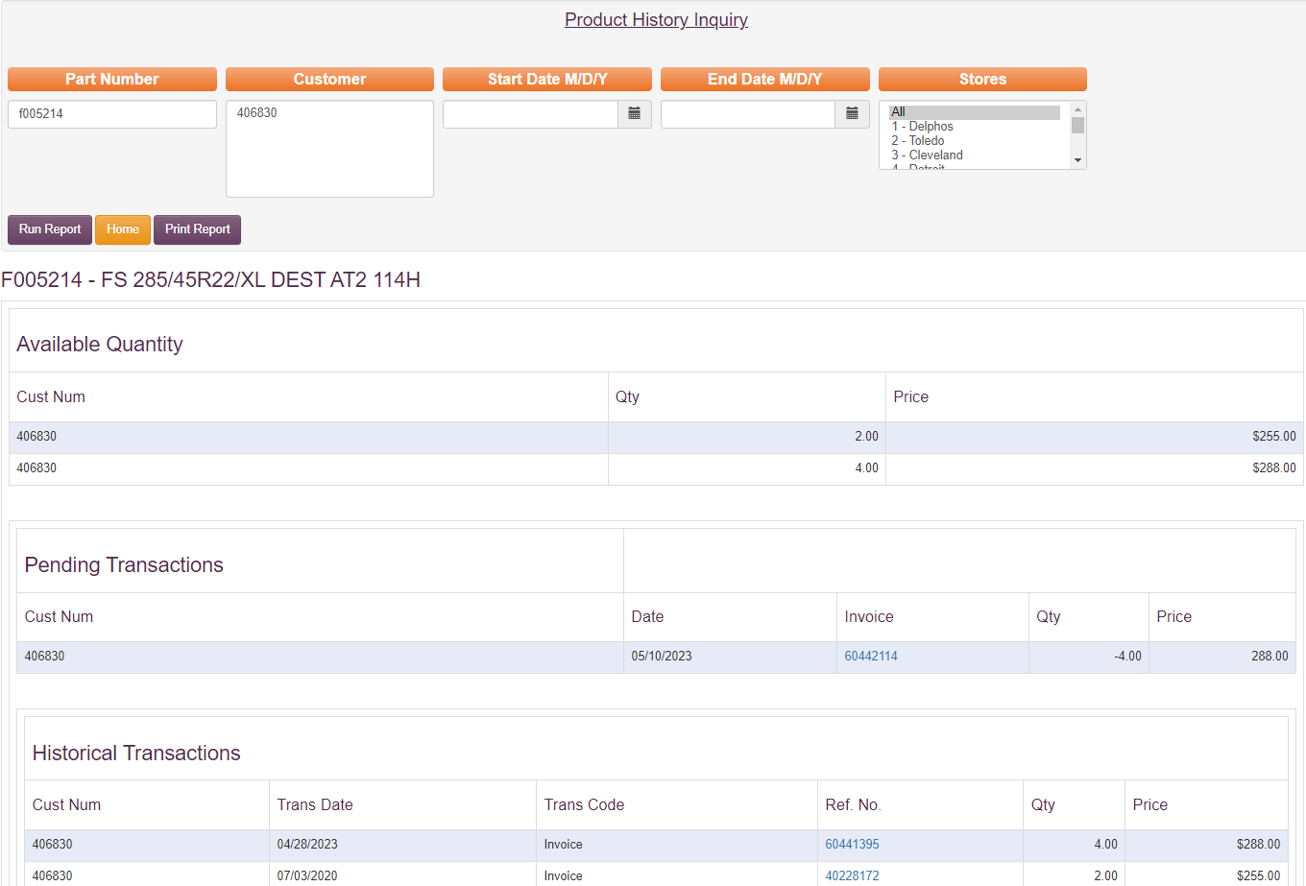

- Log into MaddenCo and Type 1 for “Tire Dealer System” and hit Enter.



- Type 7 for “Warehouse Order Entry Menu” and hit Enter.

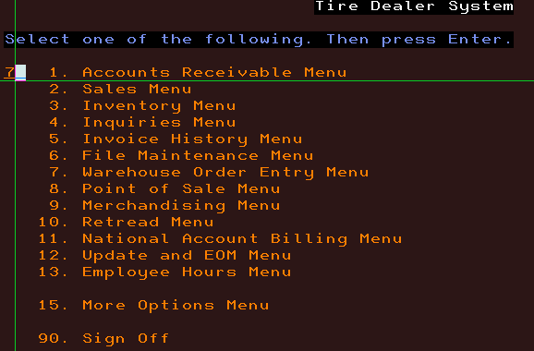

- Type 1 for “Order Entry” and hit Enter.

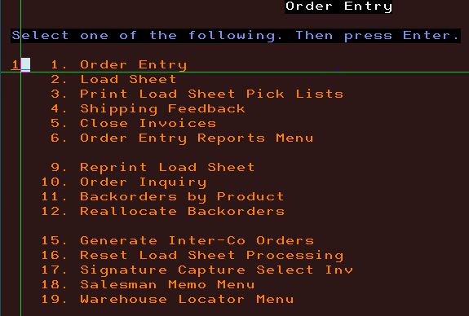

- Type the Store Number that the original invoice was billed out of hit Field Tab and hit Enter.

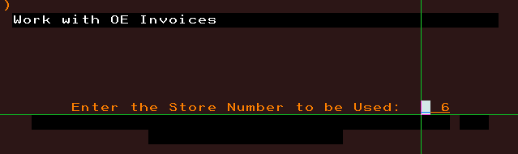

- Enter the Customer number that the rebill needs to be done to. Then hit Field Tab and hit Enter.

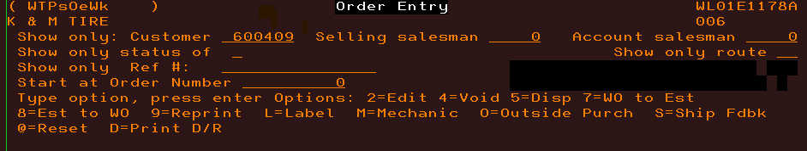

- Hit F2 to create new order and tab down to the display by Product Number. Put the product number in and enter.

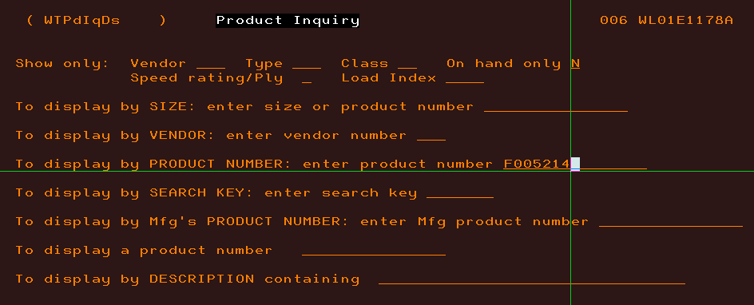

- Put the Qty on the line and hit Enter to create a new order.

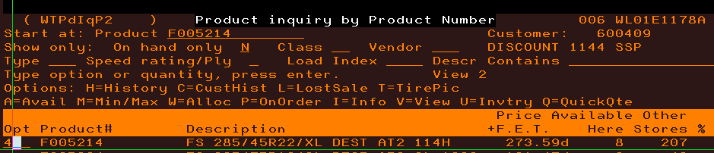

- Put an I on the line for New Order and hit Enter.

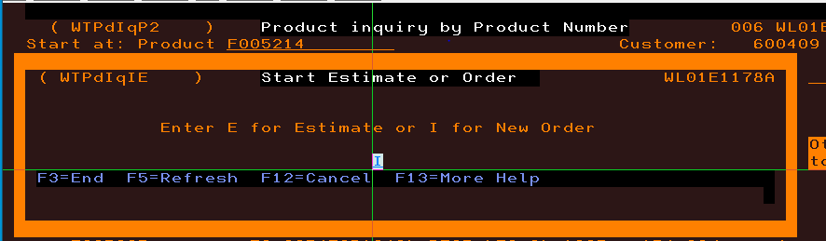

- Put the Selling Salesman number in for the person who sold the original being rebilled and put in the original PO number if there was one and hit Enter.

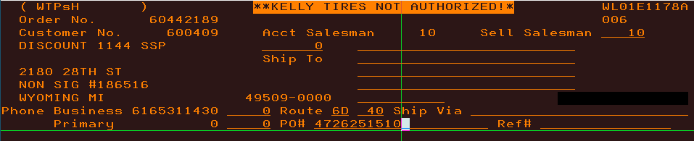

- Now put an M on the line and hit Enter to create a message line on the rebill invoice.

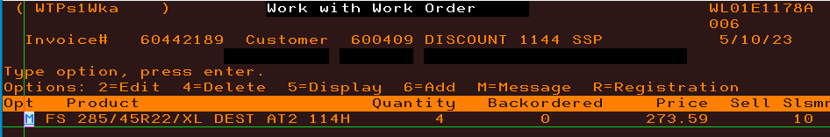
- Then put in the information showing what invoice we are billing and the reason why if necessary (Ex. Fixing price, wrong act, etc.) and hit Enter.

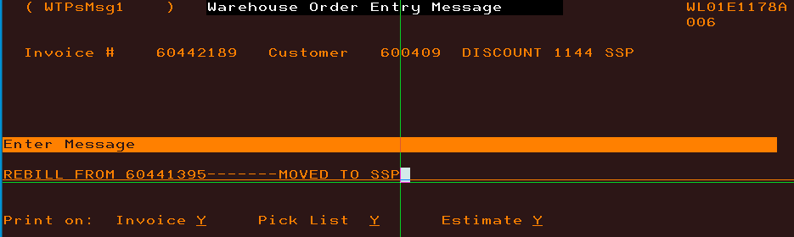

- We are now done creating the rebill (see below) and need to reverse the original invoice to create our offsetting credit. You will hit F3 once to go back to Order Entry.
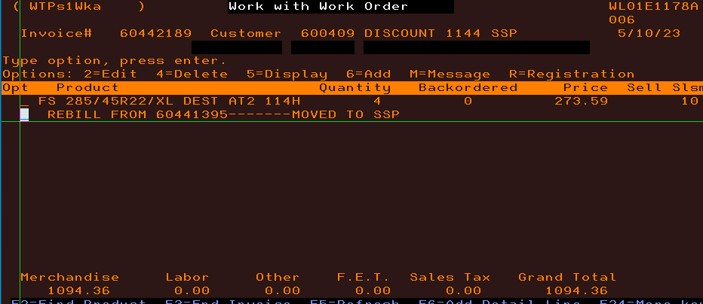

- We will type in the Customer number that will be issuing the credit to and hit Field Tab then Enter.

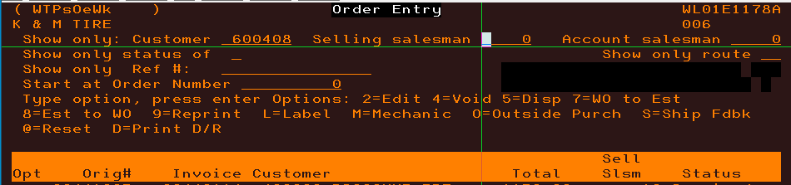

- Then hit F7 and type in the invoice number we need to reverse. Then Field tab and hit Enter.
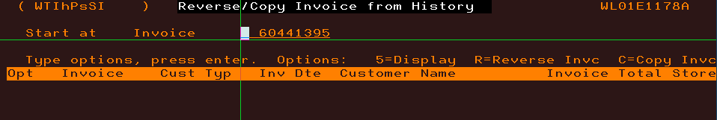

- Next put an R next to the invoice we wish to reverse and hit Enter.
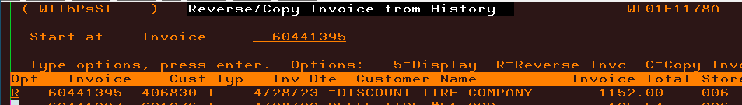

- Enter through the following screen.

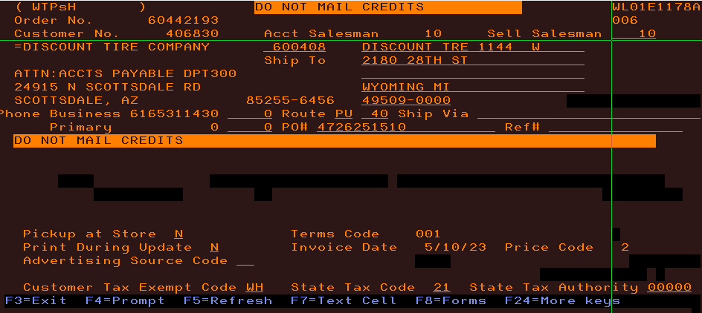

- Again, you will put an M on the line and hit Enter.
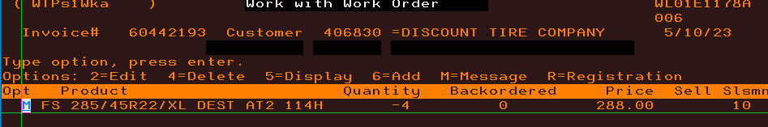

- Next you will put the reason for the credit and reference the original invoice and hit Enter.

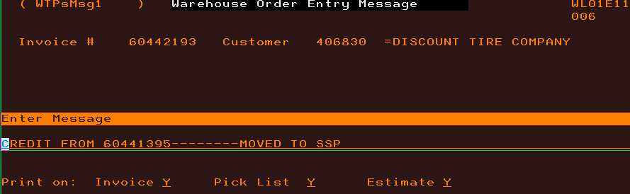

- Now you have an offsetting credit to go with the rebill we completed. Once you have both done you will go to both customers in Order Entry and Force Printer both of them by putting an S on both lines and hitting Enter.
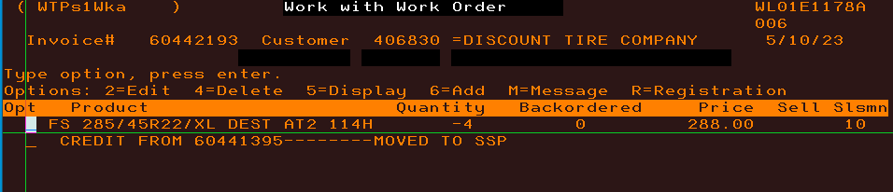

How to Release Transfer Invoices
1. Log into MaddenCo and Type 1 for “Tire Dealer System” and hit enter.


2. Type 3 for “Inventory Menu” and hit enter.


3. Type 3 for “Inventory Receivers” and hit enter.

4. Put the store number (warehouse number) that you are receiving in and Field tab (+ key on far right) and hit enter.


5. You should now be in the “Work with outstanding Receivers” screen. In this menu you will be looking at receivers (Transfer invoices) for the warehouse you choose. To release the product on that transfer you would just put a 6 on the OPT line and hit enter. The status of the invoice on the far right will change to Ready indicating that the product is now in your inventory.



Fillable Order Report
The fillable Order Report is run by the Shipping and Receiving Clerk at the end of every day to make sure all shippable products are released from backorder before invoicing. It is both a failsafe for incoming transfers and shows us allocations that can be filled from incoming vendor loads.

- Go to intranet under Sales- Inside
  - Click on SA- Fillable Order Repot

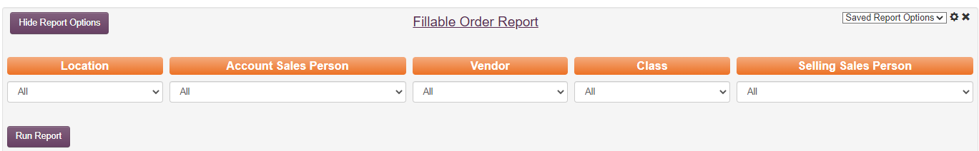

  - Choose the location you want to run from the drop-down menu and click Run Report.

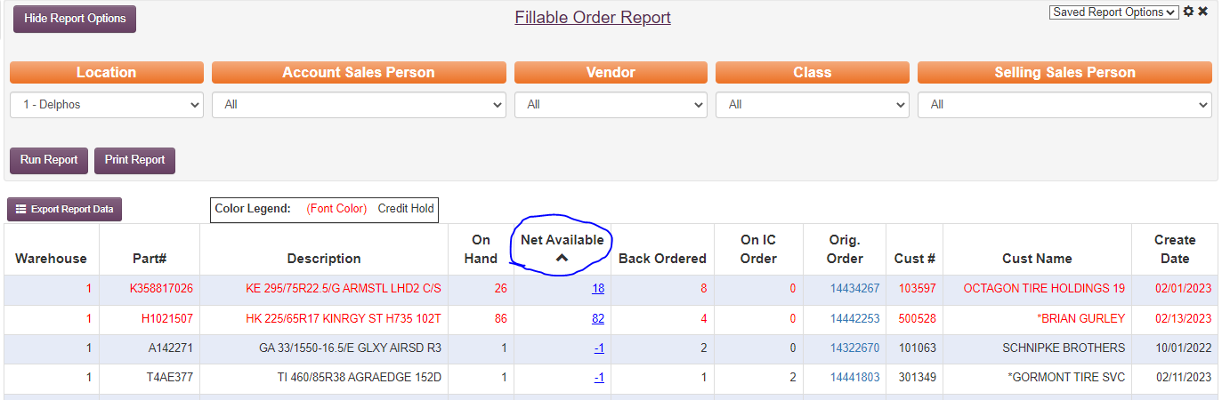

  - If the net available is 0 or more that means the tires are currently in inventory so we need to check on “orig order” to see if there is a message not to release or maybe to deliver on a certain day, then you would leave it on backorder.
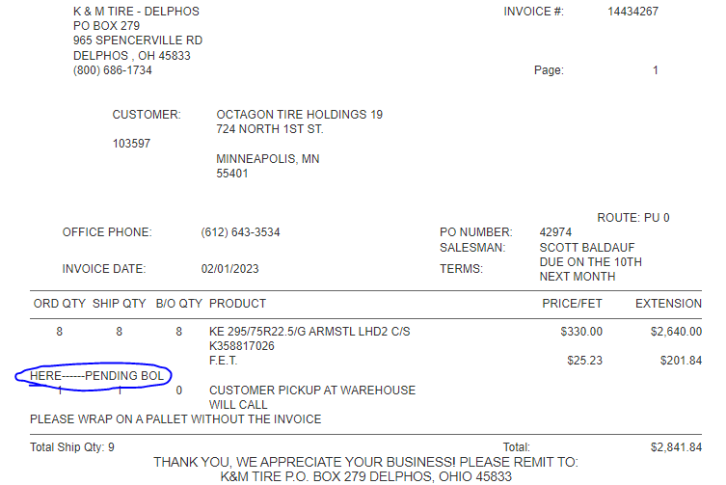
- If there are no messages, you will need to go into order entry in MaddenCo and release the backorder only for what is on hand (if there are multiple part numbers on the order only release the one that’s there)
  - After signing into MaddenCo you will choose 1 “Tire Dealer System” and hit enter.

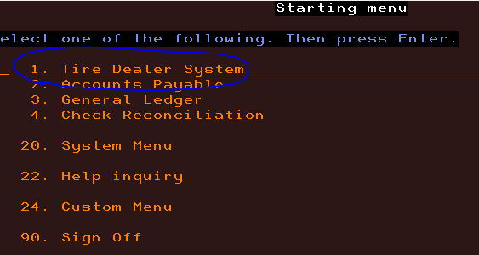

  - Then Choose 7. “Warehouse Order Entry Menu” and hit enter.

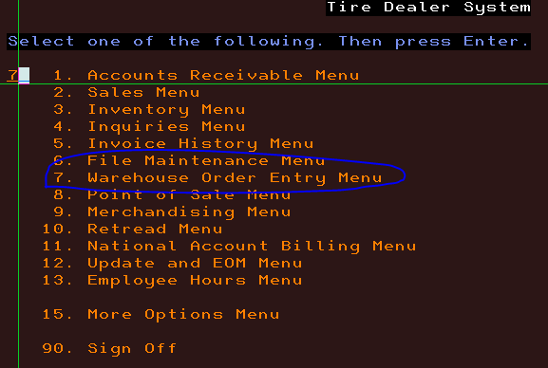

  - Then choose 1. “Order Entry” and hit enter.

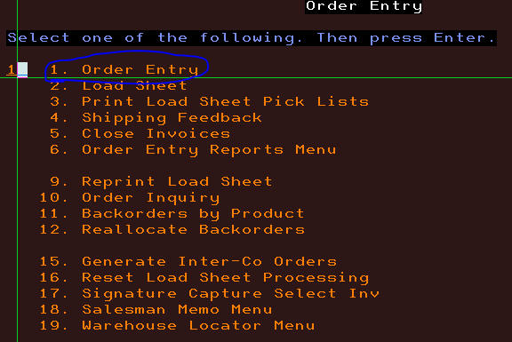

  - From here you will choose the warehouse that the order is in (this would be the same warehouse you ran the fillable order report for) and hit enter.

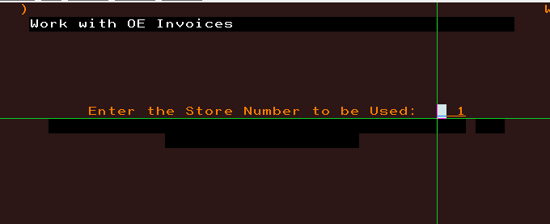

  - Then enter the customer number you need to look at and field tab it over then hit enter.
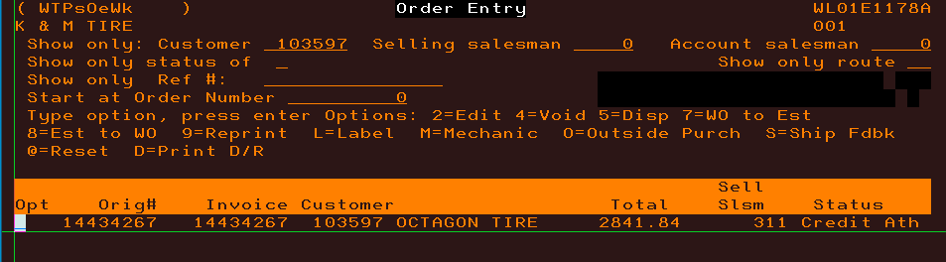

  - Then put a 2 on the line in front of the invoice you need to release the backorder on and hit enter.

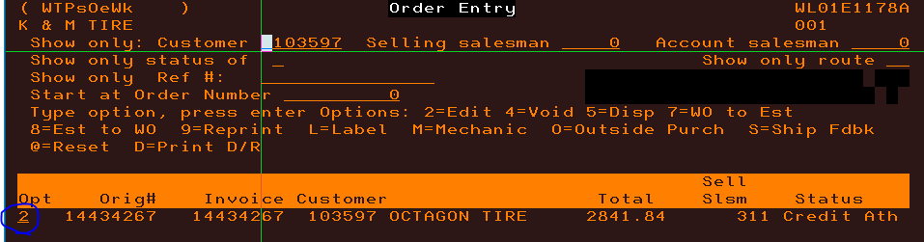

  - Then enter through the below screen.
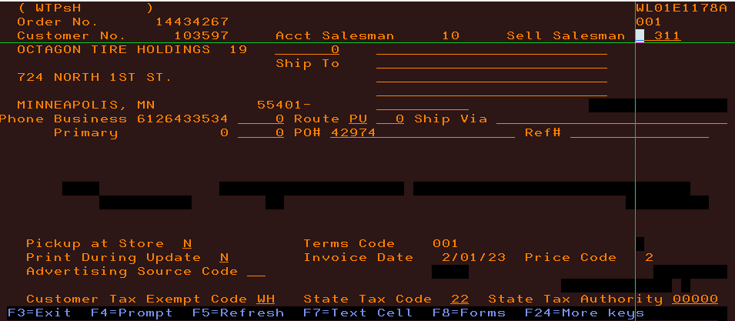
  - Next you want to put a 2 on the product line you need to release and hit enter.

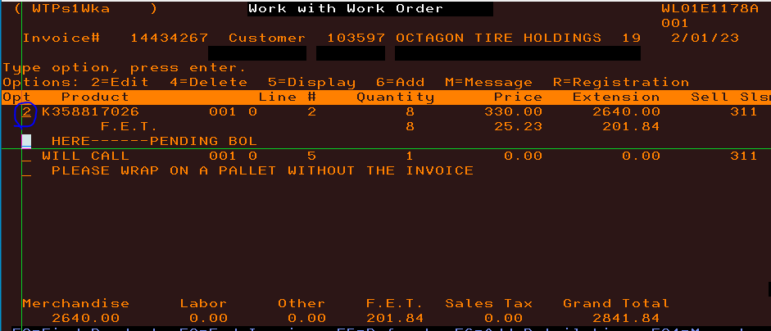

  - Then enter through the Line-item detail screen.

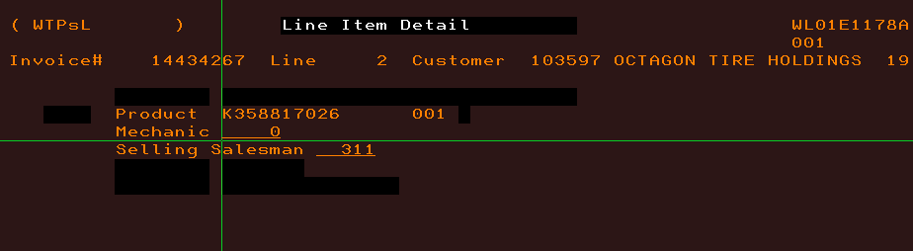

  - Now you should be on the backorder screen where you will remove the backorder. You should see the quantity in the order on top and the backorder quantity on the bottom.

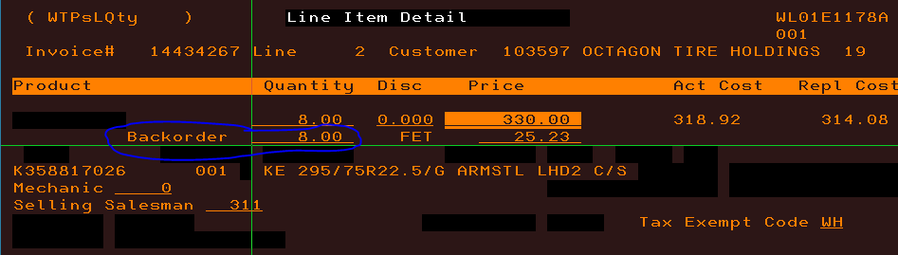

  - You will zero out the backorder quantity by field tabbing through it to remove the backorder quantity. You can also replace the number with a 0 to accomplish this.

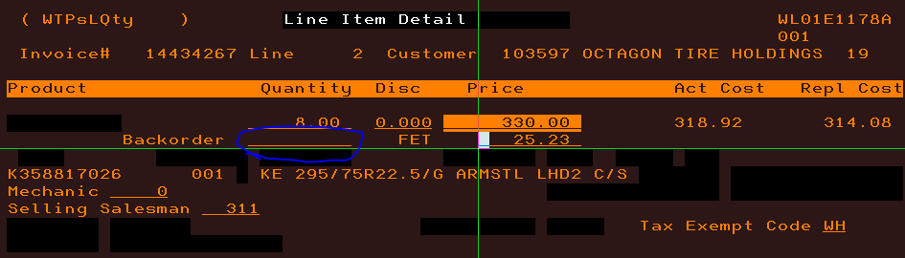

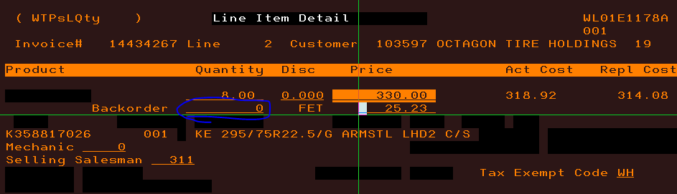

  - And hit enter. You have now removed the backorder (as seen below) and you can F3 out of the order and it will print when we invoice the route next.

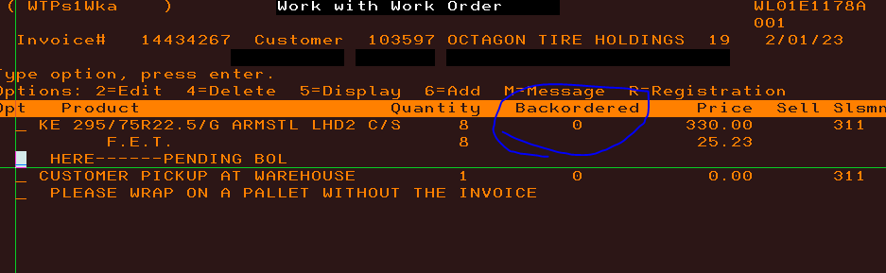

Key Account

Sun Auto
We have a select group of Sun Auto accounts that we will be handling third party logistics (3PL) for. This means that in our warehouses we will be stocking their import tires, Both Paragon and Summit (vendors 301 & 302, respectively), and delivering those accounts these products. Orders for these products will be sent to us via email. Both Paragon and Summit are shipped directly from the importer into our locations, exclusively for their participating stores; as such, these products will not show up for any customer outside of the participating Sun Auto Group. The products will also show no associated cost when billing and will invoice out at $0.00. We will be receiving the orders into our email group: sunauto@kmtire.com . Jeremie, Crystal, DeLee, Scott and Myself will be tied to this email group for incoming orders. Each participating Sun Auto location in this 3PL service will have three separate accounts in MaddenCo, and their can/can’t buy files are set up as follows:

- Regular Account (Access to all vendors except for BS/FS, Goodyear, Dunlop, Kelly, Continental, General, Kumho, Nexen, Pirelli, Yokohama, Mickey Thompson, Paragon & Summit)
- SSP Account (Access to only BS/FS, Goodyear, Dunlop, Kelly, Continental, General, Kumho, Nexen, Pirelli, Yokohama, Mickey Thompson)
- 3PL Account (Access to only Paragon & Summit) Sun Auto Group stores are not allowed to order directly from us for the 3PL product.
  - Upon Receiving emails from Sun Auto Group, it should be clear what products they require, as well as which applicable accounts to ship them to, provided they are set up in our POS. For reference, I have attached a spreadsheet of all eligible locations participating in this program.
  - For all Sun Auto locations, the sort name will be
    - Sun Auto + store number (ex. Sunauto4313)
    - TGK Auto + store number (ex. Tgkauto5299)
    - Drivers + store number (ex. Drivers4209) these accounts fall under the Driver’s Edge moniker, But we needed to remove “Edge” from the title
Very Important to note:
- Only our CSR team is allowed to process the 3PL orders
- All orders will come from the corporate office
- Sun Auto Group stores are not allowed to order directly from us for the 3PL product

Appendix A: Reference Documents

Document Name | Document Location and/or URL | Issuance Date
Manufacturing Website Training | \\file-a.kmtire.local\File Server\Sales\Public\Sales Rep Training | 10/25/2019
Sales Responsibility Cheat Sheet | \\file-a.kmtire.local\File Server\Sales\Public\P & P\Complete | 6/3/2011
Approved Tires for SSP/PR | \\file-a.kmtire.local\File Server\Sales\Public\P & P\Complete | 10/21/2019
Useful Information | \\file-a.kmtire.local\File Server\Sales\Public\P & P\Complete | 06/10/2019
Color Transfer Charts | \\file-a.kmtire.local\File Server\Sales\Public\Color Transfer Charts | 06/26/2019
Call Center Extensions | \\file-a.kmtire.local\File Server\Sales\Public\Sales Information | 10/21/2019
Schedule | \\file-a.kmtire.local\File Server\Sales\Public | Updated Weekly/Monthly
Allowable | \\file-a.kmtire.local\File Server\Sales\Public\Sales Information | 8/08/2019
Routes & Frequencies | F:\Sales\Public | 10/31/2019
Invoicing Procedure | \\file-a.kmtire.local\File Server\Sales\Public\P & P\Complete
Vendor Will Calls & ETA | \\file-a.kmtire.local\File Server\Sales\Public\Sales Information | 10/09/2018
Outside Vendor List | \\file-a.kmtire.local\File Server\Sales\Public\Sales Information | 2/23/2018
K&M Transfer Map | \\file-a.kmtire.local\File Server\Sales\Public\Sales Information | 11/28/2018

Appendix B: Revisions

Section Number | Date | Author/Owner | Description of Change
11.3 | 2-20-2020 | Corey Decker | Updated Will-Call Guidelines to reflect loc. 42
11.3 | 3/17/2020 | Corey Decker | Updated Will-Call Guidelines; changes regarding FS AG & Trelleborg/Mitas
12.2 | 7/29/2020 | Joni Zerkel | Updated video links to correct working link and KM TV
12.3 | 7/29/2020 | Joni Zerkel | Updated video links to correct working link and KM TV
 | 7/29/2020 | Joni Zerkel | Updated many broken links to correct working links.
3.1 | 1/13/2021 | Joni Zerkel | Removed links and added screenshot of websites for trainings.
4.2 | 1/14/2021 | Joni Zerkel | Added how to place a tire order.
5.11 | 3/30/2022 | Joni Zerkel | Added Will Call Colors.
3.6 | 8/9/2022 | Shaina Johnson | Added Employee Purchase.
3.3-3.5 | 8/10/2022 | Shaina Johnson | Added Nonstock unlisted items
3.3.6 | 10/28/2022 | Kayla Perrine | Updated Tire Rack policy
 | 11/17/2022 | Shaina Johnson | CC SOP Update
15-15.5 | 6/6/23  6/7/23 | Kayla Perrine | Backorders from Order Entry and Receiving backorders and Credit Rebill and Transfers, Fillable Order
6.2 | 12/4/23 | Jody Keller | Added to Dashboard Outline sheet
6 | 12/8/2023 | Shaina Johnson | Format sec 6
3.9 | 12/29/2023 | Kayla Perrine | Added 3.9 PR Return Guidelines
16.0  16.1 | 5/30/2024 | Jody Keller | Added Key Account and Sun Auto
3 | 4/21/2025 | Jody Keller | - Added Processing Returns on the Sales Dashboard. Changed out K&M Tire Return policy and PR guideline for returns

